3D Graphene Network as Platform for Emerging Applications
M. Hiramatsu¹, K. Takeda¹, H. Kondo², M. Hori²

¹ Meijo University, Japan
²Nagoya University, Japan

Abstract

Graphene-based materials such as carbon nanotube and graphene sheet itself have a wide range of possible applications. Among these graphene-based materials, carbon nanowalls (CNWs) are self-supported network of few-layer graphenes standing almost vertically on the substrate to form 3-dimensional structure. The maze-like architecture of CNWs with large-surface-area graphene planes would be useful as electrodes for energy storage devices and scaffold for cell culturing. Especially, combined with surface termination including metal nanoparticles and biomolecules, CNWs can be suitable as platform in electrochemical and biosensing applications. CNWs and similar vertical graphene materials can be synthesized by plasma-enhanced chemical vapor deposition (PECVD) on heated substrates (600-800 ˚C) employing methane and hydrogen mixtures. The height of CNWs increases almost linearly with the growth period, while the thickness of walls and interspaces between adjacent walls are almost constant. We have carried out CNW growth using PECVD with emphasis on the structure control of CNWs. Moreover, CNW surface was decorated with Pt nanoparticles by the reduction of chloroplatinic acid. We also report the performances of hydrogen peroxide sensor and fuel cell, where CNW electrode was used. Electrochemical experiments demonstrate that CNWs offer great promise for providing a new class of nanostructured electrodes for electrochemical sensing, biosensing and energy conversion applications.

Keywords—carbon nanowalls, electrochemistry, graphene, plasma-enhanced CVD

Professional Biography

Prof. Mineo Hiramatsu received Ph.D. from Nagoya University and is a Full Professor of Department of Electrical and Electronic Engineering, Meijo University, Japan. He served as the Director of Research Institute, Meijo University in 2017-2018. His main fields of research are plasma diagnostics and plasma processing for the synthesis of thin films and nanostructured materials. Author of more than 150 scientific papers and patents on plasma processes for materials science. He served as chairman and member of organizing and scientific committees of international conferences on plasma chemistry and plasma processing. He was awarded the Japan Society of Applied Physics Fellow in 2017.
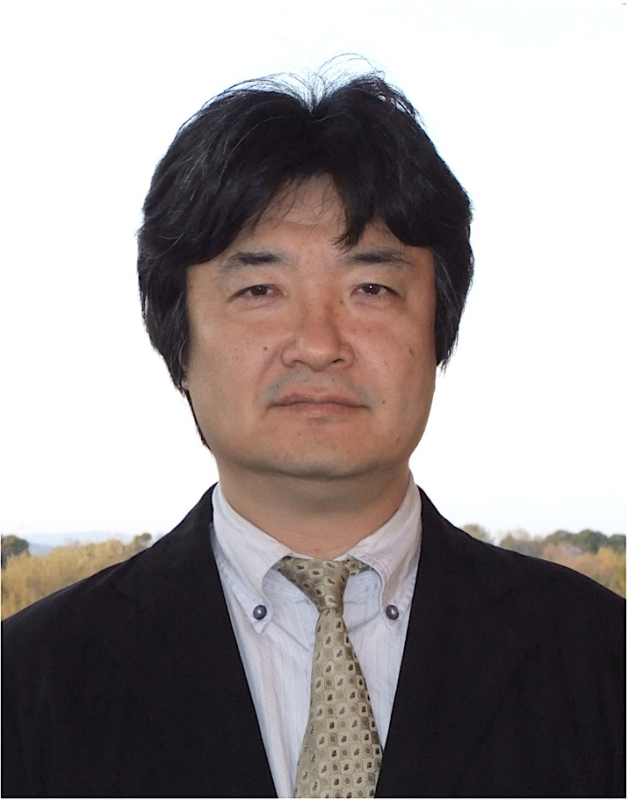

Email Id: mnhrmt@meijo-u.ac.jp

