Abstract Title: Polymer Giant Vesicles as Artificial Models of Biomembrane
Eri Yoshida

Department of Environmental and Life Sciences (Toyohashi University of Technology, Japan)

Abstract

Microsized giant vesicles are a possible artificial model of biomembranes for cells and organelles based on the similarities in their size and structure. Polymer giant vesicles consisting of amphiphilic block copolymers can be easily modified and have many industrial applications, such as microreactors, microcapsules, sensors, etc. With the aim of creating artificial cells employing polymer giant vesicles, a novel artificial model was established using amphiphilic diblock copolymers. This paper describes the fabrication of the morphologies and phenomena that are produced by a lipid bilayer in vivo by the photopolymerization-induced self-assembly of amphiphilic poly(methacrylic acid)-block-poly(methyl methacrylate-random-methacrylic acid), PMA-b-P(MMA-r-MA).
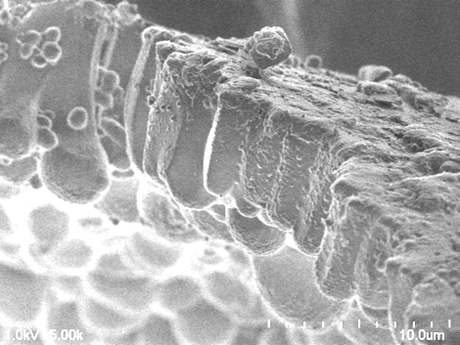
Spherical vesicles and worm-like vesicles, coupled with the elliptical, cup-like, and key-shaped vesicles were obtained by manipulating the block lengths of the copolymer. The formation of these morphologies was accounted for by a change in the critical packing shape of the copolymer with different block chains. Based on this morphology control by the critical packing shape of the copolymer, a villus-like structure was fabricated using the copolymer having a very long and highly hydrophobic P(MMA-r-MA) block to provide an inverted truncated cone-like critical packing shape, focusing on an inverted cone-like phosphatidylethanolamine, the chief lipid composing the villi of the small intestine and gallbladder (Figure 1). The anastomosed tubular network connected to a fenestrated sheet observed on the surfaces of the endoplasmic reticulum and Golgi apparatus was obtained in the restoration process of spherical vesicles from the vesicles disrupted by heat. The restoration process of the vesicles disrupted at a high pH involved budding separation from the mother membrane. Furthermore, unique artificial membrane models were created using a polyelectrolyte as a membrane protein for endocytosis and using the segmented P(MMA-r-MA) random copolymer as a sterol because the random copolymer was amphiphilic, as well as highly hydrophobic.
10 μm
The face contacting with the reaction vessel
Figure 1. The villus-like structure fabricated using the copolymer.

Keywords—Amphiphilic diblock copolymer, Artificial biomembrane models, Giant vesicles, Photopolymerization-induced self-assembly

Professional Biography

Eri Yoshida has completed her Ph.D. from Tokyo Institute of Technology. She joined Kyoto Institute of Technology as an assistant professor. She was also a visiting scientist at University of North Carolina at Chapel Hill. She is an associate professor of Toyohashi University of Technology. She has more than 100 peer-reviewed scientific publications and over 20 patents. She has been serving as an editorial board member of several international journals. Her research interests include molecular self-assembly of amphiphilic block copolymers, controlled/living radical polymerization, molecular design of functional polymers, and polymer syntheses using supercritical carbon dioxide. The study in this paper concerns the molecular self-assembly of amphiphilic diblock copolymers prepared by the photo nitroxide-mediated controlled/living radical polymerization technique recently established by her research group.

Email Id: eyoshida@ens.tut.ac.jp

Any Comments:
Eri Yoshida has been invited as a Plenary Speaker.

