The emergence of artificial intelligence: Machine learning-based recognition and treatment approach: a case study of clinical data
Moloud Abdar, MSc, The University of Aizu, JAPAN

Abstract (300 word limit)
Statement of the Problem: In recent decades, Artificial intelligence (AI) has become a very useful and powerful technology which has helped to improve the quality of people's lives worldwide. Machine learning (ML) is an especial branch of AI to apply various algorithms which can provide smarter AI-based products. These algorithms have been successfully applied on different subjects. The World Health Organization (WHO) has listed cardiovascular diseases (CVDs), which includes several types) as the leading cause of death around the globe. Coronary artery disease (CAD) is one of the most important types of CVDs. Methodology & Theoretical Orientation: The Particle Swarm Optimization (PSO) is one of the well-known evolutionary algorithms (EAs) which can be used for different purposes. Therefore, a modified and optimized PSO was applied on the Cleveland heart data with 303 records. The PSO algorithm, therefore, was used for producing different rules in heart disease from original data set and then optimization of these rules and producing the best rules using PSO algorithm. In other words, first random rules were generated and then were optimized using proposed PSO. Moreover, C4.5 decision tree algorithm was also applied to check its performance with proposed PSO. Findings: The results showed that the proposed PSO can optimize the generated rules significantly. Moreover, the findings demonstrated that the fitness function applied in our research has valuable impact on the performance of PSO. In addition, the optimized rules by PSO had better prediction accuracy compared with C4.5 algorithm. Conclusion & Significance: Classical PSO can generate different simple rules, however, optimized PSO can be more efficient to show higher accuracy. Moreover, this optimization technique can be used on different clinical and non-clinical data sets.

Image
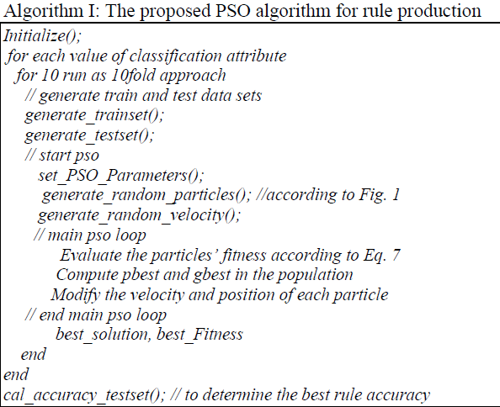
Recent Publications (minimum 5)
- Alkeshuosh, A. H., Moghadam, M. Z., Al Mansoori, I., & Abdar, M. (2017). Using PSO Algorithm for Producing Best Rules in Diagnosis of Heart Disease. In Computer and Applications (ICCA), 2017 International Conference on (pp. 306-311). IEEE.
- Abdar, M., Zomorodi-Moghadam, M., Das, R., & Ting, I. H. (2017). Performance analysis of classification algorithms on early detection of liver disease. Expert Systems with Applications, 67, 239-251.
- Abdar, M., Kalhori, S. R. N., Sutikno, T., Subroto, I. M. I., & Arji, G. (2015). Comparing Performance of Data Mining Algorithms in Prediction Heart Diseases. International Journal of Electrical and Computer Engineering (IJECE), 5(6), 1569-1576.
- Abdar, M., Yen, N. Y., & Hung, J. C. S. (2017). Improving the Diagnosis of Liver Disease Using Multilayer Perceptron Neural Network and Boosted Decision Trees. Journal of Medical and Biological Engineering, 1-13.
- Plawiak P., & Abdar, M. (2018). Novel methodology for cardiac arrhythmias classification based on long-duration ECG signal fragment analysis. Biomedical Signal Processing - Advances in Theory, Algorithms and applications. Springer, (in press).
- Lee, H., Abdar, M., & Yen, N. Y. (2018). Event-based trend factor analysis based on hashtag correlation and temporal information mining. Applied Soft Computing.

Photograph

Biography (150 word limit)
Moloud Abdar received the bachelor's degree in computer engineering from Damghan University, Iran, in 2015 and the master’s degree in computer science and engineering from the University of Aizu, Aizu, Japan, in 2018. He has several papers about data mining, machine learning, and user modeling in some refereed international journals and conferences. His research interests include data mining, artificial intelligence, machine learning, social media, big data, and human-centered computing. He is a member of International Association of Engineers. He is also very active in five international conferences and some referred international journals, including the Computer Methods and Programs in Biomedicine, the Future Generation Computer Systems, the IEEE ACCESS, the Neurocomputing, the Journal of Internet Technology, the International Journal of Social and Humanistic, and the Web Intelligence as a Reviewer.
Email: m.abdar1987@gmail.com

Notes/Comments:

