Efficiency in Additive Manufacturing Processes
Juan Carlos Cruz-Robles, USA

Abstract (300 word limit)
As any other manufacturing technology that transforms a raw material into a final product, additive manufacturing technologies requires energy sources and materials usage that will define how efficient their process can be.
This research is meant to give an approach on the efficiency of major production additive manufacturing technologies with an overview in hardware, material consumption and 3D products. These major production technologies are powder beds (metals and plastics), photopolimerization (SLA and DLP) and direct energy deposition (metals).
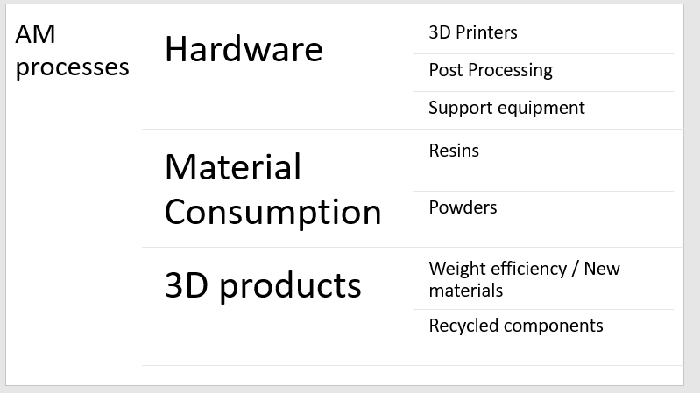

Image
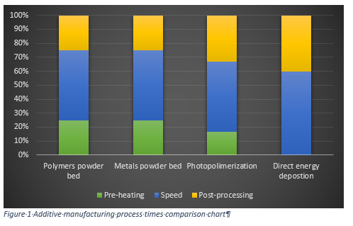
Recent Publications (minimum 5)
- Cruz-Robles, Juan Carlos (2018). Multi-materials & Multi-property components with Additive Manufacturing. https://3dprint.com/215747/multi-material-multi-properties/
- Cruz Juan Carlos, Dutta B (2015). Hard Surfacing on a Steel Punch Using Direct Metal Deposition. https://advancedmanufacturing.org/hard-surfacing-steel-punch-using-direct-metal-deposition/ .

Photograph

Biography (150 word limit)
Juan Carlos is a passionate engineer who has +5 years of experience in additive manufacturing and 11 years as a mechanical engineer. His experience involves R&D of additive manufacturing processes and product design in metal 3D printers, stereolithography and most recently on DLP printers . On the research area, he has developed and tested different metal alloys to allow them to be compatible and achieve required mechanical and metallurgical properties using direct metal deposition. On DLP printers he is currently testing different resins to achieve required mechanical properties.
He earned the degree of Master in Science from the University of Manchester in Advanced Manufacturing Technology and Systems Management in 2011, with a dissertation titled “Low power wire feeding laser additive manufacture.
In 2006, he graduated from a B.S. in Mechanical engineering with a minor in electrical engineering from the Monterrey Institute of Technology and Higher Education.
Email: juan.carlos.cr@outlook.com

Notes/Comments:

