Microstructural and crystallographic characterization of spark plasma sintered Ti-Zr and Ti-Ta based alloys
Bamidele L Bayode, Centre of Nanoengineering and Tribocorrosion, School of chemical, metallurgican and mining engineering, University of Johannesburg, South Africa
Ronald Machaka, Council for Scientific and Industrial Research, Pretoria, South Africa
Peter A Olubmabi, Centre of Nanoengineering and Tribocorrosion, School of chemical, metallurgican and mining engineering, University of Johannesburg, South Africa

Abstract (300 word limit)
Ti-Ta and Ti-Zr alloys have been identified to possess capabilities to meet the demand for light weight, commercially friendly and functionally viable high temperature shape memory applications in the aerospace industries. Characterization is at the core of understanding the phenomenological relationship between the processing method and the final materials properties. In contrast to the preponderance of reported work on the characterization of shape memory alloys fabricated from conventional techniques, not much work involving the uses of spark plasma sintering is available. In this study, Ti-30Ta and Ti-30Zr based alloys have been fabricated from elemental powders, using spark plasma sintering under varying process parameters including: sintering time, sintering pressure and powder formulations. As sintered powders were characterized for their relative density, and indentation microhardness using Archimedes buoyancy method and Vickers indentation techniques respectively. Metallographically prepared specimens were subjected to microstructural and chemical analyses using Field emission scanning electron microscope (FE-SEM) equipped with energy dispersive x-ray spectroscopy (EDS) respectively. Crystallographic properties were also determined using X-ray diffraction (XRD) and Electron backscattered diffraction (EBSD). The thermal properties of the sintered alloys were also determined using laser flash analyses and differential scanning calorimetry. The microstructural results showed improved twinned martensite plate formation with increase in at%Zr content as shown in Fig 1. Furthermore, Ta was found to stabilize beta phase in Ti while the Zr stabilize the alpha phase. Almost full densification was achieved with increase in the Zr content.

Image
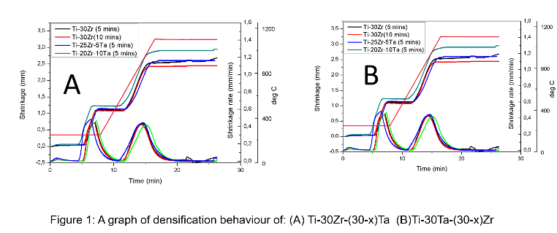
Recent Publications (minimum 5)
- Mohd Jani J, Leary M, Subic A, Gibson M.A (2014) A review of shape memory alloy research, applications and opportunities. Materials and Design 56: 1078–1113
- Lee G, Olevsky E.A, Maniere C, Maximenko A, Izhvanov O, Back C, McKittrick J (2018) Effect of electric current on densification behavior of conductive ceramic powders consolidated by spark plasma sintering. Acta Materialia 144: 524-533
- Tan Z, Ji G, Addad A, Li Z, Silvain J, Zhang D (2016) Tailoring interfacial bonding states of highly thermal performance diamond/Al composites: Spark plasma sintering vs. vacuum hot pressing. Composites: Part A 91: 9–19
- Li H, Hu X, Yang H, Li L (2016) Anisotropic and asymmetrical yielding and its distorted evolution: Modeling and applications. International Journal of Plasticity 82: 127-158
- Ishii A, Li Li, Ogata S (2016) Shuffling-controlled versus strain-controlled deformation twinning: The case for HCP Mg twin nucleation. International Journal of Plasticity 82: 32-43

 Biography (150 word limit)
Bamidele Lawrence Bayode is currently doing his PhD degree at the University of Johannesburg, South Africa. His field of study includes the spark plasma sintering (SPS) fabrication, characterization and optimization of functional properties of Ti-based high temperature shape memory alloys. The SPS is a relatively novel fabrication technique for fabrication of novel advanced materials with tailor made properties, and since the development of Ti-based shape memory alloys is still on the rise, he has therefore decided to employ the use of the novel SPS technique to investigate the various technical possibilities that Ti-Ta and Ti-Zr based shape memory alloys possess.

Email: bamlaw1st@gmail.com

Notes/Comments:

