E-BABE: The hidden relation, clues of autism, ADHD and depression which reveals the effective cause and cure
Van Duy Dao, Awaken You Wonderful We, Vietnam

Abstract

Observing the facts: they lack social skills, they cannot talk: language is the product of living environment - native language; we speak it naturally without thinking at all. We are not born with our native language, so I doubt their connection with their living environment and the state of mind that they cannot learn. Testing them with Aesop fables, metaphors, pretending game - they do not understand these as normal kids; and they are poor in interacting, communicating or persuading. They are in the low level of this. For official test: you can test them with EQ test. All these low-level vital skills make them never feel safe, connection to the environment: it makes them stress. Over time, it makes the downward spirals that make them more and more lack of social skills and suffer more stress.

Poor in EQ: autistic kids do not understand fable and metaphors. Genes cannot make them poor in EQ, and cognitive thinking. Trainers know any skill can be learned with just basic supports.

ALL IN ONE, ONE IN ALL:

As therapists: Neurologist, psychiatrist, sociologist, gastroenterologist, urologist, educators, sleep therapists, cardiologist, language therapists, educators, trainers and teachers, we should remember there is no separation in the health of heart, stomach, muscle, cognitive thinking, sleeping, hormone system: all are interdependent and under the state of mind.

Characters of the mind: irrational mind, the giant brain evolved for millions of years, illogical mind and Placebo effects, neuro-plasticity, Mirror neurons, self-affirmation, self-talk, nocebo effects, T1/2 of all substances, taboos, rituals, religious belief, compound effects, conditioned responses, flexible adaptability, illusive mind, self-healing or self-destroying, irrational thinking, Subliminal message, Marketing of luxury brand, and Hysteria. What do people feed the mind of the kids every day? And what if all of these lead to negativity or positivity? Maybe Outliers or Failures!
Image
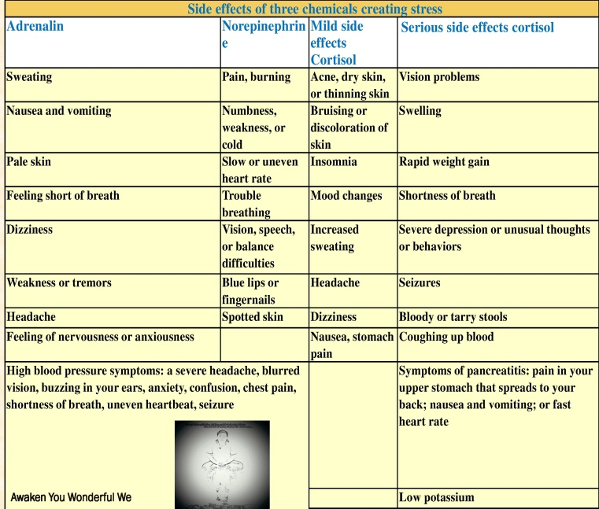

Picture: the effect of stress hormones: the best explanation for many syndromes, rainbows of problems and gut feelings.
Recent Publications
- Van D. Dao (2017) Awaken You Wonderful We: The secret of one-page table reveal all the real causes of all phenomena and problems: Ability - ADHD, Autism - Depression - Belief system - Gut feelings - Learning –Talent. Amazon.com
- Link of the video on youtube, and article on Slideshare: “The hidden relation of autism, adhd, and depression which reveal the effective cause and cure” https://www.youtube.com/watch?v=jWFU0o0Tbxw&feature=youtu.be; https://www.slideshare.net/mobile/duyvan64/the-hidden-relation-clues-of-autism-adhd-and-depression-which-reveals-the-cause-and-possible-cure

 Biography
Van Duy Dao, born 1986, had completed Pharmacist Bachelor degree in Hanoi University of Pharmacy. I am a pharmacist, personal development lover, and meditation practitioner.
Proud to be a pharmacist, but he is ashamed of the failure of knowledge and the medication in healing many unknown Causes. Most of the medications only make temporal relief and many medications chronic patients have to take in their lifetime. Worst of all: mental illness, depression, ADHD, Autism, suicide, and gunfire, social problems seem to go against all the advancement in economic, standard living and Giant leap in technology. I keep on searching. Advantage of the general knowledge of medicine, physiology, psychology, pharmacology, management, marketing, selling, persuading, motivating; and the mixing of Eastern Philosophies: Buddhism, Taoism, Confucianism which full of paradoxical subtle profound knowledge in the art of living, virtues, purposeless, pace of nature to gain success, health, happiness, and inner-peace in daily life.
Email: duyvan64@gmail.com
Blog: Awakenyouwonderfulwe.com

