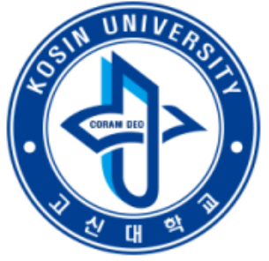
Comparison of interfacial behavior with calix[4]arene derivatives at liquid-liquid interfaces
Jee Young Kim
Department of Chemistry&Advanced Materials, Kosin University, 194, Wachi-Ro, Busan 49104, South Korea

Presenting Author Name: Jee Young Kim
Affiliation:Department of Chemistry&Advanced Materials
University:Kosin University
Country:South Korea
Category: Poster presentation

Abstract
Various p-tert-octylcalix[4]arene derivatives have been prepared to investigate Ag(I) extraction efficiency in a batch-wise process in nitric acid media. The influence of the functional groups of the hydrophobic extrctants on the interfacial behavior has been studied using the drop-volume method. The amido-type p-tert-octylcalix[4]arene derivatives have strong interfacial activity and fast extraction rates. The relationship between the interfacial activity and the dependence of the Ag(I) extraction efficiency on the different functional groups is discussed. The interfacial behavior of the extractants affected both the solvent extraction equilibrium and the kinetics and the overall results are consistent with a mass transfer mechanism at the heterogeneous liquid-liquid interfaces.

Biography
Dr. Jee Young Kim is a assistant professor of Department of Chemistry&Advanced Materials, Kosin University. She has completed Ph.D. in Saga University, Japan and Postdoctoral studies from Pusan National University, South Korea.

Research Interests: Separation Techniques
Keywords: Interfacial activity, Calix[4]arene derivatives, Ag(I) extraction, Solvent extraction kinetics

Notes/Comments:
The work was supported financially by the Environment Research and Technology Development Fund, No. 3K-123022, from the Ministry of the Environment, Government of Japan, and the grants from the Ministry of Science, ICT, & Future planning, Government of South Korea via ‘The first Research and Technology Development Fund, NO. 2017R1C1B5018365′.

