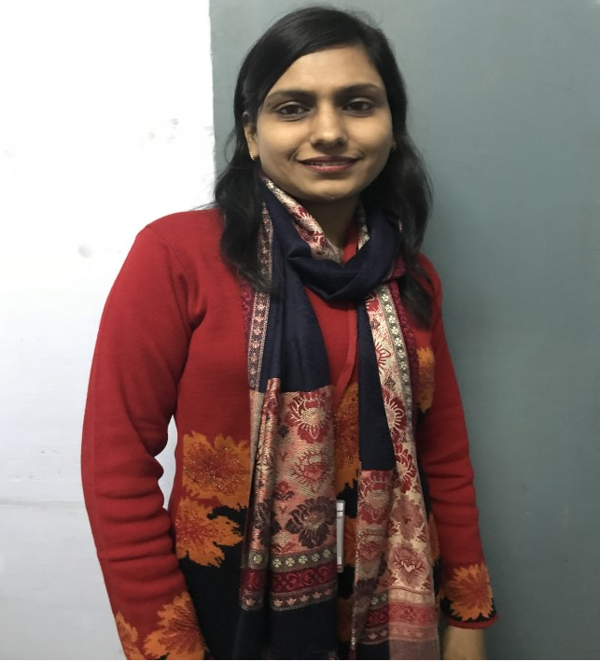

Simultaneous Sorption and Biodegradation of Phenol and Cyanide from Simulated Wastewater Using Bio-composites

Bhumica Agarwal^{a*}, Chandrajit Balomajumder^{b}
a Assistant Professor, Meerut Institute of Engineering and Technology, Meerut-250002, Uttar Pradesh, India
b Professor, Department of Chemical Engineering, IIT Roorkee, Roorkee-247667, Uttarakhand, India

Presenting Author Name: Dr. Bhumica Agarwal
Affiliation: Assistant Professor
University: Meerut Institute of Engineering and Technology, Dr. A. P. J Kalam Technical University
Country: INDIA

Scientific Session name / number: Pollution & Wastewater Treatment
Category: Oral presentation

Abstract
Bio-composites have strong potential utility for decontamination of industrial wastewater. The present study deals with the optimization of process parameters for simultaneous sorption and biodegradation of phenol and cyanide from synthetic coke waste water onto iron impregnated fly ash and isolated strain of Serratia odorifera MTCC 5700 bio-composite in batch reactor. The optimum process conditions were found to be: pH 8, temperature 30 ⁰C and contact time 48 h. Under these conditions, almost complete removal of phenol and cyanide takes place at an initial concentration of 200 mg/L phenol and 20 mg/L cyanide. Among equilibrium models, Extended Langmuir model was found suitable for description of sorption of both phenol and cyanide. The maximum sorption capacity for phenol and cyanide, as calculated by Extended Langmuir model, was found to be 817.34 and 2.72 mg/g of biosorbent, respectively. It was observed that phenol and cyanide show synergism in the process of sorption from wastewater. Kinetic modelling of experimental data on sorption of phenol and cyanide established the suitability of pseudo-second order model indicating chemisorption to be the mechanism of sorption of phenol and pseudo-first order for the sorption of cyanide on S. odorifera MTCC 5700 immobilized on Fe-FA. It was observed that sorption of phenol and cyanide is controlled by both surface and intraparticle diffusion with surface diffusion dominating the overall rate of reaction.

Biography:

Dr. Bhumica Agarwal is an Assistant professor of biotechnology at Meerut Institute of Engineering and Technology, India. She is an environmentalist with expertise in industrial wastewater remediation and green energy. Her present profile includes teaching activities at undergraduate and postgraduate level including practical sessions. Her doctoral research at the Department of Chemical Engineering, IIT Roorkee was focused on pollution abatement of industrial wastewater through physical, chemical and biological treatments. As a part of postdoctoral research she has worked on synthesis of 5-hydroxymethyl furfural from lignocellulosic biomass using heterogeneous phosphated zeolite (bi-functional) catalyst. She has more than 20 research papers in national and international refereed journals.

Research Interests: Microbiological pollution abatement, Bio-fuels and bioenergy
Keywords: Bio-composites, waste water, phenol, cyanide,
Mail Id: bhumica.agarwal@gmail.com
Contact Number: +91-9837036465

General Instruction for Abstract submission

This is the abstract text and font template which should be use for abstracts submitted to the 8th Edition of International Conference and Exhibition on Separation Techniques which will be held from July 29-30, 2019 | Dublin, Ireland

- Abstracts must be in English.
- Abstract body should be 250 words. The word limit relates only to the body of the abstract and does not include title, authors, qualifications, affiliations and institutions as these will automatically populate on the final abstract document based on the details entered into the relevant sections in the abstract submission site. (See above for abstract template)
- Underline the name of the presenting author
- It is the author’s responsibility to ensure the title, author and affiliation details entered in the abstract submission site are correct and exactly as they should be published on the abstract and all conference materials.
- Font type must be Times New Roman or Computer Modern font 12pt and 1.5 line spacing
- Abstracts must be free from typographical and grammatical errors.
- Standard abbreviations may be used for common terms. Otherwise, abbreviations should be given in brackets after the first full use of the word/s. Abbreviations may be used in the title, provided the full name/term is contained in the body of the abstract.
- Along with abstract you should provide your recent head-shot photograph of good resolution and short biography (up to 100 words) with your submission.
- You will be asked to nominate your preference for an oral, workshop or poster presentation.
- It is recommended to submit the abstract in electronic form via conference website (‘abstract submission’ link). The submitted abstract must be a Microsoft Office Word file (*.doc, *.docx). or you can send us your abstract to
mailto: separationtechniques@euroscicon.events

All submitted abstracts will be referred by the Local Organizing Committee / International Scientific Committee. Based on their scientific quality and relevance to the conference topics, the abstract will be either accepted for publication in the Conference Proceedings or rejected. The Conference Proceedings will distributed to the participants at the registration both in hard-copy and electronic versions. The abstract will not be published, unless the registration fee of the registered author is received.

