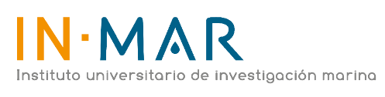
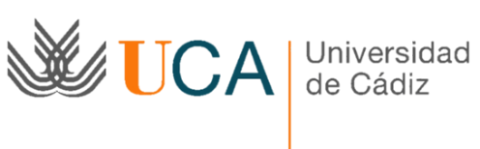
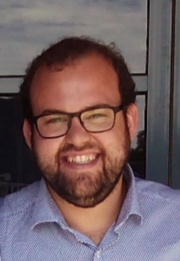

Application of Membrane Distillation for Metal Removal in Acid Mine Drainage

David Amaya-Vías ^{a*}; Laurentiu Tataru ^{b}; Belén Herce-Sesa ^{c}; José A. López-López ^{c}; Juan A. López-Ramírez ª

ª Departamento de Tecnologías del Medio Ambiente, Faculty of Marine and Environmental Sciences. Instituto Universitario de Investigación Marina (INMAR). Campus de Excelencia Internacional del Mar (CEIMAR). University of Cadiz, Av. República Saharaui, Puerto Real, 11510 Cádiz. Spain
^{b} Department of Environmental Engineering, “Vasile Alecsandri” University of Băcau, Calea Marasesti 156, 600115 Bacau, Romania
^{c} Department of Analytical Chemistry, Faculty of Marine and Environmental Sciences, Instituto Universitario de Investigación Marina (INMAR), International Campus of Global Excellence (Cei·Mar), University of Cádiz, Av. República Saharaui, Puerto Real, 11510 Cádiz, Spain

Presenting Author Name: David Amaya-Vías
Affiliation: Departamento de Tecnologías del Medio Ambiente, Faculty of Marine and Environmental Sciences. Instituto Universitario de Investigación Marina (INMAR). Campus de Excelencia Internacional del Mar (CEIMAR).
University: University of Cadiz
Country: Spain
Scientific Session name / number: Track 15: Desalination & Water Treatment
Category: Oral presentation

Abstract
Currently, metal-polluted industrial wastewater and, specifically, acid mine drainage (AMD) have the potential to cause serious environmental problems. AMD are highly acidic waters, enriched with sulphates and metals as for example iron, nickel, manganese, cadmium and copper. AMD can be generated by any anthropogenic or natural activity, which expose pyrite minerals and other sulphide rocks to oxidation, contaminating soils, aquifers and rivers, as well as affecting the health of plants, animals and humans. Conventionally, different techniques are applied to remove or to recover these metals from the water, such as absorption, chemical precipitation, ion exchange, coagulation-flocculation and electrodialysis. However, membrane technologies as nanofiltration (NF) and reverse osmosis (RO) are a valuable alternative. Within membrane-based technologies, membrane distillation (MD) is a thermal process that has certain advantages for metal removal over NF and RO, including low-grade waste heat or renewable energies use, low working pressures, more compact and safe equipment, as well as 100% theoretical rejection of non-volatile compounds, producing very high quality water.

In this work, a MD pilot plant has been used for AMD water desalination from Rio Tinto (SW Spain), using 0.45 µm unsupported PTFE membranes in water gap (WGMD) and air gap membrane distillation (AGMD) configurations. MD tests have been carried out at different operating conditions by measuring the concentrations of seven metals of interest (Fe, Cu, Zn, Cd, Co, Mn and Ni) in feed and permeate samples. Promising results were obtained for all tested operating conditions, with rejection performances well above 90% for all metals.

Biography:

Mr David Amaya-Vías is a researcher in the Environmental Technologies Department at the University of Cadiz. He has a BSc in Marine Sciences and a BSc in Environmental Sciences, with an MSc in Integrated Water Management.
His research work focuses on water treatment and desalination using membrane processes, and specifically on novel environmental applications of membrane distillation.

Research Interests: Desalination, Membrane Distillation, Membrane processes.
Keywords: Membrane technologies, Membrane Distillation, Desalination, Water Treatment, Metals.
Mail Id: david.amaya@uca.es
Contact Number: +34 662079375

General Instruction for Abstract submission

This is the abstract text and font template which should be use for abstracts submitted to the 8th Edition of International Conference and Exhibition on Separation Techniques which will be held from July 29-30, 2019 | Dublin, Ireland

- Abstracts must be in English.
- Abstract body should be 250 words. The word limit relates only to the body of the abstract and does not include title, authors, qualifications, affiliations and institutions as these will automatically populate on the final abstract document based on the details entered into the relevant sections in the abstract submission site. (See above for abstract template)
- Underline the name of the presenting author
- It is the author’s responsibility to ensure the title, author and affiliation details entered in the abstract submission site are correct and exactly as they should be published on the abstract and all conference materials.
- Font type must be Times New Roman or Computer Modern font 12pt and 1.5 line spacing
- Abstracts must be free from typographical and grammatical errors.
- Standard abbreviations may be used for common terms. Otherwise, abbreviations should be given in brackets after the first full use of the word/s. Abbreviations may be used in the title, provided the full name/term is contained in the body of the abstract.
- Along with abstract you should provide your recent head-shot photograph of good resolution and short biography (up to 100 words) with your submission.
- You will be asked to nominate your preference for an oral, workshop or poster presentation.
- It is recommended to submit the abstract in electronic form via conference website (‘abstract submission’ link). The submitted abstract must be a Microsoft Office Word file (*.doc, *.docx). or you can send us your abstract to
mailto: separationtechniques@euroscicon.events

All submitted abstracts will be referred by the Local Organizing Committee / International Scientific Committee. Based on their scientific quality and relevance to the conference topics, the abstract will be either accepted for publication in the Conference Proceedings or rejected. The Conference Proceedings will distributed to the participants at the registration both in hard-copy and electronic versions. The abstract will not be published, unless the registration fee of the registered author is received.

