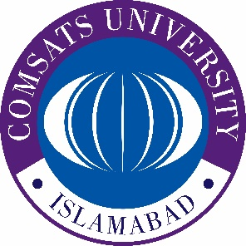
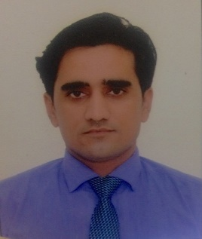

Title of the abstract: Glycerol plasticized-starch/citric acid functionalized MWCNTs: A novel sorption material for the removal of Pb from water
Faheem Shahª*, Naeemullah^{b}
ª Department of Chemistry, COMSATS University Islamabad, Abbottabad Campus, Abbottabad-22060, Pakistan
^{b} Department of Chemistry, University of Turbat-92600, Balochistan, Pakistan.

Presenting Author Name: Faheem Shah
Affiliation: Department of Chemistry
University: COMSATS University Islamabad
Country: Pakistan
Scientific Session name / number:
Category: Oral presentation

Abstract
In this study, a green, rapid, economic and proficient procedure for the synthesis and functionalization of glycerol plasticized-starch/citric acid functionalized MWCNTs (GPS-CA-MWCNTs) has been proposed. The novelty of the present work is that the entire procedure takesplace in a single pot with the aid of ultrasonic radiation. Citric acid (CA) was used as crosslinker to functionalize MWCNTs with glycerol plasticized-starch (GPS) under ultrasonic dispersion. The characterization of funtionalized MWCNTs has been carriedout with FTIR, UV/vis spectrophotometry and TEM. Lead (Pb) was complexed with 2-(5-bromo-2-pyridylazo)-5-diethylaminophenol (5-Br-PADAP) and easily extracted by the GPS-CA-MWCNTs. Different experimental parameters were optimized prior to validation and application of the developed extraction technique. It was observed that under optimal conditions, GPS-CA-MWCNTs expressed excellent stability even after >100 adsorption/desorption cycles run with 97% analyte recoveries. Validition of the developed procedure has been carriedout via certified reference materials analysis and confirmed with its precision (R.S.D. values <20%) and trueness (relative error <11%) under day-to-day conditions. Furthermore, measurement uncertainity was estimated ISO/IEC 17025 recommendations through “bottom-up” approach.
Keywords: Glycerol, microextraction, MWCNTs, ultrasound, uncertainity

Biography:

Dr. Faheem Shah is serving as Assistant Professor of Analytical Chemistry in COMSATS University Islambad (Abbottabad Campus). He got his PhD from NCEAC, Pakistan and worked under the supervision of Prof. Dr. Mustafa Soylak at Erciyes University, Turkey. Dr. Shah has published 92 research articles with a total impact factor of 260. Currently his research group is working on method development for the removal of organic and inorganic pollutants from water.

Research Interests: Method development, Sample preparation
Keywords: Preconcentartion, Microextraction, Chemometrics,
Mail Id: shah_ceac@yahoo.com, fshah@ciit.net.pk
Contact Number: 0092-340-9794462
Twitter account: (If interested)
Linked In account: (If interested)
Facebook account: (If interested)
Suggestions of colleagues/Professors/scholars to send invitation (if any)

Suggestions of Sessions in the conference (if any)

