
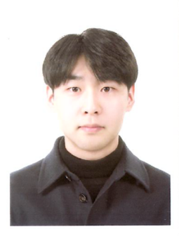
Title of the Abstract: Determination of cyaniding 3-glucoside in rat plasma using LC-MS/MS and its application to a pharmacokinetic study of aronia extracts

Presenting Author Name: Soon Uk Chae
Co-authors: Doyun Kim, Chae Bin Lee, Soo Hyun Jang, Jee Sun Min, Soo Kyung Bae
Affiliation: Department of Pharmacology
University: The Catholic University of Korea
Country: South Korea
Scientific Session name / number: Track 22: Separation Techniques and Applications
Category: Poster presentation (E-poster)

Abstract:
Cyanidine-3-glucoside(C3G) is the most abundant in the aronia extract and has an excellent antioxidation, antidiabetic activity and excellent anti-inflammatory and antipruritic effects. Thus it has been increasingly utilized as health functional foods and materials. A simple and rapid LC‒MS/MS method was developed and validated to determine the levels of cyanidine-3-glucoside in rat plasma. Cyanidine-3-glucoside was extracted from 50 μL of plasma treated with 25 μL of 1 M HCl, stored on ice after protein precipitation with 20% trifluoroacetic acid. Chromatographic separation was performed on Agilent Poroshell 120 EC- C₁₈ column (4.6 x 50 mm id, 2.7 μm). The mobile phase consisted of 0.1% formic acid in water - methanol (6:4, v/v) and the flow rate was 0.3 mL/min. The total chromatographic run time was 5.0 min. Detection was performed on a triple quadrupole mass spectrometer equipped with positive-ion electrospray ionization by selected reaction monitoring of the transitions at m/z 449.05 > 287.2. The lower limit of quantification was 2.5 ng/mL and the linear range was 2.5‒500 ng/mL (r ≥ 0.9966). Cyanidine-3-glucoside All validation data, including selectivity, precision, accuracy, matrix effect, recovery, dilution integrity, and stability, were well within acceptance limits. This newly developed bioanalytical method was simple, highly sensitive, required only a small volume of plasma (50 μL), and was suitable for application in pharmacokinetic studies after oral administration of a standardized aronia extracts in rat that used serial blood sampling.
Biography:
Soon Uk Chae is a graduate student with major in pharmacology/pharmacokinetics of The Catholic University of Korea.
Research Interests: Bioanalysis, Non-clinical pharmacokinetics, In vivo drug-drug interaction study
Mail Id: zldtnseoz@naver.com
Contact Number: 82-10-5177-7294

