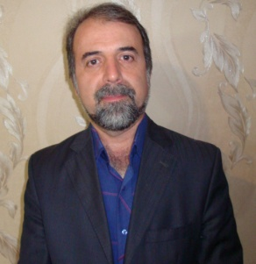

Title of the Abstract: 1-Buthyl - 3- methyl imidazolium Hydrogen Sulfate Ionic Liquid as an Efficient and Reusable Catalyst for the Synthesis of 5-Substituted 1H-Tetrazoles
Presenting Author Name: Abbas Amini Manesh
Affiliation: Department of Chemistry, Payame Noor Universtiy, P. O. Box 19395-3697, Tehran, I. R. of Iran
University: Payame Noor Universtiy
Country: IRAN
Scientific Session name / number:
Category: (Poster presentation)

Abstract: Tetrazoles which containing four contiguous nitrogen atoms are one of the most stable nitrogen heterocyclic compounds among other heterocyclic systems¹, however they not generally found in nature ². Recently, tetrazoles are receiving much interest due to their important role in many fields. Tetrazoles show a wide range of applications in materials science, medicinal chemistry ³, photography ⁴, agriculture, ⁵ and as components of explosives.⁶ Ionic liquids (ILs) are a type of organic salts which are liquid at or near room temperature. Most of the ionic liquids are generally composed of a large asymmetric organic cation and either an organic or inorganic anion.⁷
In continuation of our research in the development of new synthetic methodology,⁸ herein we wish to report a simple and efficient method for the synthesis of 5-substituted 1H-tetrazoles by reaction of organic nitriles and sodium azide using 1-buthyl - 3- methyl imidazolium hydrogen sulfate: [bmim]HSO₄ ionic liquid as an efficient and reusable catalyst in DMF, (Scheme 1).
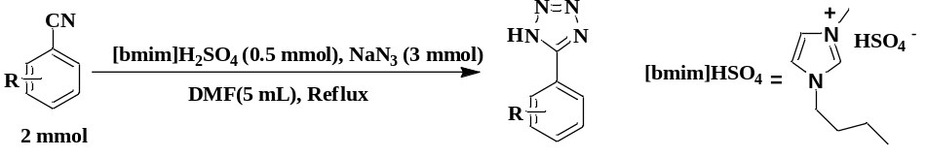
Scheme 1
Method for separation of the catalyst from aqueous phase: After completion of the reaction (as monitored by TLC), the reaction mixture was cooled to room temperature, and was treated with ethyl acetate (30 mL) and 6 N HCl (20 mL), it was stirred for 10 minute. The organic layer was separated, and the aqueous layer was again extracted with EtOAc (20 mL). The combined organic layers were dried over anhydrous sodium sulfate and evaporated under reduced pressure to give the tetrazole. The water was removed under reduced pressure from aqueous phase, then acetonitrile (20 mL) was added and stirred at 60 ^{ο}C for 10 minute, and was filtered. Evaporation of acetonitrile gave pure catalyst ([bmim]HSO₄) which can be used as least for 2 further reaction.

Table 1 shows the results of the reaction:
Table 1
Yield (%) | Time (h) | Tetrazoles | Nitriles | Entry
96 | 6 | 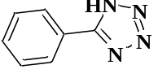 | 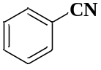 | 1
86 | 5 | 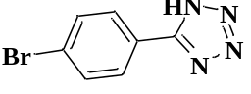 | 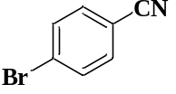 | 3
87 | 5.5 | 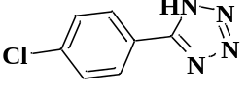 | 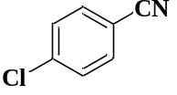 | 4
95 | 4.5 | 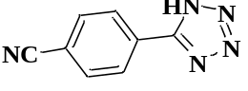 | 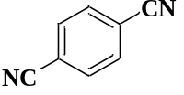 | 5
65 | 7.5 | 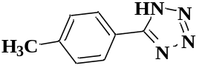 | 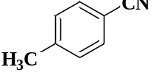 | 8
72 | 6,5 | 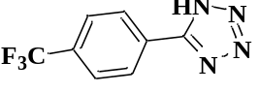 | 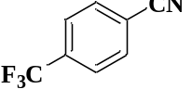 | 9

References:
1. B. Patil, Umakant, R. Kumthekar, Kedar, and M. Nagarkar, Jayashree, Tetrahedron Lett. 2012, 53, 3706.
2. P. B. Mohite and V. H. Bhaskar, Int. J. Pharm. Tech Res., 2001, 3, 1557.
3. R.N. Butler, in Comprehensive Heterocyclic Chemistry II; Katritzky, A. R.; Rees, C.W.; Scriven, E. F. V. Eds., Pergamon Press: Oxford, 1996, Vol. 4, p. 621, 905.
4. A. R. Modarresi-Alam, F. Khamooshi, M. Rostamizadeh, H. Keykha, M. Nasrollahzadeh, H. R. Bijanzadeh and E. Kleinpeter, J. Mol. Struct., 2007, 841, 61.
5. V. A. Ostrovskii, R. E. Trifonov and E. A. Popova, Russ. Chem. Bull., 2012, 61, 768.
6. B. S. Jursic and B. W. Leblanc, J. Heterocycl. Chem., 1998, 35, 405 and references cited therein.
7. K. Binnemans, Chem. Rev., 2007, 107, 2592.
8. A. Amini Manesh and B. S. Shirmardi, J. Chem. Sci., 2015, 3, 493.

Biography:

Dr. Abbas Amini Manesh is an Assistant professor of Organic Chemistry in Payame Noor University of Hamedan (IRAN).
Research Interests: Synthesis of new brominating reagent- Synthesis of new sulfonamides- Diels Alder reactions- Synthesis of polymer supported drugs- Oxidation reactions- Chemical Methodology.

Mail Id: a_aminima@yahoo.com

Contact Number: +989188153410

