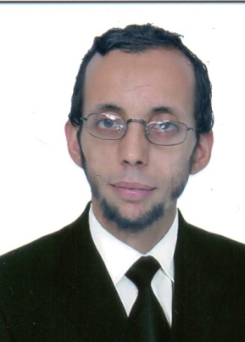

Title of the Abstract: Air separation used a cryogenic system
Presenting Author Name:SAOULA NACEREDDINE
Affiliation:AURES GAS
University:USTHB University of science and technology /Cryogenic Department
Country:Algeria
Scientific Session name / number:TRACH18/16 / Separation in process Engineering / nanotechnology
Category: (Oral presentation / Poster presentation)

Abstract:
Cryogenic air separation involves the use of a cold generation or a cold source. It is known to relax with external work pressurized gases introduced into a machine at temperatures well above their dew point.

At the moment, we try to do a separation of neutralized gas as Nitrogen on sew and others frastic gases,to abtained an ensure for environmental protection during all steps of production.
This Topic is a large to minimized it in this paragraph so I appreciate to took more about that in Germany .

BiographIC/

Dr.SAOULA NACEREDDINE Is an searcher in cryogenic department of USTHB (University of Science and technology of Algeria),he has spent over 05 years in cryogenic separation plant ,and do a several project researching in this filed.

Research Interests: LNG, Dynamic fluids ,Cryogenics application ,water treatment ,HSE.

Mail Id:saoula10@live.fr

Contact Number:+213(0)561441249
Linked In account: SAOULA NACEREDDINNE
Suggestions of Sessions in the conference :Separation in process Engineering / nanotechnology

