On-line and off-line analysus using a microfluidic-chip as sample treatment miniaturization
María Ramos Payán, PhD, Department of Analytical Chemistry, Faculty of Chemistry, University of Sevilla, c/Prof. García González s/n, 41012, Seville, Spain

Abstract (300 word limit)
Statement of the Problem: The most critical stage of the analytical process is the preparation of the sample requiring different stages prior to analysis, long extraction times, large volumes of reagents, etc., with the objective of obtaining a good clean-up for the analysis by instrumental techniques (as HPLC). Nowadays, one of the dominant trends in sample preparation is miniaturization and automation. In this paper, we present the advantages presented by the use of microfluidic systems in this field. These devices allow to work in different configuration s depending on the nature of the analyte to be extracted: either by liquid phase microextraction or by electromembranes.
Methodology: Our group have demonstrated the possibility of on-line and off-line analysis by HPLC. Two pumps are used to introduce the sample and the acceptor phase into the microfluidic device. The microfluidic device is fabricated using two patterned plates of poly(methyl methacrylate), which are symmetrical. The channels are separated by a polypropylene membrane. For off-line analysis, the acceptor outlet (extract) is collected and injected directly into a HPLC. For on-line analysis, the acceptor outlet is connected to the HPLC.
Findings: This type of device provides high selectivity, clean-up, reduces sample volume and low consumption of reagents, significantly reduces time of analysis and has demonstrated its ability to online coupling with HPLC. Additionally, the microchip-devices are reusable (allow membrane exchange) and each membrane is stable during more than ten consecutive microextractions.
Conclusion & Significance: The miniaturization and automatization of sample treatment procedures (on-chip) offer multiple advantages compared with existing traditional techniques. It also, offer excellent clean-up either with biological or environmental samples and significantly reduce the time of analysis from the sample collection till data obtaining.

Image

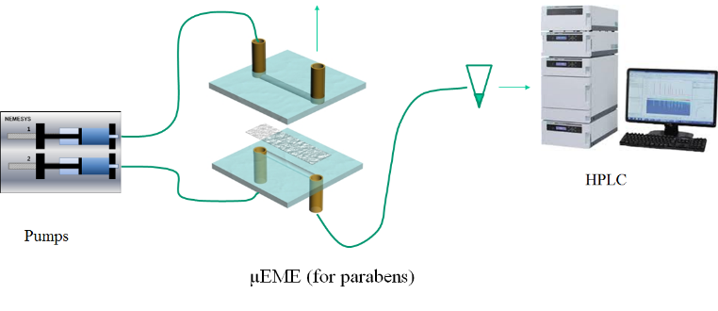
Microfluidic device

Figure 1. Schematic of microfluidic device. The extract collected is analyzed by HPLC.

Recent Publications
- Maria Ramos Payan; Santiago Maspoch; Andreu Llobera. An effective microfluidic based liquid-phase microextraction device (μLPME) for extraction of non-steroidal anti-inflammatory drugs from biological and environmental samples. Talanta 165, 496 - 501.
- Maria Ramos Payan; Santiago Maspoch; Andreu Llobera. A simple and fast Double-Flow microfluidic device based liquid-phase microextraction (DF-µLPME) for the determination of parabens in water samples. Talanta 165, 496-501
- María Ramos Payán; Henrik Jensen; Nicolaj Petersen; Steen Honorée; Sig Pedersen Bjeergard. Liquid-phase Microextraction in a microfluidic-chip – high enrichment and sample clean-up from small volumes of biological fluids.Analytica Chimica Acta 735, 46
- Bin Li; Nickolaj Petersen; María Ramos Payán; Steen Honorée; Stig Pedersen Bjergaard. Automated on-line clean-up and enrichment of opium alkaloids using a liquid-phase microextraction-chip directly coupled to high-performance liquid chromatography.Talanta 120, 224 - 229.
- María Ramos Payán; Bin Li; Henrik Jensen; Nickolaj Petersen; Steen Honoreé; Stig Pedersen Bjergaard. Nano-Electromembrane Extraction. Analytica Chimica Acta 785, 60 - 66.

 Biography
Dr. María Ramos Payán has completed her PhD from University of Seville, Spain and postdoctoral studies from University of Copenhagen (Denmark), University of North Carolina (USA) and Microelectronic National Center of Barcelona (Spain). She is leader of the microfluidic research line. She has published more than 30 papers in reputed journals and has been serving as an editorial board member of repute.

Acknowledgements
This work was supported by the Grant Juan de la Cierva-Incorporación (Ministry of Economy, industry and competitiveness), Grant number JCI-2015-26647.
Email: ramospayan@us.es

Notes/Comments:

