Study of the efficiency of the electrode applied to Electromembrane extraction as sample pre-treatment
María Ramos Payán, PhD, Department of Analytical Chemistry, Faculty of Chemistry, University of Sevilla, c/Prof. García González s/n, 41012, Seville, Spain

María Ramos Payán, University of Seville (Spain)

Abstract

The use of electromembranes as a procedure for the pre-treatment of samples has gained special interest in recent years. The extraction by electromembranes in three phases favors the migration of the analytes from a donor / sample phase (aqueous) to an acceptor phase (aqueous) through the supported liquid membrane, thanks to an electric field generated when a potential difference is applied between both phases.

The extraction by means of electromembranes is applied using systems of different geometries. The factors that affect the electromembrane are the nature of the organic solvent, the composition and pH of the donor and acceptor phase, and the applied voltage. Depending on the type of geometry and the work mode, they may depend on other factors such as the speed of agitation, the flow of both the donor and acceptor phases, etc.

Until now, the importance of the characteristics of the electrode has not been taken into account, nor has it been monitored for the stability and effectiveness of the same prior to its application in electromembrane. Therefore, an electrode characterization procedure is prepared to study how it affects electromembrane procedures. The study is performed using microfluidic devices1 and using a platinum cylindrical electrode of 100 μm external diameter and 20 mm in length. The characterization of the electrode is made by cyclic voltammetry and an impedance study, using for both the ferrio / equimolar ferrio / ferrocyanide pair, and SEM microoscopy techniques on the electrode.

In this paper we present the recoveries and extraction efficiencies obtained when the electromembrane is applied to a series of analytes using new, reused and reactivated electrodes. Reactivation of the electrode is achieved by using a 0.1M solution of KNO₃.
Image
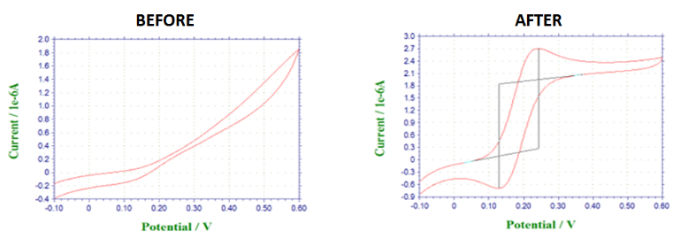
Recent Publications
1. Maria Ramos Payan; Santiago Maspoch; Andreu Llobera. An effective microfluidic based liquid-phase microextraction device (μLPME) for extraction of non-steroidal anti-inflammatory drugs from biological and environmental samples. Talanta 165, 496 - 501.
2. Maria Ramos Payan; Santiago Maspoch; Andreu Llobera. A simple and fast Double-Flow microfluidic device based liquid-phase microextraction (DF-µLPME) for the determination of parabens in water samples. Talanta 165, 496-501
3. María Ramos Payán; Henrik Jensen; Nicolaj Petersen; Steen Honorée; Sig Pedersen Bjeergard. Liquid-phase Microextraction in a microfluidic-chip – high enrichment and sample clean-up from small volumes of biological fluids.Analytica Chimica Acta 735, 46
4. Bin Li; Nickolaj Petersen; María Ramos Payán; Steen Honorée; Stig Pedersen Bjergaard. Automated on-line clean-up and enrichment of opium alkaloids using a liquid-phase microextraction-chip directly coupled to high-performance liquid chromatography.Talanta 120, 224 - 229.
5. María Ramos Payán; Bin Li; Henrik Jensen; Nickolaj Petersen; Steen Honoreé; Stig Pedersen Bjergaard. Nano-Electromembrane Extraction. Analytica Chimica Acta 785, 60 - 66.

Biography (150 word limit)
Dr. María Ramos Payán has completed her PhD from University of Seville, Spain and postdoctoral studies from University of Copenhagen (Denmark), University of North Carolina (USA) and Microelectronic National Center of Barcelona (Spain). She is leader of the microfluidic research line. She has published more than 30 papers in reputed journals and has been serving as an editorial board member of repute.

Acknowledgements
This work was supported by the Grant Juan de la Cierva-Incorporación (Ministry of Economy, industry and competitiveness), Grant number JCI-2015-26647.

Email: ramospayan@us.es

Notes/Comments:

