Optimization and design of a continuous biosorption process using brown algae and Chitosan/PVA nano-fiber membrane for removal of nickel by a new biosorbent
Akbar Esmaeili, Ali Aghababai Beni
Department of Chemical Engineering, North Tehran Branch, Islamic Azad University, PO Box 19585/936, Tehran, Iran

Abstract
In this study, Nickel ions adsorption from zinc ingot factory wastewater by brown algae (Sargassum glaucescens) and chitosan/Polyvinyl alcohol (PVA) nano-fiber membrane at continuous system. The continuous process included a biosorption reactor and fixed-bed reactor that were optimized by predicting two batch steps with Response Surface Modeling (RSM), based on the Box–Behnken (BB) in the novel approach. Nano-biosorbent characterized by scanning electron microscopy (SEM), Brunauer-Emmett-Teller (BET) and Fourier transform infrared spectrometer (FT-IR) analysis. maximum biosorption in this continuous system was at pH 6, biosorbent doses 8 g L^{–1} Sargassum glaucescens and 0.48 g L^{–1} nano-fiber. The study of the reaction rate showed kinetic data best fitted by pseudo-first order model with R²>0.95 than pseudo-second order and Intraparticle diffusion models. Biosorption equilibrium data were performed using Langmuir isotherm and Freundlich isotherm, Langmuir isotherm fit better with equilibrium data.
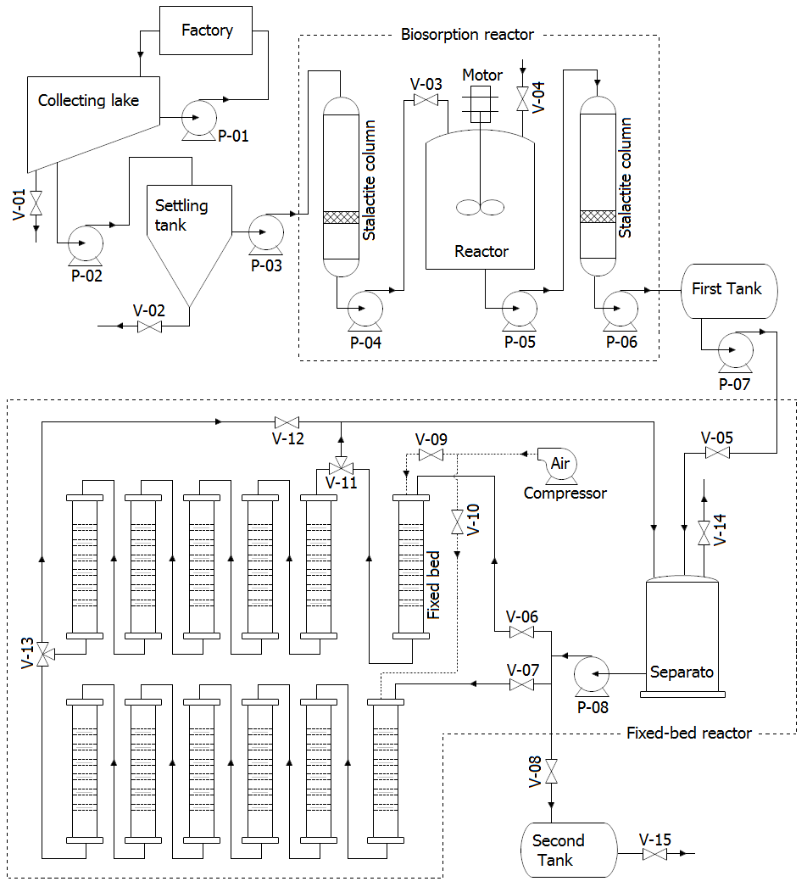
Figure 1. Steps of continuous biosorption process

