A Road Side Animal Detection System in South Africa
Irene Nandutu, Department of Mathematics, Rhodes university, 6139 Grahamstown, South Africa
Marcellin Atemkeng, Department of Mathematics, Rhodes university, 6139 Grahamstown, South Africa
Patrice M. Okouma, College of Graduate Studies, University of South Africa, Johannesburg, South Africa

Abstract
Many animal-vehicle accidents on South African Roads remain rampant. The collisions have damaged properties, harmed human race and wildlife species. Factors such as changes in human and animal behaviors, road features and climatic conditions have served as a catalyst to these animal-vehicle collisions. Destabilization of animals in their habitats is highly attributed to Human activities. Humans engage in activities such as conurbations, wildfires and emission of green gasses that are harsh to these vertebrates. These acts have led to a rise in the distribution of animal species, making species move from one habitat to seek for a new settlement that is comfortable. These movements if not monitored will cause a drastic increase in the animal-vehicle collision cases. In February 2012, at least 470 wildlife animals were killed in South Africa. Birds were the leading victims, followed by reptiles, mammals and amphibians. These roadkill mortality rates continue to happen globally and in other parts of Africa such as East Africa. Globally, roadkill has been addressed through traditional systems, and automated systems. Automatic systems are integrated with machine learning such as Break the beam sensors and Mobile Mapping. These existing automated systems have been implemented in developed economies to prevent Roadkill. Such solutions do not exist in Africa especially South Africa, which has a high demand due to the alarming cases of animal-vehicle collisions. In this work, we want to develop a road side animal detection system to address the above challenges, and integrate it with traditional systems such as fencing. The proposed system will detect an animal meters away, alert the driver on the road about the existence of an animal on the road. This system will be composed of hardware and software components. The Hardware components such as computing unit, camera, sensors, Alert system to display unit and power supply plus software such as tensorflow, protocol buffers, etc. Photoelectric sensors through the beam will be considered since they can detect even small objects in a long distance with extremely high accuracy. Rasyberry pi will be configured to work with the ML detected images, camera and sensor in real time. This research will contribute to conservation on road and help mitigate Animal-vehicle collisions in South Africa.

Image
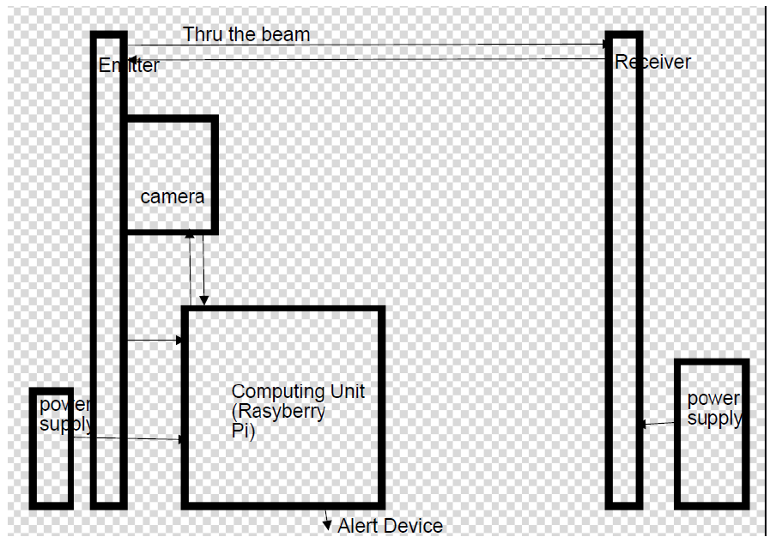
Publications
References
- Wendy Collision(2012). Roadkill Study Highlights Wildlife Road Deaths.https://www.bridgestone.co.za/news-article/698/roadkill-study-highlights-wildlife-road-deaths, April 10, 2012.
- John Kioko,Christian Kiffner,Nicole Jenkins & Wendy J Collinson (March, 2015). Wildlife roadkill patternson a major highway in northern Tanzania, Pages 17-22.https://doi.org/10.1080/15627020.2015.1021161
- William H. S. Antˆonio, Matheus Da Silva, Rodrigo S. Miani & Jefferson R.Souza (2019) A Proposal of anAnimal Detection System Using Machine Learning, Applied Artificial Intelligence, 33:13, 1093-1106, DOI:10.1080/08839514.2019.1673993
- Naira C. de Carvalho, Marcelo O. Bordignon & Julie T. Shapiro1(2014). Fast and furious: a look atthe death of animals on the highway MS-080, Southwestern Brazil, DOI:http://dx.doi.org/10.1590/1678-4766201410414349[15]
- Wendy J. Collinson, Harriet T. Davies-Mostert & Warwick Davies-Mostert(2017). Effects of culverts androadside fencing on the rate of roadkill of small terrestrial vertebrates in northern Limpopo, South Africa.ISSN 1758-2067
- van der Ree, Rodney & Gagnon, J.W. & Smith, D.J.. (2015). Fencing: A Valuable Tool for ReducingWildlife-Vehicle Collisions and Funnelling Fauna to Crossing Structures. 10.1002/9781118568170.ch20
- I. Silva, M. Crane, T. Savini(2020). High roadkill rates in the Dong Phayayen-Khao Yai World Heritage Site:conservation implications of a rising threat to wildlife,https://doi.org/10.1111/acv.12560
- Carine Firmino CARVALHO, Ana Elizabeth Iannini CUST ́ODIO, Oswaldo MARC ̧ AL J ́UNIOR(2017). INFLUENCE OF CLIMATE VARIABLES ON ROADKILL RATES OF WILD VER-TEBRATES IN THE CERRADO BIOME, BRAZIL.http://docs.bvsalud.org/biblioref/2018/12/966527/influence-of-climate-variables-on-roadkill-rates-of-wild-verteb_Mq0an36.pdf
- Seo, Changwan & Thorne, James & Choi, Taeyoung & Kwon, Hyuksoo & Park, Chong-Hwa. (2013). Disentangling roadkill: the influence of landscape and season on cumulative vertebrate mortality in SouthKorea. Landscape and Ecological Engineering. 11. 10.1007/s11355-013-0239-2.
- Kioko, John & Kiffner, Christian & Jenkins, Nicole & Collinson, Wendy. (2015). Wildlife roadkill patternson a major highway in Northern Tanzania. African Zoology. 50. 1-6. 10.1080/15627020.2015.1021161
- Seiler A. (2003). Effects of infrastructure on nature. In: Trocm ́e M, Cahill S, de Vries JG, Farall H, Folkeson

Photograph

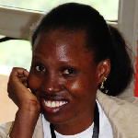Biography
Irene is a first year PhD Student in Applied Math at Rhodes University. She is understanding the integration of sensor technology and machine learning to mitigate conservation problems with a keen focus on animal-vehicle collisions. As humans engage in activities that are harsh to wildlife, we witness species distribution in search for new habitats which are conducive to these vertebrates, Irene is particularly interested in regions near the game reserves or hotspots and existing systems developed that prevent roadkill. What are some of the reasons why animals move towards particular roads, during a particular season of the year? How can an automatic animal detection system be developed to reduce animal mortality rates due to animal-vehicle collisions? Irene aims to answer these questions by exploring datasets and building models while understanding the fields of wildlife, biodiversity and environmental science, plus Artificial Intelligence. She hopes to continue her journey of building skills for contributing towards a transition to sustainable practices in Research and Artificial Intelligence in the developing world.

Email: irenenanduttu@gmail.com

Notes/Comments:

