Artificial Intelligence and Machine Learning Applications in Smart Production: Progress, Trends, and Directions
Alessandro Graps
Stefano Tempesta

Abstract

Modern machines are equipped with a plethora of sensors, generating plenty of data. However, without the necessary analytical tools and workflow in place, the readings of these sensors often leave plenty of untapped potentials on the table. In addition, a factory could possibly deploy machines of different varieties and makes, which leads to increased complexity of maintenance, and an increased need for technical know-how. The lack of these would hamper maintenance efforts as well as prolong downtime. Thus, with the onset of Industry 4.0, the ubiquity of sensors leading to large volume of data together with the advancements made in artificial intelligence, will lead to increased productivity as well as enabling the automation of systems. This project aims to demonstrate the concept of predicting machine faults by manipulating advanced data analysis techniques and enhancing maintenance efforts through the use of Augmented Reality. Relevant data with regards to the health and performance of the machines such as current consumption, voltage, sectional vibration and others are collected and transmitted through an Internet of Things (IoT) gateway to a centralized location, where the factory guardians are in place to monitor in real-time. This model allows maintenance sessions to be pre-planned so replacement parts and resources can be made available and maintenance breaks to be executed efficiently. All of which contribute to greatly increase the productive time of assets in a manufacturing scenario.

Image

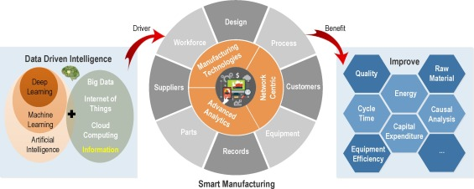

Photograph


Alessandro Graps
CEO and Founder, JouleHub, Switzerland
Email: a.graps@joulehub.com


Stefano Tempesta
CTO and Microsoft Regional Director, SxiQ, Australia
Email: stempesta@sxiq.com.au

Notes/Comments:

