A new reference point for Natural Language Processing

Abstract (300 word limit)
This presentation is an insight into the creation of a graph based, quantum inspired neural network that outperforms the Big Players (Google, IBM, Microsoft and Alexa) in Natural Language Processing
drawing a comparison between the main players in this field.
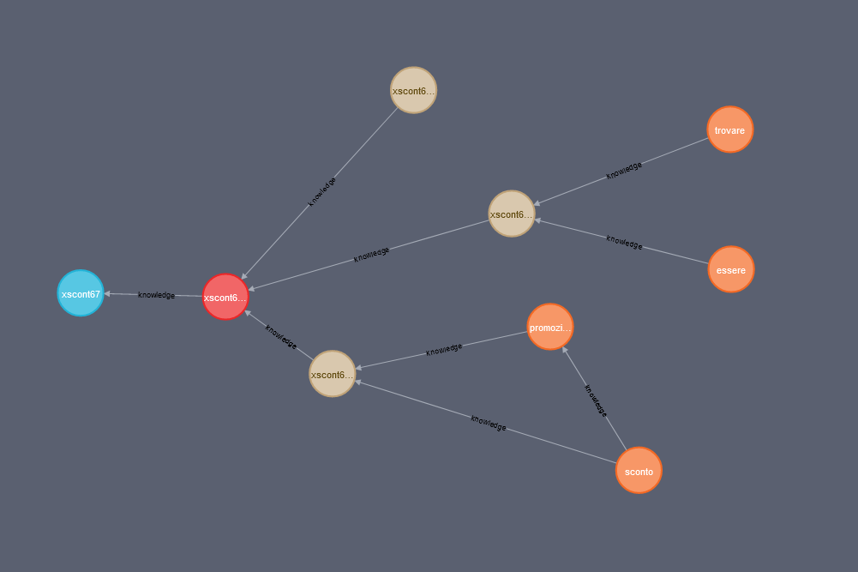
Reviewing the approaches of IBM, Microsoft, Google and Amazon, I will draw attention to both the strengths and weaknesses each application presents for clients and direct users.
A live comparison demo will evaluate the performance of each platform when faced with a complex question in natural language.
http://compare.eeve.ai/

Image
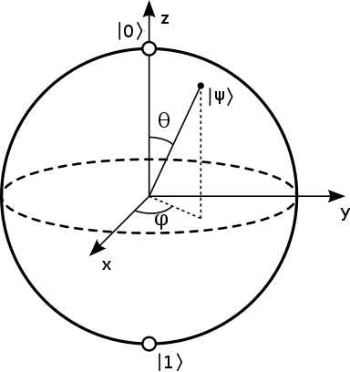
The Qbit that inspired the behavior of the graph neural network

Photograph

Biography (150 word limit)
Winner of two AI awards, I’ve been working in AI and machine learning for 15 years, designing and developing AI and computer graphic algorithms.
I’m very passionate about AI, and I’m specifically interested in technologies focused on Natural Language Processing, image recognition and predictive analysis.
I have received several national and international awards, that recognize my work and contributions in these areas.
Microsoft MVP for Artificial Intelligence Category, I have had the pleasure of being a guest speaker in national and international events.

Email: sebastiano.galazzo@gmail.com

