A new reference point for Natural Language Processing

Abstract (300 word limit)
This presentation is an insight into the creation of a graph based, quantum inspired neural network that outperforms the Big Players (Google, IBM, Microsoft and Alexa) in Natural Language Processing
drawing a comparison between the main players in this field.
The proposed neural network leverage the simulation of qbit behavior to exchange data between neurons.
The NN is made by 300.000 neurons and 1.000.000 connections (Something impossible with common math models).
For each input query is extracted the smallest subgraph having as input the informations in the input query that lead to the so called "inference" or a special neuron that is the result of a reasoning.
On that subgraph are applied the math rules inspired to quantum bit behavior to trigger the correct "inference"
It means that compared to well-known common neural networks, the proposed NN does not provide the rigid concept of input, output and intermediate nodes, as it does not foresee a division of the network into input, intermediate and output levels.
The input nodes change dynamically depending on the specific query, which corresponds to the natural language expression from to interpret.
The simulation of the behavior of a qbit is made replacing the "real" number used in neural network as the "weight" by an array of complex numbers.
Each slot of the array is related to a "channel" (Alpha,Beta,Gamma,Delta,Lambda, Omega,Tau...).
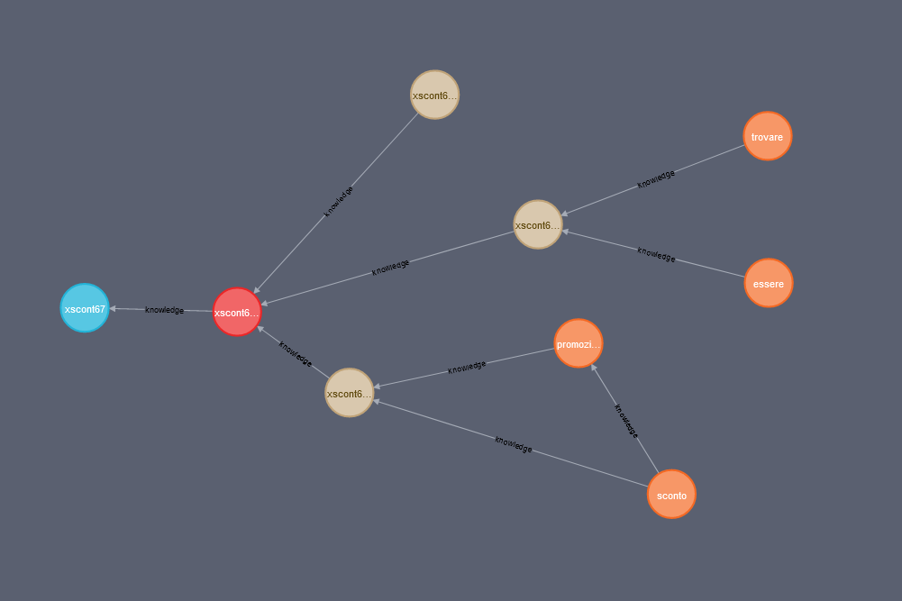
The topology of the neuron connections is one, the best simple and more accurate possible, but each neuron can run at the same time N neural networks having different weights at the same time, where N is the number of channels we implemented.
In our implementation "Delta" is used to manage complex sentences: "I had a problem with my pc and lost my data, how can I restore my password"?
where "Gamma" for sentences like "login how to recover".
That's also possible because the NN is at the same time a knowledge graph and concept are connected by semantic meaning.
The use of Complex numbers helps for example to manage past, present,future:
Who was the U.S. president?
Who is the U.S. president?
Who will be the U.S. president?
where in our implementation the imaginary part of the value represents the person, the real part the time.

Reviewing the approaches of IBM, Microsoft, Google and Amazon, I will draw attention to both the strengths and weaknesses each application presents for clients and direct users.
A live comparison demo will evaluate the performance of each platform when faced with a complex question in natural language.

http://compare.eeve.ai/

Image
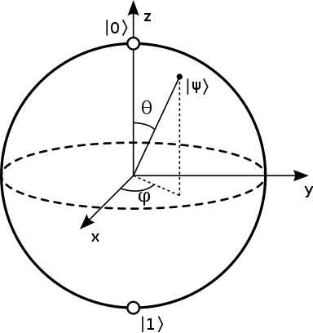
The Qbit that inspired the behavior of the graph neural network

Photograph

Biography (150 word limit)
Winner of two AI awards, I’ve been working in AI and machine learning for 15 years, designing and developing AI and computer graphic algorithms.
I’m very passionate about AI, and I’m specifically interested in technologies focused on Natural Language Processing, image recognition and predictive analysis.
I have received several national and international awards, that recognize my work and contributions in these areas.
Microsoft MVP for Artificial Intelligence Category, I have had the pleasure of being a guest speaker in national and international events.

Email: sebastiano.galazzo@gmail.com

