Multi-Agent Coordinated Strategic Team Behavior
Dr. D. Michael Franklin, PhD
Telemetry Data Science
Atlanta, GA, USA

Abstract

Many researchers and industrial partners have worked over the years to produce multi-agent artificial intelligence and teams of agents working together. Most of the previous work to date has fallen short of this goal, resulting in multiple agent AI, where each agent has their own policy but there is no larger group policy. This results in each agent doing the best they can to achieve the goal but falling woefully short because they have no awareness of the other agents around them. In multi-robot scenarios, this means that the robots move inefficiently and often collide with one another or must wait for clear space to operate. This is far from the desired goal of synergistic team behavior.

Our latest research has seen the emergence of multi-agent AI, where each agent has an individualized policy, but they are also compliant to a larger group policy. This means that our newer systems are functioning as a team rather than as a set of individuals with similar goals. Multi-agent AI produces a stronger synthesized synergistic outcome where both short-term and long-term goals can be met with local and global optimization. Further, the teams can be organized hierarchically so that there is a chain of command. This means that the teams of robots function independently optimally, but also take commands from above towards larger goals. This can occur up through multiple layers.

This talk will explore several ideas in this area, including coordinated deep-learning, emergent behavior in groups, model-based hierarchical systems, and more.

Image
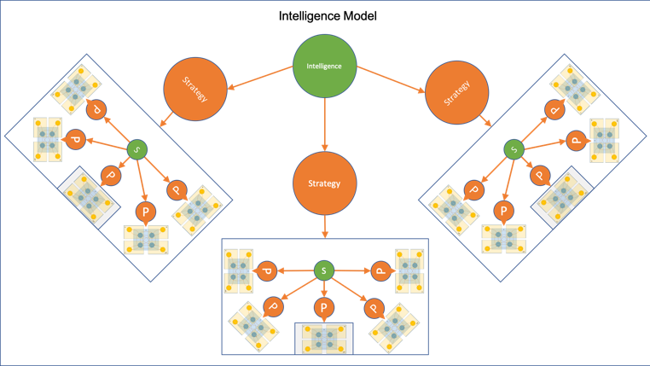
Recent Publications (minimum 5)
- Franklin, D. Michael (2019) Hierarchical Modeling for Strategy-based Multi-Agent Multi-Team Systems. AIKE 2019 Proceedings.
- Franklin, D. Michael (2019) Strategic Hierarchical Modeling and Simulation of Real-world Systems. DISP 2019 Proceedings.
- Franklin, D. Michael (2018) eSense 2.0: Modeling Multi-agent Biomimetic Predation with Multi-layered Reinforcement Learning. Springer, 2019.
- Franklin, D. Michael, Hu, Xaolin (2017) SiMAMT: A Framework for Strategy Inference in Multi-Agent Multi-Team Scenarios. IJMSTR, Spring, 2017.
- Franklin, D. Michael (2017) firstGlimpse: Learning How to Learn through Observation via Memory Modeling with Reinforcement Learning. FLAIRS 2017 Proceedings.

Photograph

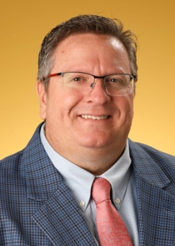
Biography
Dr. D. Michael Franklin holds a Ph.D. in Computer Science specializing in Artificial Intelligence and Robotics. His research areas also include Machine Learning, High-Performance Computing, Big Data and Data Science, and Serious Games and Simulations. Dr. Franklin worked for over 25 years in the IT industry helping companies large and small solve their technical issues. He specialized in Solutions Engineering for Fortune 500 companies where he integrated their vision and business plan with their technology and implementation. After over two decades of success running his own consulting firm and helping push the IT industry forward, he returned to his first passion: teaching. Dr. Franklin is an enthusiastic speaker well-known for engendering passion in his listeners, motivating them to succeed, and equipping them to thrive.
Email: mfranklin@trulyintegrated.com

Notes/Comments:

