Design and Simulation of a Dual-Arm Robot for Machining and Assembly Operations in a Railcar Manufacturing Industry
*Daniyan, I. A.ª and Mpofu K.ª
ªDepartment of Industrial Engineering, Tshwane University of Technology, Pretoria 0001, South Africa*

Abstract (300 word limit)
Statement of the Problem: The manufacturing operations in the railcar manufacturing industries are sometimes characterized by human error and expensive rework, high manufacturing cost and unplanned interruptions, hence, the application of the Artificial Intelligence (AI) and the elements of the Fourth Industrial Revolution (FIR) via robotic solutions to the machining, assembly and handling processes during rail car manufacturing and the intelligent coordination of the system will improve the overall productivity, efficiency, reliability and safety of the manufacturing process. Methodology & Theoretical Orientation: This work proposes a dual arm, 16-axis robot with advance sensors, camera and algorithm as well as intelligent control system for the machining, assembly and handling operations during rail car manufacturing. The system comprises of a robotic manipulator with an end-effector for gripping, positioning and machining of various component parts. The smart sensors are incorporated for data collection to enhance the measurement, monitoring, diagnosis and efficient communication of the process conditions. The Computer Aided Design (CAD) and the Finite Element Analysis (FEA) was done in the Solidworks 2017 environment and simulated using the Adaptive Neuro-Fuzzy Interference System (ANFIS) in a MATLAB 2018 b environment in order to determine the kinematic motion of the robotic arm and the angles of joint. Findings: The simulation results showed the smooth motion of the robot and its suitability to carry out the machining assembly, and handling operations for mass production of components during rail car manufacturing. Conclusion & Significance: This will lead to significant reduction in the manufacturing cycle time, with high operational efficiency. Since the overall production cost is partly a function of the total operation cycle time and the production rates, the use of the dual arm-welding robot will significantly improve the overall economics of the manufacturing process. It is recommended that the railcar manufacturing industries will adjust their business models to embrace the elements of the Fourth Industrial Revolutions.

Image
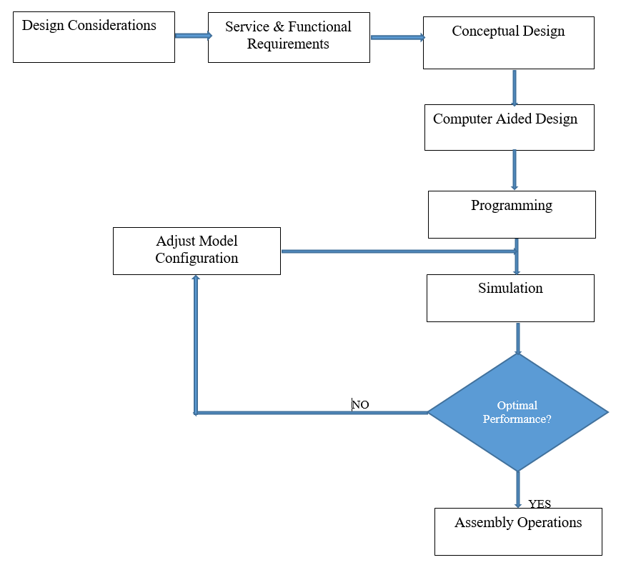
Fig. 1: The Design Framework

Recent Publications (minimum 5)
[1] Daniyan, I. A., Adeodu, A. O., Oladapo, B. I., Daniyan, O. L. and Ajetomobi, O. R. (2019). Development of a reconfigurable fixture for low weight machining operations. Cogent Engineering, 6: 1579455, pp. 1-17. https://doi.org/10.1080/23311916.2019.1579455. Scopus Indexed.
[2] Tlhabadira, I., Daniyan, I. A., Machaka, R. , Machio, C ., Masu, L. and VanStaden L. R. (2019). Modelling and Optimization of Surface Roughness during AISI P20 Milling Process using Taguchi Method. Int. Journal of Advanced Manufacturing Technology, 102(9-12):3707-3718. https://doi: 10.1007/s00170-019-03452-4. Scopus Indexed.
[3] Daniyan, I. A., Mpofu, K., Daniyan, O. L. and Adeodu, A. O. (2019). Dynamic Modelling and Simulation of Rail car Suspension Systems using Classic Controls. Cogent Engineering. 6:1602927. http://doi:10.108/23311916.2019.1602927. Scopus Indexed.
[4] Daniyan, I. A., Mpofu, K. and Adeodu, A. O. (2019). Investigating the Effect of Carbon Steel STKM13a Thermal Properties during Welding Assembly of Rail Car Suspension System. Procedia CIRP, 81:886-891. Scopus Indexed.
[5] Daniyan, I. A., Mpofu, K., Adeodu, A. O. and Daniyan, O. L. (2019). Model Design, Simulation and Control of Rail car Suspension System. Published Proceedings of the 2019 IEEE 10th International Conference on Mechanical and Intelligent Manufacturing Technologies (ICMIMT 2019). IEEE 978-1-5386-7972-2/19. pp. 37-42. Scopus Indexed.
[6] Daniyan I. A., Mpofu K., Adeodu A. O. and Azeez T. M. (2019). Investigating the Quality and Conformity of Carbon Steel AISI 1035 under Varying Heat Treatment Conditions. Procedia Manufacturing 35:1111–1116. Scopus Indexed.
[7] Phokobye, S.N., Daniyan, I. A., Tlhabadira, I. A., Masu, L. and Van Staden, L. R. (2019). Model Design and Optimization of Carbide Milling Cutter for Milling Operation of M200 Tool Steel. Procedia CIRP 84:954–959. Scopus Indexed.
[8] Daniyan, I. A., Mpofu K., Fameso, F. O., Adeodu, A. O. and Bello, K. A. (2019). Development and Simulation of Isotropic Hardening for AISI 1035 for Weld Stress Prediction during Design and Welding Assembly of the Lower Bracket of Rail Cars. Procedia CIRP 84:916–922. Scopus Indexed.
[9] Tlhabadira, I. A., Daniyan, I. A., Masu, L. and Van Staden, L. R. (2019). Process Design and Optimization of Surface Roughness during M200 TS Milling Process using the Taguchi Method. Procedia CIRP 84:868–873. Scopus Indexed.
[10] Daniyan, I. A., Tlhabadira, I., Daramola, O. O. and Mpofu K. (2019). Design and Optimization of Machining Parameters for Effective AISI P20 Removal Rate during Milling Operation. Procedia CIRP 84:861–867. Scopus Indexed.
[11] Daramola, O. O., Tlhabadira, I. , Olajide, J. L., Daniyan, I. A., Sadiku, E. R. and Masu, L. (2019). Process Design for Optimal Minimization of Resultant Cutting Force during the Machining of Ti-6Al-4V: Response Surface Method and Desirability Function Analysis. Procedia CIRP 84:854–860. Scopus Indexed.
[12] Oyesola, M. O., Mpofu, K. Mathe, N. R. and Daniyan, I. A. (2019). Development of an Integrated Design Methodology Model for Quality and throughput of Additive Manufacturing processes. Procedia CIRP 84:688–693. Scopus Indexed.

Photograph

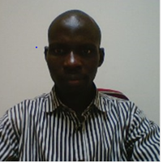
Biography (150 word limit)
Dr. Daniyan Ilesanmi is a Postdoctoral Research Fellow at the Department of Industrial Engineering, Tshwane University of Technology, Pretoria, South Africa where I work with other research team members on the development of indigenous technology for the development of the railcar manufacturing industry in South Africa. Prior to that, I was a Senior Lecturer in the Department of Mechanical and Mechatronics Engineering, Afe Babalola University, Ado Ekiti, Nigeria. I am a registered member (Professional Engineer Cadre) of the Council for the Regulation of Engineering in Nigeria (COREN), Engineering Council of South Africa (ECSA) and the Southern African Institute of Industrial Engineering (SAIEE). As at October 2019, I have published extensively both at the local and international peer reviewed journals and conferences numbering 82 and 57 respectively with 1 Book and 3 Book Chapters. My teaching and research interests include; Production Engineering, Advanced Manufacturing as well as Automation and Robotics.
.
Email: afolabiilesanmi@yahoo.com

Notes/Comments:

