A comparative study of sagittal spinal-pelvic parameters between patients with adolescent idiopathic scoliosis and healthy controls
Cong Zhang1,Yunfeng Zhang2,,Xiaohe Li1

Inner Mongolia Medical University, Inner Mongolia ,Huhhot010010，P.R. China
Department of CT center, The second affiliated hospital of Inner Mongolia Medical University，Huhhot 010110,Inner Mongolia, P.R.China

Abstract (300 word limit)
Statement of the Problem: This study aimed to investigate the sagittal spinal-pelvic morphological changes, as well as the relationship between pelvic anatomical changes and the spinal-pelvic plane in patients with adolescent idiopathic scoliosis (AIS), in order to provide guidelines for orthopedic surgery in AIS. Methods: X-ray data were collected for retrospective analysis from 30 patients diagnosed as AIS from April 2014 to November 2018, along with 30 normal adolescents as control. Pelvic parameters, including pelvic incidence (PI), pelvic tilt (PT), and sacral slope (SS), a spinal parameter, lumbar lordosis (LL), and anatomical parameters, including sacral width (SW) and femoral head- sacrum distance (FH-S), were measured.AIS affects some of the sagittal spinal-pelvic parameters and anatomical parameters. In AIS, there is a significant correlation between the spinal-pelvic parameters, and the anatomical parameter is significantly correlated with multiple spinal-pelvic parameters.

Image
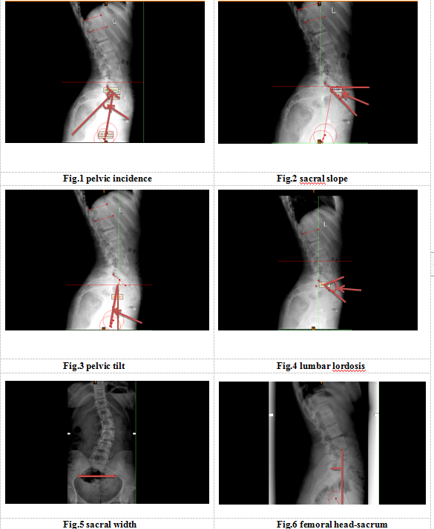

Recent Publications (minimum 5)
- Xiaohe Li, Xing Wang, Shang Gao, He En, Yunfeng Zhang, Haiyan Wang, Yongqiang Cai, Zhiqiang Wang, Zhijun Li, Cong Zhang, Jierong Ma, Shaojie Zhang.（2009）Computed tomography measurement of the bone matrix of vertebral pedicle and its clinical significance.Folia Morphologica，DOI: 10.5603/FM.a2019.0009
- Li XH, Xu DC, Li ZJ, Wang X, You B（2010）An anatomical study in a Chinese population of the position of the rib head for placing anterior vertebral body screws,Orthopedics.33(12): 884.
- .Xiaohe Li, He En, Yunfeng Zhang, Shang Gao, Guimin Li, Yu Guo, Xin Wang, Haiyan Wang, Yongqiang Cai, Zhiqiang Wang, Zhijun Li, Cunbao Li, Feifei Zhao.（2016）Digital Anatomical Measurement for Anterolateral Fixation of Middle and Lower Thoracic Vertebrae,medical science monitor,22:5021-5027.
- LI, X. H., CAI, Y. Q.,WANG, X., GAO, S. & LI, Z. J. （2014）Anatomical characteristics of infra-lamina ridge in Chinese population. Int. J. Morphol.,,32(2):583-588.

Photograph

Biography (150 word limit)
Li xiaohe: Ph.D., professor, supervisor of master's degree.Vice chairman and secretary general of Inner Mongolia anatomical society, standing director of Inner Mongolia digital translational medicine society, member of clinical anatomy branch of Chinese anatomical society, member of professional committee of physical anthropology, member of nursing anatomy branch.Editorial board member of the Chinese journal of clinical anatomy, the core journal of science and technology, the China medical journal and the journal of Inner Mongolia medical university;
Email: drXXXXXXX@xxxmail.com

Notes/Comments:

