Dr El-Hadary HF, MD, Kasr Alaini, Egypt

Abstract

Immunoglobulin G4-related disease (IgG4-RD) is an immune-mediated fibro-inflammatory disease that consists of a collec¬tion of disorders that share particular pathologic, serologic, and clinical features. These disorders were previously thought to be unrelated. The most characteristic features include tumor-like swelling of involved organs, a lymphoplasmacytic infiltrate enriched in IgG4-positive plasma cells, and a variable degree of fibrosis that has a characteristic “storiform” pattern. In addi¬tion, elevated serum concentrations of IgG4 are found in 60 to 70 percent of patients with IgG4-RD.

IgG4-related sclerosing cholangitis (IgG4-SC) is a characteristic type of sclerosing cholangitis, with an unknown pathogenic mechanism. Patients with IgG4-SC display increased serum IgG4 levels and dense infiltration of IgG4-positive plasma cells with extensive fibrosis in the bile duct wall. Circular and symmetrical thickening of the bile duct wall is observed in the areas without stenosis that appear to be normal on cholangiography, as well as in the stenotic areas. IgG4-SC has been recently recognized as an IgG4-related disease. IgG4-SC is frequently associated with autoimmune pancreatitis (AIP). IgG4-related dacryoadenitis/sialadenitis and IgG4-related retroperitoneal fibrosis are also occasionally present with IgG4-SC. However, some IgG4-SC cases do not involve other organs. IgG4-SC is most common in elderly men. Obstructive jaundice is frequently observed in IgG4-SC.

A number of diseases, such as, Cystic fibrosis, Chronic obstructive Choledocholithiasis, Biliary strictures (secondary to surgi¬cal trauma, chronic pancreatitis), Anastomotic strictures in liver graft, Neoplasms (benign, malignant, metastatic), Infections, hypertonic saline instillation in the bile ducts, Post-traumatic sclerosing cholangitis, Systemic vasculitis, Amyloidosis, Radia¬tion injury, Sarcoidosis, Systemic mastocytosis, Hypereosinophilic syndrome, Hodgkin’s disease, may easily be confused with IgG4-related sclerosing cholangitis, or coexist in a patient .

In this case, report a 57 years male patient presented with jaundice, fatigue, weight loss, oral moniliasis and right sided neck swelling. He was misdiagnosed as Cholangiocarcinoma.
Image
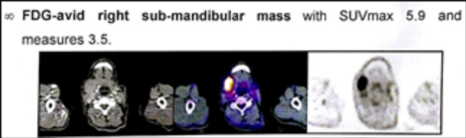

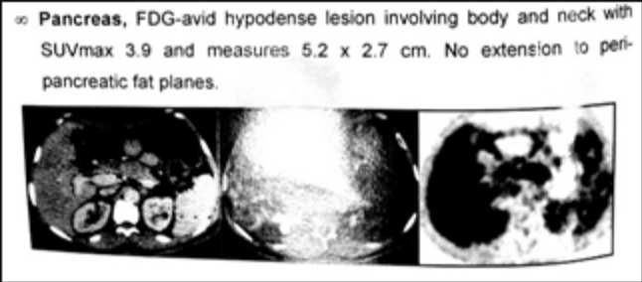

Recent Publications
- El-Hadary HF, Saad S (2018) Hereditary Multiple Exostoses Misdiagnosed as Rheumatoid Arthritis. OMICS J Radiol 7: 287. DOI: 10.4172/2167-7964.1000287
- Hala El-Hadary, et al. (2018). A Case Report of Idiopathic Hyper Eosinophilic Syndrome (HES) in a Rheumatoid Arthritis Patient. CPQ Orthopaedics, 1(1), 01-07.
- Hala El-Hadary, Dadour NM, Ahmed H and Mo’nes D. (2018). IgG4-Related Disease Misdiagnosed as Cholangiocarcinoma. M J Canc. 3(1): 015.
- El Hadidi K. T, El-Hadary HF, Abdel Baki N. M., Abdel Kafy H., Abdelrahaman W., et al. (2018). Characteristics of systemic lupus erythematosus in a sample of the Egyptian population: a retrospective cohort of 1109 patients from a single center. Lupus, 27(6), 1030-1038.


Photograph

Biography
Hala El-Hadary is a Rheumatology & Immunology consultant at faculty of medicine, Cairo university. She obtained her M.D. from faculty of medicine, Cairo university in 2012. She is the head of Rheumatology department in Dar El- Fouad hospital and El-katib hospital. she creates new pathways for improving healthcare. She has built this model after years of experience in research, evaluation, teaching and administration both in hospital and education institutions.
Email: Drhalaelhadary@yahoo.com

Notes/Comments:

