The effects of neurokin1 receptor antagonist for arthritic pain in a rat model of osteoarthritis
¹Dongyeon Nam, BK21+ Program, Dept. of Public Health Science, Graduate School, Korea University, Seoul, Korea, Republic of
²Taemin Kim, Department of Physical Therapy, Korea University, College of Health Science, Seoul, Korea, Republic of
³Jinseng Lee, BK21+ Program, Dept. of Public Health Science, Graduate School, Korea University, Seoul, Korea, Republic of
⁴Jinju Kwon, BK21+ Program, Dept. of Public Health Science, Graduate School, Korea University, Seoul, Korea, Republic of
⁵Junesun Kim*, Dept. of Public Health Science, Graduate School & Department of Physical Therapy, Korea University, College of Health Science, Seoul, Korea, Republic of,

Statement of the Problem Osteoarthritis (OA) cause inflammation in the joint and is a common degenerative disease in elderly people. Chronic pain is a main symptom in OA patients. However, medications for OA pain limited effects due to the side effects depending on long- lasting usage. Substance P is a neuropeptide release from nociceptive afferent fiber to peripheral and central nervous system that is responsible for neurogenic inflammation and pain transmission through the activation of neurokinin 1 (NK1) receptor. This study was designed to examine a possibility for the NK1 receptor antagonist to be a therapeutic agent for OA pain.
Methodology & Theoretical Orientation: Knee joint inflammation was induced by intra-articular injection of monosodium iodoacetate (MIA, 2mg/50ul). NK1 receptor antagonist (TOCRIS, GR92334, 10uM/30ul) injected before (Pre group) and after MIA injection (Post group). To assess edema, the knee joint diameter was measured by caliper. Paw withdrawal threshold (PWT) was used by von Frey filament to measure mechanical hypersensitivity, and weight bearing test, knee bending test were performed to evaluate the pain during knee joint move. Findings: Both pre- and post-administration of NK1 receptor antagonist significantly reduced edema in ipsilateral hind-limb on days 2 and 3 after MIA injection. Significant decrease of PWT caused in the MIA group was observed from days 10. However, a single injection of NK1 receptor antagonist into the knee joint inhibited to develop mechanical allodynia in both PRE and POST groups. However, NK1 receptor antagonist in both PRE and POST group did not produce any significant changes in reduced weight bearing and increased knee joint score on the ipsilateral hind-limb after MIA injection compared with the MIA only group. Conclusion & Significance: Administration of NK1 receptor antagonist in early stage of OA inhibited the initiation of chronic pain through alleviation of inflammatory responses in the joints.

Image
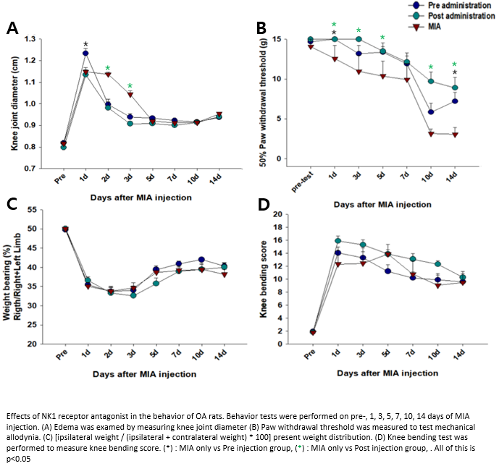

- Richardson JD, Vasko MR (2002). Cellular mechanisms of neurogenic inflammation. The Journal of pharmacology and experimental therapeutics 302(3): 839-845.
- Keeble JE, Brain SD (2004). A role for substance P in arthritis? Neurosci Lett 361(1-3): 176-179.
- Liu D, Jiang L-S, Dai L-Y (2007). Substance P and its receptors in bone metabolism. Neuropeptides 41(5): 271-283.
- Liu D, Jiang L-S, Dai L-Y (2007). Substance P and its receptors in bone metabolism. Neuropeptides 41(5): 271-283.
- Uematsu T, Sakai A, Ito H, Suzuki H (2011). Intra-articular administration of tachykinin NK1 receptor antagonists reduces hyperalgesia and cartilage destruction in the inflammatory joint in rats with adjuvant-induced arthritis. European Journal of Pharmacology 668(1–2): 163-168


Junesun Kim is P.T. and Ph.D. in Physiology. She is a professor at Department of Physical Therapy Korea University College of Health Science. Her major fields of academic interest are the peripheral and central mechanisms of chronic pain, and regenerative mechanisms governing spinal cord injury. She has several publications in in peer-reviewed journals. She provides continuing education lectures regarding neurological physical therapy for SCI and mechanisms of chronic and pathologic pain to student majoring in rehabilitation science at graduate program.
Email: junokim@korea.ac.kr

Notes/Comments:
Acknowledgement: This work was supported by the convergence technology development program for bionic arm(2014M3C1B2048632), (2017M3C1B2085303) and by the Basic Science Research Program (2019R1I1A2A01060115) through the National research Foundation of Korea (NRF) funded by the Ministry of Science, ICT & Future Planning

