Comparing the Effects of Oleoresin of Pistacia Atlantica Tree and Diclofenac Gel in Improving the Knee Osteoarthritis
Dr Hamid Zaferani Arani
Young Researchers and Elite Club, Tehran Medical Sciences, Islamic Azad University, Tehran, Iran.

Abstract
Statement of the Problem: Osteoarthritis (OA) is one of the most common chronic rheumatoid disease, which affects the cartilage and tissues around the joints. OA will cause to the pain and disability among olderies in most of the developing and developed countries. This disease does not have definitive treatment, and the used treatment controls the symptoms and pain. P. atlantica cream can inhibit many of the enzymes involved in the inflammation process of osteoarthritis disease. The aim of this study was to evaluate the effect of topical cream of P. atlantica oleoresin on pain relief in patients with knee osteoarthritis.
Methodology & Theoretical Orientation: Formulation of P. atlantica cream was used to reduce the pain, inflammation, and problems of patients with knee osteoarthritis with the aim of reducing the serious side effects of conventional therapies. Clinical trial with participants of 410 patients with knee osteoarthritis (grade 2 and 3) was conducted parallely for periods of three months, and diclofenac gel was used as a control drug. The formulation was analyzed for standardization with the GC-Mass apparatus. A WOMAC questionnaire was used to assess the therapeutic trends and the related results were analyzed by using SPSS 19 software. In addition, this study was registered with IRCT201506073106N26 in the Iranian Center for Clinical Trials Registration.
Findings: According to the results, the improvement trend was observed in both groups, while the percentage of improvement in the symptoms of the disease in the P. atlantica cream treated group was significantly higher than those found in diclofenac gel treated group (P<0.05) (Figure 1).
Conclusion & Significance: P. atlantica cream significantly reduced the pain and stiffness of patients' joints in performing the daily tasks. The main reason of high anti-inflammatory effect of P. atlantica was due to the high analgesic effect of α-pinene (the main component of P. atlantica) and anti-inflammatory effect of P. atlantica. The topical use of the formulated P. atlantica cream beside other common drugs can be suggested.

Image
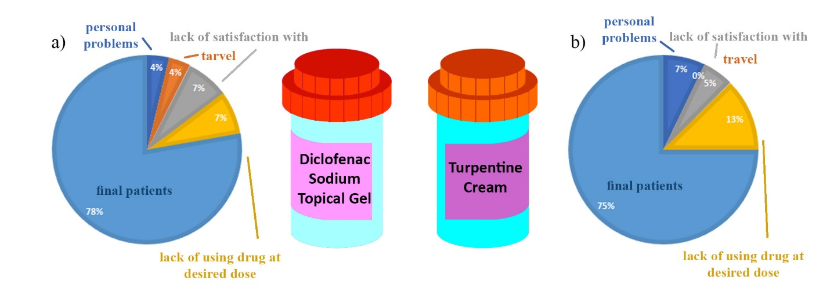
Figure 1: participants in the clinical trial and the statics of their exclusion from the study due to categorized reasons of personal problems, lack of satisfaction with treatment, travel, and lack of using drug at desired dose for a) patients treated with diclofenac gel, and b) patients treated with turpentine cream.
Recent Publications
- Felson DT, Lawrence RC, Dieppe PA, Hirsch R, Helmick CG, Jordan JM, et al. Osteoarthritis: new insights. Part 1: the disease and its risk factors. Ann Intern Med. 2000;133(8):635-46.
- Yelin E, Weinstein S, King T. The burden of musculoskeletal diseases in the United States. Semin Arthritis Rheum. 2016;46(3):259.
- Farzaei MH, Rahimi R, Abbasabadi Z, Abdollahi M. An evidence-based review on medicinal plants used for the treatment of peptic ulcer in traditional Iranian medicine. Int J Pharmacol. 2013;9(2):108-24.
- Vítor JM, Vale FF. Alternative therapies for Helicobacter pylori: probiotics and phytomedicine. FEMS Immunol Med Microbiol. 2011;63(2):153-64.
- Sharifi MS, Hazell SL. Isolation, analysis and antimicrobial activity of the acidic fractions of Mastic, Kurdica, Mutica and Cabolica gums from genus Pistacia. Glob J Health Sci. 2012;4(1):217.
- Khorasani M, Nosrati H, Razbane haghighi A, Kelig S. Study of morphological diffrentiation of leaf in males and females of Pistacia atlantica desf species in Arasbaran forests. J Plant Res. 2015; 27(4): 605-12.
- Farzaei MH, Rahimi R, Attar F, Siavoshi F, Saniee P, Hajimahmoodi M, et al. Chemical composition, antioxidant and antimicrobial activity of essential oil and extracts of Tragopogon graminifolius DC., a medicinal herb from Iran. Nat Prod Comm. 2014;9(1):121-124.

Biography
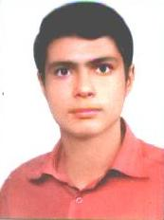
Hamid Zaferani Arani is currently enrolled as a seventh-year student at Islamic Azad University of Tehran Medical Sciences. Hamid successfully finished his level 4 English proficiency. One of the most important things he does after studying university courses is reading articles and doing research in all fields of Medicine. He has about 14 publications (Article and book) and 3 inventions. He likes swimming in free time as a professional exercise. Hamid is still in the process of identifying his learning method. In the course of this, he got the chance to involve himself in teaching research. Through this opportunity, daunting identified his own learning style by reflecting on his experiences. And now, he is involved in his thesis and a hot topic systematic review manuscript with his foreign friends.
E-mail: Hamid_zaferani@iautmu.ac.ir

