Switching from reference to biosimilar rituximab in rheumatoid arthritis patients: experience from a single rheumatology centre.
Dr Renna Daniela, MD, University of Bari, Italy
Dr Cacciapaglia Fabio, MD, Rheumatology Unit, Bari,Italy
Prof. Iannone Florenzo, Associate Professor, Rheumatology Unit, Bari, Italy

Abstract

Statement of the problem: clinical and real-word data on the effects of switching are currently limited to transition studies of approved biosimilars. Few data have been published about the outcome of switching from reference to biosimilar rituximab in rheumatoid arthritis (RA) and this monocentric study aimed to evaluate the effectiveness and safety of this switching. Material and methods: we evaluated RA patients who consented to switch to biosimilar RTX with a 52-weeks follow-up. Clinical and laboratory findings, DAS28, CDAI and SDAI, as well as any adverse events (AEs) have been recorded, before the first dose and 6 and 12 months after the switch. Results: a total of 62 RA patients consented to switch after a median (IQR) of 12 (6-14) cycles of reference RTX. At last follow-up visit of reference RTX a mean of 2,2±1,0, 3,7±4,3 and 4,2±4,4 of DAS28, CDAI and SDAI, respectively, were observed. After switching to biosimilar RTX no statistically significant changes in DAS28, CDAI and SDAI were observed. At 12months after switching to biosimilar RTX, 50 (81%), 54 (87%) and 56 (90%) patients were still on remission/low-disease activity according to DAS28, CDAI and SDAI, respectively (p>0,05). In biosimilar RTX we registered 3 cases of leukopenia, 9 infections and 5 hospitalizations. All cases were resolved after RTX suspension and specific antibiotic treatment. These AEs occurred after a global exposure to 11 (4-11) cycles of RTX in biosimilar RTX. Similar conditions have been already observed during treatment with reference RTX (3 leukopenia; 15 infections; 3 hospitalizations) after 8 (5-12) cycles. Conclusion: our study demonstrates the maintenance of effectiveness of biosimilar after switching from reference RTX. On safety concerns are more relevant the cumulative and repeated administrations of RTX rather than the use of the biosimilar.
Image
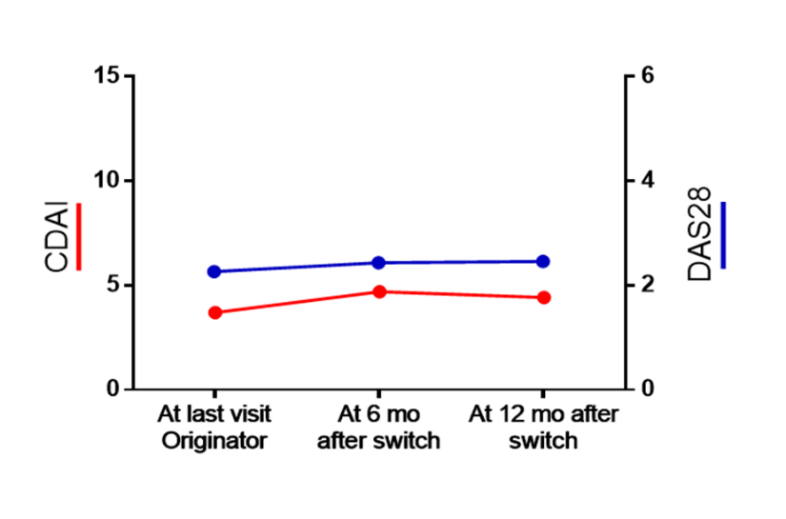
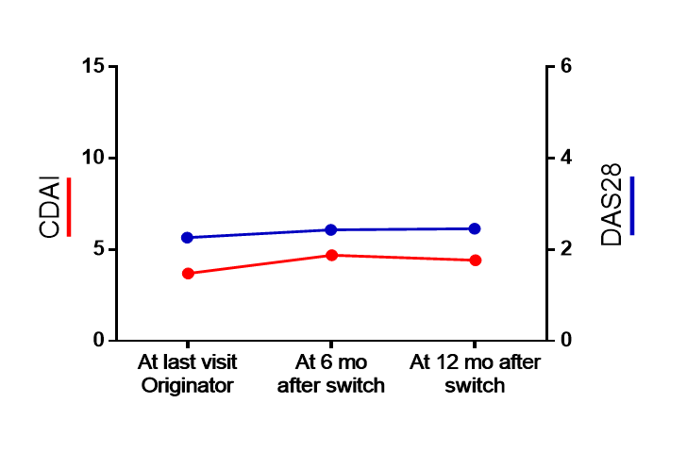
Recent Publications
- B cell therapy for rheumatoid arthritis: the rituximab (anti-CD20) experience. T Shaw et al. Ann Rheum Dis 2003
- Rituximab for Rheumatoid Arthritis Refractory to Anti–Tumor Necrosis Factor Therapy. Cohen et al. Artritis and Rheumatism 2006
- Comparison of biosimilar CT-P10 and innovator rituximab in patients with rheumatoid arthritis: a randomized controlled Phase 3 trial. Park et al. MABS 2018, VOL. 10, NO. 6, 934–943
- Effectiveness and safety of switch to rituximab biosimilar with rheumatoid arthritis. a single centre experience. Saleem et al., Rheumatology, May 2019
- Efficacy and safety of switching from rituximab to biosimilar CT-P10 in rheumatoid arthritis: 72-week data from a randomized Phase 3 trial. Seung Cheol Shim et al. Clinical Science June 2019

Biography
Dr Daniela Renna graduated in December 2016 in Medicine and Surgery magna cum laude at the University of Bari. She is a Rheumatology resident in Bari University, currently working at the Rhematology Unit of Bari’s Policlinico. She spent her first year of residency at the Rheumatology ward; she’s currently attending her second year of residency at the outpatient clinic “pre-infusional visits”; she manages follow-up visits of patients with RA, SpA and other rheumatic diseases in treatment with i.v. biological therapies (Tocilizumab, Abatacept, Infliximab, Rituximab).
Email: daniela.renna.91@gmail.com

Notes/Comments:

