Tuberculosis reactivation in patients with rheumatoid arthritis on tumor necrosis factor-alpha-blockers: A case report
Poopak Mohaghegh1*, Alireza Tavasoli 2, Sahar Mohaghegh 3
1 Department of Internal Medicine, School of Medicine, Fasa University of Medical Sciences, Fasa, Iran. 2 Department of Pathology, School of Medicine, Fasa University of Medical Sciences, Fasa, Iran. 3 Department of Optometry, School of Rehabilitation Sciences, Shahid Beheshti University of Medical Sciences, Tehran, Iran

Abstract
Tumor necrosis factor-alpha-blockers have revolutionized the treatment of rheumatoid arthritis. They do, however, increase the risk of latent tuberculosis (TB) reactivation. In many countries, including Iran, TB skin tests and chest radiography are used to assess this risk. The interferon-gamma release assay test is a secondary test used to rule out the potential risk of latent TB reactivation but is not required. In this report, we present a 67-year-old female rheumatoid arthritis patient who was on tumor necrosis factor-alpha-blockers (Adalimumab) and manifested severe symptoms of TB infection in our service eight months after taking the initial treatment. In this case, the TB skin test and chest radiography were negative at initiating the remedy. Following a timely diagnosis and TB treatment, the patient was cured. Mandatory double-checking with TB skin test and interferon-gamma release assays test is recommended before tumor necrosis factor-alpha-blocker prescription in rheumatoid arthritis patients to prevent the risk of fatal tuberculosis reactivation.
Image
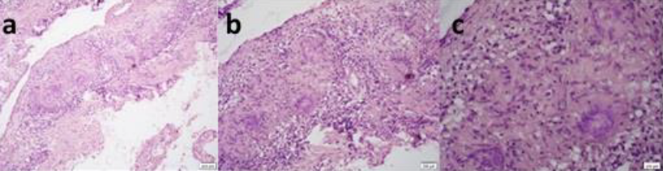
Figure 1: Multiple non-caseating granulomas with the aggregate of epithelioid histiocytes and Langhan's type multinucleated giant cells in peritoneal membrane section (Magnification: X100 (a), X200 (b), X400 (c) Hematoxylin & Eosin or H. & E. stained).
Recent Publications

1.Keane J, Gershon S, Wise RP, Mirabile-Levens E, Kasznica J, Schwieterman WD, et al. Tuberculosis associated with infliximab, a tumor necrosis factor alpha-neutralizing agent. N Engl J Med 2001; 345:1098-104. doi: 10.1056/NEJMoa011110
2.Dixon W, Hyrich K, Watson K, Lunt M,Galloway J, Ustianowski A. et al. Drug-specific risk of tuberculosis in patients with rheumatoidarthritis treated with anti-TN therapy: results from the British Society for Rheumatology Biologics Register (BSRBR). Rheum Dis 2010;69(3):522-28. doi:10.1136/ard.2009.118935.
3.Dantes E, Tofolean DE, Fildan AP,Craciun L,Dumea E, Tofolean IT, et al.Lethaldisseminated tuberculosis in patients under biological treatment - two clinical cases and a short review. J Int Med Res 2018;46(7):2961-69. doi: 10.1177/ 030006051 8771273.
4.Wańczyk-Dręczewska B,Owcz arczyk-Saczonek A, Placek W. Tuberculosis in patient with psoriasis receiving biologic therapy: Case report. Pol Ann Med 2020;27(2):209-13. doi:10.29089/2020.20.00135
5..Mazurek GH, Jereb J, Vernon A, LoBue P,Goldberg S, Castro K. Updated guidelines for using Interferon Gamma Release Assays to detect Mycobacterium tuberculosis infection -United States, 2010. MMWR Recommendations and reports: Morbidity and mortality weekly report Recommendations and reports 2010; 59:1-25.
Biography
Dr Poopak Mohaghegh has her expertise in medicine about 23 years and her activity in rheumatology field as assistant professor is from 2013. She practices in this field in management of hospitalized and out patients in Iran. This case is one of her patients that was seen in local hospital and she believes that attention to this case may help to save other patients because in some TB endemic areas, dual testing for latent TB before starting of TNF blockers is not mandatory.
Email: mohaghp@yahoo.com

