A rare case of juvenile systemic lupus erythematosus associated with neuromyelitis optica spectrum disorder presenting as area postrema syndrome

Dr Sunil V Kapur, MD, FIRH, MSc (Immunology)- India
Dr Anirudda Desphande, DM (Neurology)- India

Abstract
Introduction: Rare demyelinating disorders known as neuromyelitis optica spectrum disorder (NMOSD) primarily involve transverse myelitis and optic neuritis and is associated with specific IgG antibodies against anti-aquaporin-4 (AQP4) and anti-myelin oligodendrocyte glycoprotein (MOG). Myelitis and optic neuritis are uncommon systemic lupus erythematosus (SLE) presentations, and it is unknown how much and to what extent NMOSD is responsible for these symptoms. NMOSD and SLE associations in children have not been reported.
Purpose: We report a challenging case of juvenile SLE whose intractable nausea, vomiting, and hiccups (Area postrema syndrome-APS), which were the presenting symptoms of NMOSD resolved after the patient was started on pulse steroids and Rituximab.
Case Report: A 17 year old girl was diagnosed with SLE based upon manifestations of alopecia, inflammatory arthritis, hemolytic anemia, pancytopenia, Raynaud phenomenon, with positive anti-nuclear, anti-double stranded deoxyribonucleic acid, anti-Smith, and hypocomplementemia.. She came to our hospital five years later with a fever, headache, diplopia, and myalgia for two weeks. Both the brain and orbits' MRI results were normal. Low glucose (39 mg/dL), high protein (170 mg/dL), and pleocytosis (WBC 429 cells/uL) with neutrophilic preponderance and normal Adenosine Deaminase levels were shown by CSF tests. CSF cultures remained sterile. After receiving intravenous antibiotics for what was thought to be bacterial meningitis, she was released from the hospital after 14 days. She was kept on low-dose prednisone, azathioprine, and hydroxychloroquine. Two months later, she was readmitted once more due to headache, hiccups, vomiting, fever, and intractable nausea. Low glucose (24 mg/dL), high protein (168 mg/dL), and pleocytosis (WBC 394 cells/uL) with a predominance of neutrophils were all again shown by CSF studies. She was treated with broad-spectrum intravenous antibiotics, but there was no appreciable improvement in her condition. Her condition worsened with new-onset diplopia. A repeat brain and spinal MRI confirmed an isolated T2-weighted-Fluid-Attenuated Inversion Recovery (T2-FLAIR) enhancement in the tegmentum of the medulla and pontomedullary junction, which represents area postrema area (Figure 1), supporting our diagnosis of APS due to NMOSD. (Figure 1). The ophthalmology examination was normal, and the MRI orbit revealed no abnormalities related to the optic nerve. Both MOG-IgG and AQP4-IgG were positive. The patient was identified as having coexisting SLE and seropositive NMOSD. She was given a pulse dose of 30 mg/kg/day of methylprednisolone for three days in addition to receiving Rituximab 1000 mg IV on days 0 and 14. Low dose steroids and hydroxychloroquine were kept up while azathioprine was stopped. After a year, there was no recurrence of either NMOSD or SLE, and both conditions were under good control.
Conclusion & Significance: NMOSD and juvenile SLE can coexist, as demonstrated by this case. The first step in adjusting treatment is to determine which disease is clinically active. AQP4-IgG and MOG-IgG antibody testing can detect coexisting NMOSD, even though the neurologic symptoms of the two disorders are similar. It is vital to identify coexisting conditions because treatment for coexisting SLE and NMOSD varies and because improper treatment can have severe and irreversible neurologic consequences in children.

Image

MRI T2 FLAIR sequence demonstrating bilateral lesions in the area postrema (highlighted by arrows) in the (A) sagittal and (B) transverse planes.

Hyperintensity in this area at the level of the medulla oblongata with associated severe nausea and vomiting is consistent with a diagnosis of area postrema syndrome- a characteristic presentation of neuromyelitis optica disorder (NMOSD).

Figure1: A B
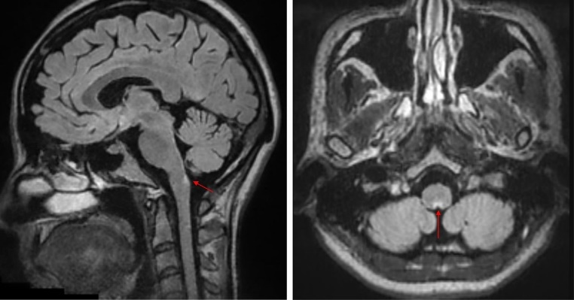

Recent Publications (minimum 5)
Mehta LR, Samuelsson MK, Kleiner AK, et al. Neuromyelitis optica spectrum disorder in a patient with systemic lupus erythematosus and anti-phospholipid antibody syndrome. Multiple Sclerosis Journal. 2008;14(3):425-427.
Wingerchuk DM, Banwell B, Bennett JL, Cabre P, Carroll W, Chitnis T, et al. International consensus diagnostic criteria for neuromyelitis optica spectrum disorders. Neurology. 2015 ;85(2):177-89.
Kumar A, Gupta A, Gupta P, Vasdev V, Kartik S. The Coexisting Neuromyelitis Optica Spectrum Disorder and Systemic Lupus Erythematosus: A Therapeutic Challenge. Mediterranean Journal of Rheumatology. 2023 ;34(3):372
Elnady B, Fathy SM, Elkhouly T, Ganeb S. Neuromyelitis optica spectrum standstill in rheumatic systemic autoimmune diseases. Egyptian Rheumatology and Rehabilitation. 2020 ;47:1-8.
Jacobi C, Stingele K, Kretz R, et al. Neuromyelitis optica (Devic’s syndrome) as the first manifestation of systemic lupus erythematosus. Lupus. 2006;15 (2):107–109.


Biography (150 word limit)
Dr Sunil V Kapur is a consultant Rheumatologist and Immunologist with 10 years of consulting and international clinical research experience. He has more than fifty scientific posters and publications in national and international journals and is a member of Indian association of Rheumatology. He has been a member of American Society of Clinical Pharmacology and American Society of Clinical Pharmacology and Therapeutics.
Email: sunilvkapur@gmail.com

