Results of joint-preserving procedures for forefoot deformities in patients with rheumatoid arthritis compared to resection arthroplasty
YUYA TAKAKUBO1, 2, Yoshihiro Wanezaki2,Masashi Aso2,Ryusuke Honma2,Hiroharu Oki3,Yasushi Naganuma4,Junichiro Shibuya5,Akemi Suzuki2,Michiaki Takagi2
1Dept. of Reha. , Yamagata University Faculty of Medicine,2Dept of Orthop Surg, Yamagata Univ Faculty of
Medicine,3Dept of Orthop Surg, Yamagata Saisei Hospital,4Dept of Orthop Surg, Yamagata Prefectural Central
Hospital,5Dept of Orthop Surg, Izumi Orthopaedic Hospital

Abstract (300 word limit)
Introduction: Joint-preserving surgeries for forefoot were increased after the paradigm shift of rheumatoid
arthritis (RA) therapy. We investigated joint-preserving procedures compared to resection arthroplasty for RA
forefoot. Methods: Forefoot interventions from 2002-2018 were 62 toes in 42 cases (40 females/ 2 males). Of 62 toes, we have 31 toes in 22 cases with joint-preserving surgeries using modified Mann methods for big toe and off-set osteotomy for lesser toe (PP group), 15 toes in 9 cases with joint-preserving procedure for big toe and resection arthroplasty for lesser toe (PR group), 16 toes in 11 cases with resection arthroplasty for all toes (RR group). Mean age was 61 year-old.
Results: Mean JSSF RA foot ankle scale was 38.7 at pre-surgery and 78.6 at latest follow-up. Mean JSSF RA foot ankle scale at latest follow-up in PP group was significantly higher compared to RR group (86 vs 75, p<0.05). Recurrence of hallux valgus (more than 20 degrees) at latest follow-up (mean follow-up period, 9.4 years) was 32% in PP group, 60% in PR group and 100% in RR group. Discussion: Joint-preserving surgeries have the potential to be superior to prevent the function loss and recurrence of hallux valgus compared to resection arthroplasty.
Image
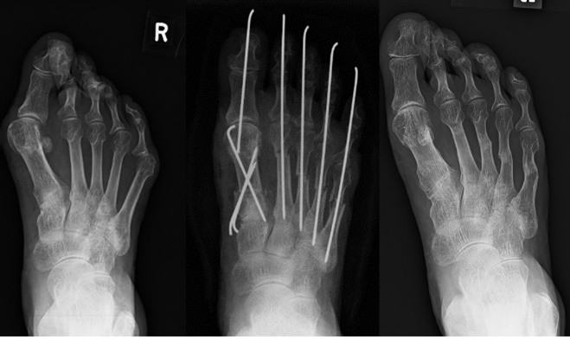
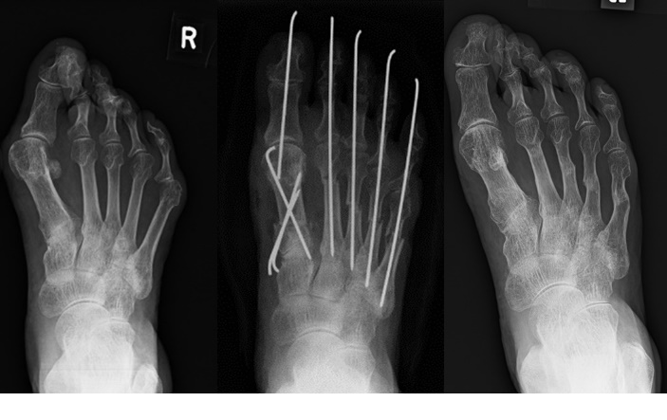

Fig. PP group: modified Mann methods for big toe and off-set osteotomy for lesser toes

Recent Publications (minimum 5)
¹ Yano, K. et al. Patient-reported and radiographic outcomes of joint-preserving surgery for rheumatoid forefoot deformities: A retrospective case series with mean follow-up of 6 years. J. Bone Joint Surg. Am. 2021, 103, 506–516.
² Hirao, M. et al. Outcomes of modified metatarsal shortening offset osteotomy for forefoot deformity in patients with rheumatoid arthritis: Short to mid-term follow-up. Mod. Rheumatol. 2017, 27, 981–989.
³ Takakubo Y, et al. Forefoot Deformities in Patients with Rheumatoid Arthritis: Mid- to Long-Term Result of Joint-Preserving Surgery in Comparison with Resection Arthroplasty. Int J Environ Res Public Health. 2021 Oct 26;18(21):11257.

Photograph

 Biography (150 word limit)
National Board of Medicine (No. 401083, 1999), Japanese Board of Rheumatology, Certificate (Nr. 4044, 2005-), Japanese Board of Orthopaedic Surgery, Certificate (Nr. 117838, 2007-), Japanese Board of Rheumatic Disease Foundation, Certificate (No. 6102, 2009-), Japanese Board of Rehabilitation Medicine, Certificate (No. 02703, 2019-)
Email: takakubo@med.id.yamagata-u.ac.jp
Notes/Comments:

