Bioinformatic Analysis and Genotyping of Rheumatoid Arthritis risk-associated Genes

Yasir Ali: School of Biomedical Sciences, The Chinese University of Hong Kong
Dr. Fazal Jalli: Department Biotechnology, Abdul Wali Khan Univeristy Mardan, KPK, Pakistan
Prof. Dr. Yangchao Chen: School of Biomedical Sciences, The Chinese University of Hong Kong

Abstract
Background: Rheumatoid arthritis (RA) is a complex disease influenced by both genetic and environmental factors. Single nucleotide polymorphisms (SNPs) have been found to play a role in RA susceptibility and account for approximately 15% of its heritability. Objectives: This study aimed to investigate the association of RA susceptibility genes in Pakistani patients and predict the structural and functional importance of these variants bioinformatically. A case-control study was conducted on 600 individuals, including 300 RA patients and 300 matching healthy controls. The genotypes for variants were obtained using PCR and TaqMan assays. Various bioinformatic tools were used to predict the damaging and deleterious effects of these variants on the protein structure and function. Additionally, gene-gene interaction networks and potential therapeutic targets were identified. Bioinformatics Results: Four SNPs, rs2476601, rs5029941, rs2230926, and rs34536443, were predicted to be the most damaging. Furthermore, 42 intronic SNPs were predicted to create or abolish potential splice sites, and only one UTR SNP, rs1128334, caused functional pattern changes. Thirteen potential target sites were identified for the development of RA drugs, including three novel target genes. These findings provide insights into the underlying mechanisms of RA and potential therapeutic targets. Genotyping Results: The present study investigated the association of various genetic variants with rheumatoid arthritis (RA) susceptibility in the Pakistani population. The results revealed a significant association of the CCR6 rs3093024 variant with RA risk, with the A variant being significantly associated with an increased risk of RA, while the G variant was found to be protective. Bioinformatics analysis indicated that the CCR6 rs3093024 variant might have a potential impact on the product of this gene. However, no significant association was found between the AFF3 gene (rs10865035) and miRNA variants (rs2910164 and rs185070757) with RA susceptibility in the Pakistani population. Moreover, the IL-17F rs763780 and rs11465553 variants were found to be significantly associated with RA susceptibility at the genotypic level. Additionally, the MIR149 rs2292832 and MIR499 rs3746444 variants were found to be significantly associated with RA susceptibility in various genetic models. Further in vivo and in vitro studies are required to validate the potential effects of these genetic variants on RA pathogenesis.

Image
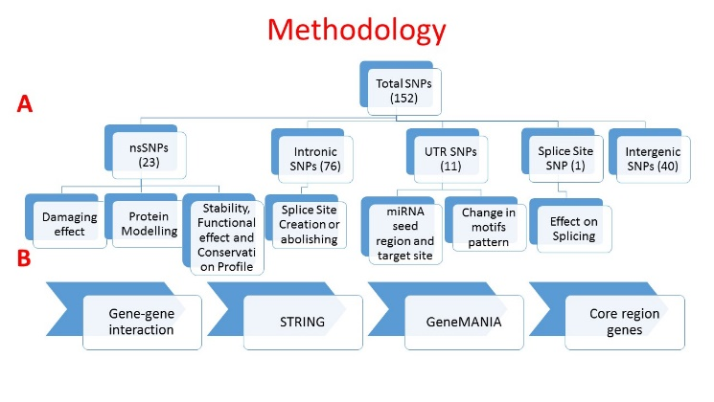
Figure 1. Complete Bioinformatics Methodology

Recent Publications
- Association study of CCR6 rs3093024 with Rheumatoid Arthritis in a Pakistani Cohort.
- Characterization of Rheumatoid Arthritis Risk-Associated SNPs and Identification of Novel Therapeutic Sites Using an In-Silico Approach
- Association of AFF3 Gene Polymorphism rs10865035 with Rheumatoid Arthritis: A Population-Based Case-Control Study on a Pakistani Cohort.
- MIR149 rs2292832 and MIR499 rs3746444 Genetic Variants Associated with the Risk of Rheumatoid Arthritis
- Exploring the associations and molecular impacts of miR-146a/rs2910164 and miR-196a2/rs185070757 with Rheumatoid Arthritis in a Pakistani population (Accepted in Lifestyle genomics, not yet published.
- Association of IL-17F rs2397084 (E126G), rs11465553 (V155I) and rs763780 (H161R) variants with Rheumatoid Arthritis and their effects on the stability of protein (Accepted in PLOS ONE, PONE-D-23-01312R1).

Photograph



Biography
Yasir Ali, as a doctoral student with a strong background in human genetics, bioinformatics, and critical analysis of scientific literature, I am committed to advancing our understanding of complex diseases. Currently, I am working as a Research Assistant in the laboratory of Prof. Yangchao Chen at the School of Biomedical Sciences, Faculty of Medicine, The Chinese University of Hong Kong, where I am investigating the roles of various genes in the development of Rheumatoid Arthritis, Coronary Artery Disease, and myocardial infarction. My research experience in immunogenetics and Cardio genetics has equipped me with the knowledge and skills to identify key genetic factors and pathways that contribute to these conditions. My dedication to research is reflected in my publications in peer-reviewed journals and my active participation in scientific conferences. I am eager to continue making significant contributions to the field of human genetics and its applications in personalized medicine.

Email: Yasirali@cuhk.edu.hk

Notes/Comments:

