Patients with moderate fibromyalgia syndrome had improved functional status after receiving remote approach based external myofascial mobilization: a retrospective analysis
Dr Ajimsha MS, Hamad Medical corporation, Qatar

Abstract
Objective: Fibromyalgia (FM) is a chronic pain syndrome characterized by a large variety of symptoms. The purpose of this study is to evaluate the outcome of a four-week Remote approach based external myofascial mobilization (RAEMM) program based on myofascial connectivity in the management of Patients with fibromyalgia syndrome.
Patients and methods: A retrospective chart review of patients with a diagnosis of fibromyalgia who underwent RAEMM therapy between March 2020 and April 2022 was organized for this analysis. The outcomes at a follow up visit at 6 months were also extracted. The functional status, twenty-four-hour pain status quality of life and sleep were analyzed at the baseline, after completion the program and at 6 months.
Results: The data from 19 moderately affected female fibromyalgia patients who completed the RAEMM therapy and the follow up session at 6 months were included in the analysis. The mean (range) age of patients was 46 (28-62) years. The mean (SD) FIQ score at initial evaluation was 64.8 (9.3) and decreased to 26.7 (6.4) at the post test and remained largely unchanged at 6-month follow-up (28.5 ±8.3), indicating a robust treatment response. Analysis of the 24-hour pain behavior also revealed significant improvement in pain (P < 0.001) with a retaining of effect at 6 months follow up.
Conclusions: A RAEMM approach based on fascial connectivity led to significant symptom improvement in all the studied patients. The relative retention of effects found in the pain and the quality-of-life scales at the follow-up was promising finding. RAEMM may be an effective treatment option for fibromyalgic patients with moderate symptoms. Future high-quality studies with control groups are needed to confirm the present findings and to identify the effects on chronicity, durability, and long-term outcomes.

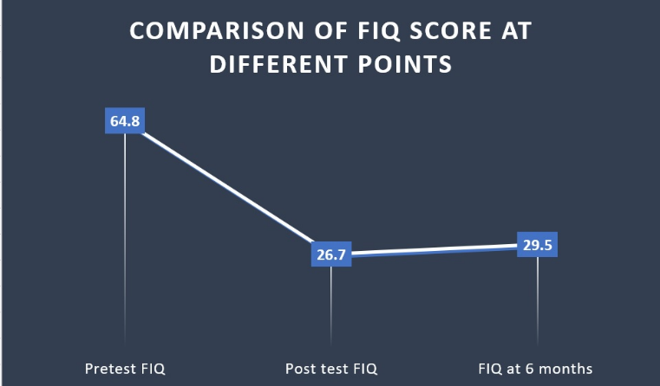
Recent Publications (minimum 5)
- Ajimsha MS, Shenoy PD, Surendran PJ, Jacob P, Bilal MJ. Evidence of in-vivo myofascial force transfer in humans; a systematic scoping review. Journal of Bodywork and Movement Therapies. 2022 May 18.
- Ajimsha MS, Ismail LA, Al-Mudahka N, Majzoub A. Effectiveness of external myofascial mobilisation in the management of male chronic pelvic pain of muscle spastic type: A retrospective study. Arab Journal of Urology. 2021 Jul 3;19(3):394-400.
- Ajimsha MS, Shenoy PD, Gampawar N. Role of fascial connectivity in musculoskeletal dysfunctions: A narrative review. Journal of Bodywork and Movement Therapies. 2020 Oct 1;24(4):423-31.
- Ajimsha MS, Gampawar N, Surendran P, Jacob P, Karpouzis V, Haneef M, Aleef M, Ali S, Praveen R, Bouguerra E, Almudahka N. Acute Care Physiotherapy Management of COVID-19 Patients in Qatar: Consensus-Based Recommendations.
- Ajimsha MS, Shenoy PD. Improving the quality of myofascial release research–A critical appraisal of systematic reviews. Journal of Bodywork and Movement Therapies. 2019 Jul 1;23(3):561-7.

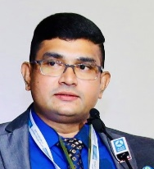
Dr. Ajimsha MS
ADMFT, PhD, PhD, DO, MBA, CFFT-2
Physiotherapy Specialist and fascial fitness trainer
Hamad Medical Corporation, Doha, Qatar

Dr. MS Ajimsha has been a Physiotherapy specialist at Hamad Medical Corporation for almost a decade. Following his post-graduate degree in Neuro Physiotherapy and Master’s in Healthcare Management, he has obtained consecutive doctoral degrees in Neurorehabilitation, Myofascial mobilization and in Osteopathy from India, UK and Spain respectively. He is a Fascia Training Academy, USA-licensed, Level 2 fascial fitness trainer.
His credentials as a clinical specialist, researcher, academician, and administrator are well known. He has presented at numerous international conferences and published more than 30 highly-cited articles with more than 800 citations. He is well known as a fascia researcher all over the world, and fascial enthusiasts greatly value and refer to his publications and speeches. He has extensive connections to all fascial researchers worldwide and frequently collaborates with them.
The studies of Dr. Ajimsha on myofascial connectivity and myofascial force transmission are pivotal works in the modern fascial science. He represented Qatar at the Fascia Research Congresses held in Germany and Brazil. He is the founder of macrofascial mobilization (MFM) and pelvic external myofascial mobilization (PEMM) therapies. He has received various awards for his contributions to fascia-oriented research and Neurorehabilitation.
Dr. Ajimsha is very skilled in organizing world-class events and conferences. Since 2012, he actively contributes to the academics and research field of physiotherapy and represents physiotherapy and Qatar in elite conferences and events.
Email: ajimshaw.ms@gmail.com
Notes/Comments:

