Management of spine fractures in ankylosing spondilitis
Dr Leandro Vinicius Vital, spine surgeon Federal University of Minas Gerais /Biocor Institute

Abstract (300 word limit)

Ankylosing Spondilitis affects the axial skeleton, causing not only inflammation but also ossification of the end plates, discs, ligaments and apophyseal joints. It induces the development of syndesmophytes leading to a “bamboo-spine” appearance and a consequently deformed and rigid spine. This stiffness renders the spine prone to fracture and even minor traumas, like simple falls, can have catastrophic consequences, even leading to death in severe cases.
In fact, cervical spine fractures are three times more frequent in patients with AS. Fractures in the ankylosed segments are often unstable because of the ossification of supportive and elastic soft tissues.These fractures are B3 type for AOSPINE classification, because the trauma mechanism is in extension. These are more prone to dislocation with associated neurologic deficits. Moreover, even though patients may be initially neurologically intact, secondary neurologic deterioration is common due to unprotected transfers and inadequate manipulation. Also, clinical outcomes are worse in patients with ankylosed spine segments compared to the general population.²
Treatment is controversial. There are reports on non-surgical treatment, due to the higher morbidity and mortality rates of the surgery However, recent studies have shown better outcomes in surgically-treated patients, with lower complication and mortality rates and higher chances of neurological improvement. It can be performed successfully by different means, and should be individualized for each patient, depending on the clinical evolution and the surgeon’s experience. All approaches can be safe and successful, provided the characteristics of the patients and the lesions are taken into consideration.

Image
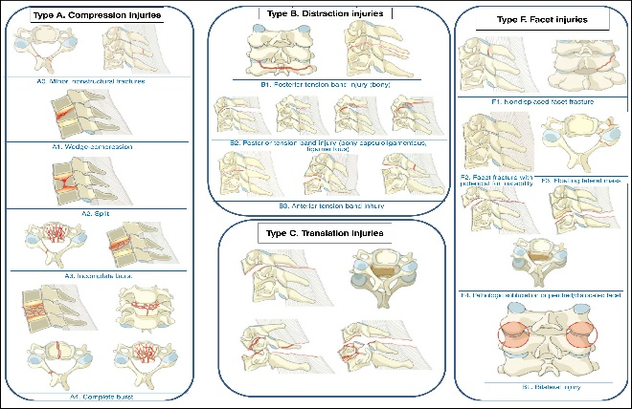
Recent Publications (minimum 5)
- Vaccaro AR, Koerner JD, Radcliff KE, Oner FC, Reinhold M, Schnake KJ, et al. AOSpinesubaxial cervical spine injury classification system. 2016;25(7):2173-84.
- Vaccaro AR, Oner C, Kepler CK, Dvorak M, Schnake K, Bellabarba C, et al. AOSpinethoracolumbarspine injury classification system: fracture description, neurological status, and key modifiers.(2013;38(23):2028–37
- Allen BL Jr, Ferguson RL, Lehmann TR, O'Brien RP. A mechanistic classification of closed, indirect fractures and dislocations of the lower cervical spine. 1982;7(1):1–27
- Vaccaro AR, Hulbert RJ, Patel AA, Fisher C, Dvorak M, Lehman Jr RA, et al. The subaxial cervical spine injury classification system: a novel approach to recognize the importance of morphology, neurology, and integrity of the discoligamentous complex. 2007;32(21):2365–74.
- Negrelli MAC, Oliveira RG, Rocha ID, Cristante AF, Marcon RM, Barros Filho TEP. Traumatic injuries ofthe cervical spine: current epidemiological panorama. Acta Ortop Bras. 2018;26(2):123-6

Photograph



Biography (150 word limit)
Dr has his expertise in evaluation and passion in spine surgery. Graduate at the Universidade Federal de Juiz de Fora, fellow in orthopedic surgery at Santa Casa de Santos and fellow in Spine Surgery at Universidade Federal de Minas Gerais. Nowadays study spine trauma and degenerative pathologies of spine.
Email: leandrovvital@gmail.com

Notes/Comments:

