SAPHO syndrome

Tamari Papidze, MD
Tbilisi State Medical University (American MD program of Emory university)

Abstract
Statement of the Problem: SAPHO is a rare (1/10,000), heterogenic syndrome with synovitis, acne, pustulosis, hyperostosis, and osteitis manifestations. It is common in children and young to middle-aged females. Since SAPHO’s pathophysiology and etiology are not fully clear and understood, treatment stays empirical. NSAIDs are the treatment of choice for symptomatic relief. Immunosuppressants, immunomodulators, Antibiotics anti-TNF-alpha therapies, glucocorticoids, bisphosphonates are also used for SAPHO syndrome treatment. Is it a rare disease or just unrecognized? This is a commonly heard question. SAPHO syndrome etiology is influenced by genetic, infectious, and immunological components. Mostly Propionibacterium acnes is isolated from the skin lesions. In terms of immune reaction, IL-8 and TNF-alpha are increased in the patients in response to the inflammatory process caused by P. acnes. The diagnosis of SAPHO syndrome is very challenging, made by exclusion. Not all symptoms are present altogether, the biopsy is needed sometimes to exclude other diagnoses, especially if only skin symptoms are present. Importantly, rs-fMRI shows functionally abnormal areas in the brain that explains the mechanism of depression in SAPHO syndrome. There is no difference between treatment in depressed and undepressed SAPHO patients, but recognition of it can indicate the best choices for monitoring mood changes in the future. It’s worth noting that more research and scientific approach is needed to understand the pathophysiology of SAPHO syndrome and this will lead the invention of new treatment guidelines, especially for patients who are refractory to all existing therapies. By increasing the awareness of this syndrome among rheumatologists, surgeons, patients will reduce the incorrect approach to diagnosis, treatment, prevention of progression, and most importantly unrecognition of this syndrome.

Image
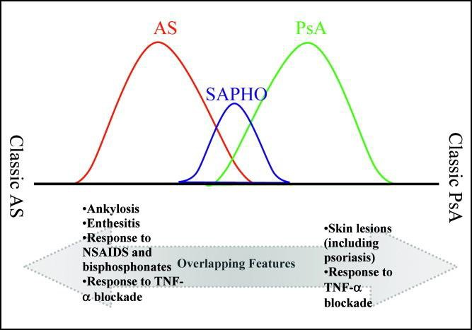
Model of overlapping features in a spectrum of disease. (AS: ankylosing spondylitis; PsA: psoriatic arthritis; NSAIDs:
nonsteroidal anti-inflammatory drugs; TNFα: tumor necrosis factor α)

Recent Publications
- Olivieri I, Padula A, Palazzi C. Pharmacological management of SAPHO syndrome. Expert Opin Investig Drugs 2006;15:1229–33
- Ben Abdelghani K, Dran DG, Gottenberg JE, et al. Tumor necrosis factor-alpha blockers in SAPHO syndrome. J Rheumatol 2010;37:1699–704
- Webster GF. Inflammatory acne represents hypersensitivity to Propionibacterium acnes. Dermatology (Basel) 1998;196:80–1
- Fox MD, Raichle ME. Spontaneous fluctuations in brain activity observed with functional magnetic resonance imaging. Nat Rev Neurosci. 2007;8:700–11.
- Rozin AP, Nahir AM. Is SAPHO syndrome a target for antibiotic therapy? Clin Rheumatol 2007;26:817–20

Photograph


I am Dr. Papidze, graduated recently from American MD program of Emory University. I am applying for internal medicine residency in the States. I’ve done three clerkships in the USA with scholarships: Harvard Medical School, Brigham and Women’s Hospital, Emory University Hospital, Aurora Medical group. I work as an USMLE step 1 tutor at American MD program. Involved in genetic research about biomarkers of inborn errors of metabolism in infants. I am working on case reports in surgery, nephrology, rheumatology and neurology. Recently my abstract about Hashimoto encephalopathy was accepted for e- poster on ANA conference. I am involved in community projects, our latest one was about healthy lifestyle, “Stop smoking, Start running!”.
Email: tamar.papidze1@gmail.com

