The role of Physical Therapy in the treatment of patients with chronic pain
Katharina Beckel, BSc., Praxis 1190, Austria

Abstract

Despite a better understanding of chronic pain during the last decade, treatment remains difficult and is often unsuccessful.
Recent studies suggest that mechanisms of central pain modulation play an important role in the development of chronic pain. Knowledge on how these central pain modulatory mechanisms relate to the level and intensity of pain and how they could be influenced should be considered in the treatment of these patients.
For successful pain management a few key points should be considered:
- Including biopsychosocial aspects in the thought process of the assessment of chronic pain patients.
- As research shows that education of pain neurophysiology will improve the outcome of other therapeutic approaches such as various exercise strategies the patients understanding of underlying mechanisms is critical for the success of therapy.
- Aim for treatment should be, to introduce the theory and evidence base for cognitive and behavioral approaches to pain management.
.

Image
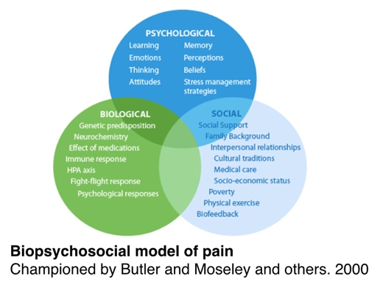
Recent Publications
- Butler S, Moseley L (2013) Explain Pain.
- Moseley,L (2003) Unravelling the barriers to reconceptualization of the problem in chronic pain: The actual and perceived ability of patients and health professionals to understand the neurophysiology.
- Gatchel, RJ., Peng YB., et al. (2007) The biopsychosocial approach to chronic pain: scientific advances and future directions.
- Moseley, L (2005) Combined physiotherapy and education is effective for chronic low back pain. A randomized controlled trial.
- Louw, A., Diener, I., et al. (2011) The Effect of Neuroscience Education on Pain, Disability, Anxiety, and Stress in Chronic Musculosceletal Pain.

 Biography
Katharina Beckel is a Physiotherapist who graduated in 2011 from FH Joanneum with a Bachelor of Health Science in Physiotherapy. Currently she is working as CEO and Therapist in three different therapy offices in Graz and Vienna. Having worked in a variety of settings, she brings a multifaceted perspective to treatment. Her specialization involves chronic pain syndromes and postpartum recovery. She has a history of working with people with complex chronic musculoskeletal conditions and is dedicated to continuing her education and evolving her skills.
Email: beckel@praxis1190.at

Notes/Comments:

