Is there a window of therapeutic opportunity in lupus nephritis? An analysis of the evolution of a cohort of 54 pediatric patients
Dr. Juan M. Moreno Lubertino, PhD, Chief of Department of Rheumathology, Sagrado Corazon Hospital and Fundacion Hospitalaria Children Hospital, Buenos Aires, Argentina. S. Meiorin, G. Espada, Argentina.

Abstract
Although there have been advances in effectiveness of lupus nephritis treatment due to new therapeutic options, this progress seems to have stalled in last decade, without improving the prognosis of pediatric patients. However, more and more predictors of relapse and absence of response are found, which allows the identification of patients that will have a torpid evolution. Perhaps, the next advance will not be a new drug, but a new strategy to treat lupus nephritis. Some authors suggest a window of opportunity that implies an early change in therapy in absence of response in patients with predictors, both of relapse and treatment failure. We retrospectively analyzed a cohort of 54 children with lupus nephritis, with a mean follow-up of 5.8 years, looking for evolution predictors. We evaluated clinical and laboratory parameters, as well as response at the 3rd, 6th, 12th month and at last visit. We found that response at 3rd month is decisive in the future evolution, having significant differences in the degree of proteinuria (p<0.001) as well as in the type of response at 3rd month (p<0.001) between responders and non-responders at long term . Of those with a complete response at 6th month, 77.2% were inactive at last visit, while of those with an early failure to treatment, 66.7% had long-term treatment failure. When looking for predictive models of response we found that, the non-response at 12 months combined with the presence of flares, were predictors of long-term non-response (p <0.001, OR 12.524, p <0.001, OR 13.406 respectively), while the best predictor of flare was the presence of proteinuria >a 2 gr. at 3rd month(p <0.001, OR25.667). We believe that there is a window of opportunity between the 3rd and 6th month, after which there is renal damage that is hardly reversible despite the different therapeutic efforts.

Photograph
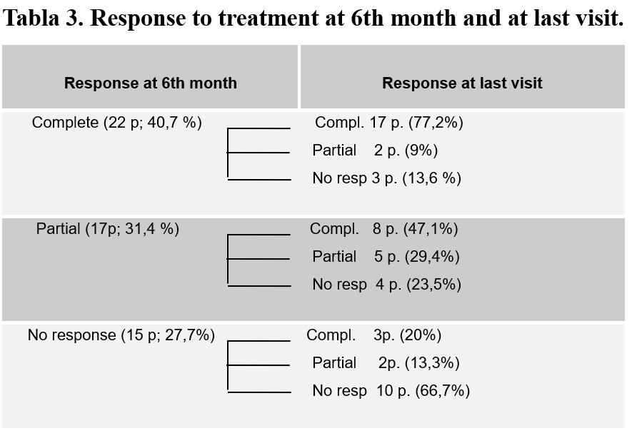
Bibliography
1) Houssiau FA. Therapy of lupus neprhitis: lessons learned from clinical research and daily care of patients. Arthritis Res Ther 2012; 14 (1):202.
2) Moroni G. et al. Remission and withdrawal of therapy in lupus nephritis. J. Nephrol 2016. DOI 10.1007/s40620-016-0313-6.
3) McCurdy D. et al. Lupus Nephritis: Prognostic factors in children. Pediatrics 92. 89: 240-246.
4) Bargman J et al. Resolution of Proteinuria in Lupus Nephritis: Hurry Up and Wait. J Rheumatol 2014; 41:622-625.
5) Hironari Hanaoka et al. Lack of partial renal response by 12 weeks after induction therapy predicts poor renal response and systemic damage accrual in lupus nephritis class III or IV. Arthritis Research & Therapy (2017) 19:4.
6) JY. Wuet al. Early predictors of outcomes in pediatric lupus nephritis: Focus on proliferative lesions. Seminars in Arthitis and Rheumatism 2013.
7) FA. Houssiau,et al. Early Response to Immunosuppressive Therapy Predicts Good Renal Outcome in Lupus Nephritis. ARTHRITIS & RHEUMATISM 2004. 50.12: 3934–3940.
8) S. Wilhelmus et al. Lupus nephritis management guidelines compared. Nephrol Dial Transplant (2015) 0: 1–11.
9)Hironari Hanaoka et al. Early achievement of complete renal response predicts good long-term renal outcome and low systemic damage in newly diagnosed lupus nephritis class III or IV.Mod.Rheumatol. Doi: 10.3109/14397595.2014.1003172.
10) Gibson K et al. Predictors of relapse and end stage kidney disease in proliferative lupus nephritis: Focus on children, adolescents and young adults. Clin J Am Soc Nephrol 4: 1962-1967,2009.
11) Miettunen P et al. Therapeutic approaches for the treatment of renal disease in juvenile systemic lupus erythematosus: an International multicentre PRINTO study. Ann Rheum Dis 2012; 0: 1-7.

Biography
Dr. Juan Manuel Moreno Lubertino is in charge of the Rheumatology Department in Sagrado Corazon Hospital, Fundacion Hospitalaria Children s Hospital and consultant of OSECAC and ELEVAR in Buenos Aires, Argentina. He has dedicated the past few years developing a proyect of early arthritis clinic in children, to improve the JIA outcome, and studying the therapeutic window of opportunity in lupus nephritis in pediatric patients.
Email: juanmmoreno_l@hotmail.com

