Abstract Template
Abstract Title: Floating Energy
First A. Author, Second B. Author, Jr., Third C. Author

¹ First Author
^{Shamil Ayntrazi, PE}
ABSTRACT (not more than 300 words)
The “floating Energy System” (FloatNRG) extracts offshore energies from; sea waves, ebb/tidal currents, solar, thermal and wind as one coordinated system. Wave potential, kinetic and horizontal energies are extracted from wave front, lee sides and from wave horizontal forces. The FloatNRG system is of modular construction, completely assembled at the shore line on a floating “Tension Leg Platform” (TLP), floated and towed to location ready for anchoring to the sea bed beyond 30m depths ready for operation. For each 6MW wind turbine the (TLP) consists of submerged fixed floats with a foot print of 1,600 square meters, handle waves up to 8m high and storms with wind speeds up to 240 Km per hour by developing resisting moments up to 56,525 ton-meters, an energy output of 1,779,393 KW-hour per year and volume of 2,217 cubic meters for energy storage as compressed air
Keywords—Wave, Tidal, Solar, Wind
Professional Biography (100-150 words)
EDUCATION and EXPERIENCE.
Education
- BSc. Electrical Engineering-American University of Beirut
- Graduate Courses towards MBA-New York.
- Registered Professional Engineer – Lebanon, No. 834
- Registered Professional Engineer - State of New York, No. 45762
Experience
- CEO, Fouad Bross Elmeco & CEO, Elmeco International,
- For other firms: Design Director, Senior Construction Manager.
- Designed and/or Executed Projects in Excess of 10 Billion US$.
Publications
- Developed www.renewableenergypumps.com and www.FloatNRG.com
- Developed and Published Integrated Project Management System-IPMS,
- Holder of Six Patents in Renewable Wave Energy (some are pending).
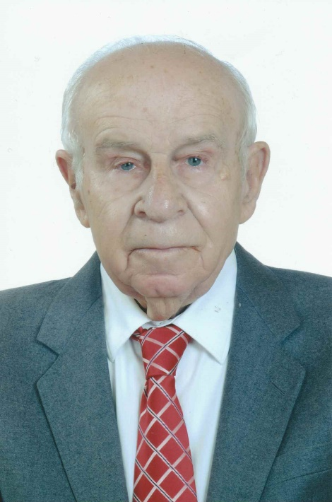
Paste your Photograph here

Email Id: sayntrazi@hotmail.com
Contact Number:

Any Comments:
Thanks and good luck

