Demand Response Strategies For a Sustainable Future
Robert Sarai, LEED AP

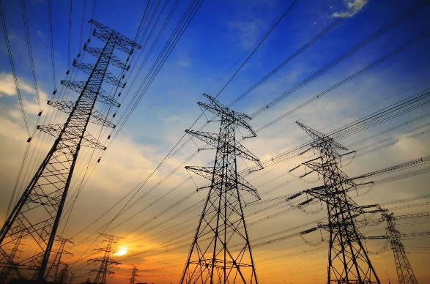
Abstract (300 word limit)

California is pushing the most progressive sustainability laws in the country. Many states such as Hawaii have also begun to follow. The goal is to educate and bring to awareness how smart strategies to reduce building energy expense can be implemented through renewable energy practices such as battery storage and how it benefits buildings.

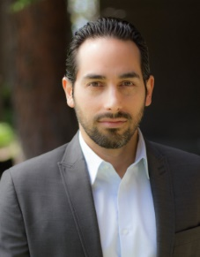
This speaking submission will discuss California's goal as a leader to meet their sustainability exceptions for 2030. The topic will discuss how other state can follow California’s leadership. This includes discussing how California passed State Bill 100 a mandatory goal for reducing GHG and energy consumption by 45% by the year 2030. We will introduce new emerging opportunities for buildings to be smarter with their Demand Response strategies. We will explain how to utilize battery storage and set a clear management and operation plan to make less impact with the environmental footprint. We will also provide a LEED approach to how buildings can reduce the carbon offset by utilizing renewable technologies to become less despondent from utility companies saving them money in the short term and improving our environment in the long term.
Image

Recent Articles (minimum 5)

https://www.linkedin.com/pulse/san-franciscos-energy-goals-robert-sarai/

https://www.linkedin.com/pulse/demand-response-los-angeles-robert-sarai/

https://la-solargroup.com/2018/06/18/2018-energy-storage-market-trends/

https://la-solargroup.com/2018/07/31/battery-storage-can-prevent-los-angeles-blackouts/

https://la-solargroup.com/2018/10/23/understanding-storedge/

Biography
Robert Sarai, LEED AP, is a leading expert in energy efficiency and sustainability with L.A. Solar Group, an Inc. 500 company and one California’s highest-rated solar installers. As the company's Business Development Manager, Robert has had a key role in LA Solar Group's success of achieving 1,233% growth in the last 3 consecutive years. Skilled in Business Strategy, Thought Leadership, Energy Consulting, Negotiation, Marketing, and Digital Media, he oversees LA Solar Group's development and marketing efforts to guide property owners toward smart energy solutions. He also writes engaging and thoughtful online content about solar technology, energy efficiency, sustainability, market trends, and news in Los Angeles and California.

Email: robertsarai@gmail.com

Notes/Comments:

