Adaptive piezoelectric harvester from footsteps for a wireless switch system
Kyung-Bum Kim, Ph.D , Hanyang University, Republic of Korea
Sang Bum Woo, Ph.D , Hanyang University, Republic of Korea
Chul Hee Ryu, Ph.D , Hanyang University, Republic of Korea

Abstract (300 word limit)
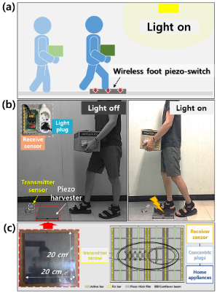
A sustainable energy supply in a wireless switch system is an important component for a smart home to realize the self-driven functions of some intelligent devices. Here, we report a newly developed foot switch powered by a piezoelectric generator, which exhibits an obvious advantage with regard to stable energy harvesting. The system is able to convert the energy from human footsteps into electricity while delivering a power density up to 1.0 mW/cm³, which was demonstrated to operate home appliances instantaneously. The harvested footstep energy from human motion is capable of powering a wireless switch for real-time transmitting. This work represents a significant step toward energy harvesting from human biomechanical movement given the multifunctional characteristics of piezoelectric generators as power sources for wireless self-powered devices.

Image

 Biography
Paste your Logo here
Sang Bum Woo received a B.Sc. in Electrical Engineering from Hanyang University, Seoul, Republic of Korea. He undergoes M.Sc. and Ph.D. integrated course in Hanyang Universtiy. His research interests include designing piezoelectric material and modelling of energy harvesting technology,
Email: wsb9393@naver.com

Notes/Comments
Presenting author details
Full name: Sang Bum Woo
Contact number: +82 010 2684 5035
Mail id: wsb9393@naver.com
Category: Poster presentation

