Enhanced Flexible Piezoelectric Generating Performance via High Energy Composite for Wireless Sensor Network

Chul-Hee Ryu, masters, Hanyang university, republic of Korea
Kyung-Bum Kim, Ph.D. Hanyang university, republic of Korea
Jae Yong Cho, Ph.D. Hanyang university, republic of Korea
Tae Hyun Sung, Prof, Hanyang university, republic of Korea

Abstract

Piezoelectric 0.72Pb(Zr_{0.47}Ti_{0.53})O₃-0.28Pb[(Zn_{0.45}Ni_{0.55})_{1/3}Nb_{2/3}]O₃ + 0.5 mol% CuO (PNNC) particles were made for use in a composite of flexible energy harvester (FEH) that can convert sustainable mechanical deformation into electrical energy. The PNNC particles with a high transduction coefficient (d₃₃×g₃₃) were mixed with polydimethylsiloxane (PDMS) matrix to produce the FEH. The FEH generated maximum output voltage of 55.24 V and current density of 2.76 μA/cm². The developed energy harvester is demonstrated in the self-powered wireless sensor node application in which the FEH spontaneously generated stable power under sustainable mechanical stress.

Image
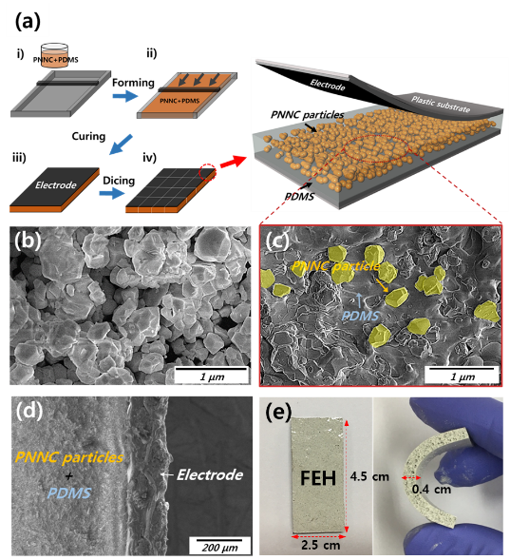
Figure 1. (a) Schematic illustration of the FEH fabrication. (b) FE-SEM image of the PNNC particles sintered at 950°C. (c) FE-SEM image of piezoelectric nanocomposite PNNC particles with PDMS matrix. (d) Cross sectional FE-SEM image of the FEH. (e) Optical images.

Recent Publications (minimum 5)

Biography
Paste your Logo here
Chul Hee Ryu received the Bachelor of Social Work degree from Gyeongsang university, Jinju, South Korea in 2016. He is currently pursuing his M.Sc & Ph.D. degree from Hanyang university. His research interests include material of piezoelectric, energy harvesting system and designing for application.
Email: ryunaol00@gmail.com

Notes/Comments:

Presenting author details
Full name: Chul Hee Ryu
Contact number: +821047387124
Mail id: ryunaol00@gmail.com
Category: Poster presentation

