Piezoelectric energy harvesting techniques for self-powered versatile system of conveyor belt
Jae Yong Cho, Hamid Jabbar, Kyung-Bum Kim and Tae Hyun Sung*
Department of Electrical Engineering, Hanyang University, Seoul 133-791, Republic of Korea.

Abstract

In a factory, there are numerous conveyor belts operated for a long time and it can bring about dangerous situations such as skew of product, movement of an item to wrong destination and missed assembly, if they don’t work in a set speed. Therefore, it is necessary to monitor speed condition of conveyor belt in a real-time. In this paper, we designed the versatile piezoelectric energy harvesting for self-powered smart warning system of conveyor belt for smart factory. The harvester has a role of sensing velocity of a belt as well as generating power for self-powered system. In terms of power generation, the output voltage of 1.56 V and the output power of 0.1 mW were obtained. Schmitt trigger topology was used for the harvester to be a velocity sensor by detecting two rising moments and calculating velocity from dividing distance between two moments into time.
Image
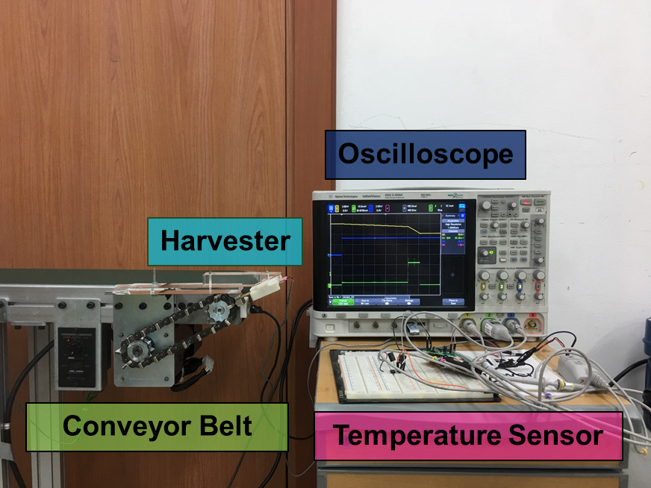
Figure 1. Experimental setup for self-powered temperature monitoring system from energy harvesting
Recent Publications
- JY. Cho (2018) Design of optimized cantilever form of a piezoelectric energy harvesting system for a wireless remote switch. Sensors and Actuators A 280 (2018) 340-349.
- JY. Cho (2017) Design of hydro electromagnetic and piezoelectric energy harvesters for a smart water meter system. Sensors and Actuators A 261 (2017) 261-267.
- JY. Cho (2016) Piezoelectric energy harvesting system with magnetic pendulum movement for self-powered safety sensor of trains. Sensors and Actuators A 250 (2016) 210-218.

Biography
First A. Jae Yong Cho was born in Seoul, Republic of Korea in 1991. He received the B.Sc. degree from Hanyang University, Seoul, Republic of Korea. He undergoes Ph.D course in the same university now. His major is electronic, electrical and communication engineering. His research interests include energy harvesting system and energy harvesting circuit designing for Application.

Email: wjp3579@gmail.com

Notes/Comments:

Presenting author details
Full name: JAE YONG CHO
Contact number: +821063647954
Mail id: wjp3579@gmail.com
Category: (Oral presentation/ Poster presentation)
Poster presentation

