Optimized Composite Piezoelectric Energy Harvesting Floor Tile for Smart Home Energy Management
Kyung-Bum Kim†, Jae Yong Cho, Jabbar Hamid, Jung Hwan Ahn, Hong Seong Do, Sang Bum Woo, and Tae Hyun Sung*
Department of Electrical Engineering, Hanyang University, Seoul 04763, Republic of Korea

Abstract
One factor in the energy management of smart home is based upon the location of the home occupants. This location information then can be used to control various electrical and electronic devices and appliances. A floor tile is presented which can be used at different locations in the home and can generate enough energy to wirelessly transmit the information to electrical appliance when a person steps on it. In this work, a novel piezoelectric material system of 0.72Pb(Zr0.47Ti0.53)O3-0.28Pb[(Zn0.45Ni0.55)1/3Nb2/3]O3 + x mol% CuO (PZNxC) was designed, and the energy harvesting characteristics were tailored through composition driven phase boundary evolution. The rhombohedral-tetragonal phase boundary is the best performance area in terms of energy harvesting, which exhibits an obvious advantage in regards to stable energy harvesting. When a person steps on the floor tile, the peak output voltage and current of 42 V and 11 μA, was generated. This energy is then utilized to power a wireless sensor node which can control the power on and off function of home appliances in a real-time.

Image
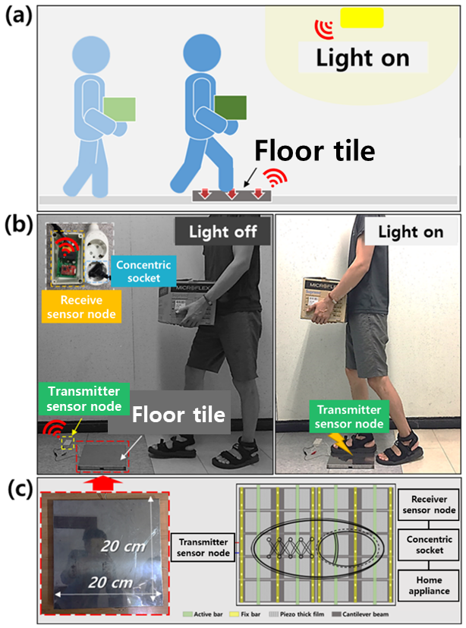
Figure. (a) Schematic illustration of the floor tile with the lights on. (b) Photograph of the developed foot switch as an integrated piezoelectric self-powered system using the energy converted from a walking human with the piezoelectric harvester, transmitter sensor, receiver sensor, and the light plug. (c) Photograph of the as-fabricated self-powered energy harvester and structural design of the floor tile.
Recent Publications
- Energy Conversion and Management 171 (2018) 31–37
- Energy 159 (2018) 196e2020196-8904/ © 2018 Published by Elsevier Ltd.


Biography
KYUNG BUM KIM has her expertise in evaluation and passion in improving the reaching skills. I am open and contextual evaluation model based on responsive constructivists creates new pathways for improving science. She has built this model after years of experience in research, evaluation, teaching and administration both in hospital and education institutions. The foundation is based on fourth generation evaluation which is a methodology that utilizes the previous generations of evaluation: measurement, and description.
Email: LNYLOVE17@NAVER.COM

Presenting author details
Full name: KYUNG BUM KIM
Contact number: 82-10-6573-1101
Mail id: LNYLOVE17@NAVER.COM
Category: Poster presentation

