Development of Phase Change Material-Expanded Clay Composites Capsules Coated with Geopolymer For Buildings
Ahmad Hasan¹, Najif Ismail², Abdel-Hamid Mourad¹, Yasir Rashid¹, Mohammad S. Laghari¹
¹College of Engineering, United Arab Emirates University, P.O. Box 15551, Al Ain, United Arab Emirates.
²School of Engineering, Wellington Institute of Technology, Lower Hutt, New Zealand

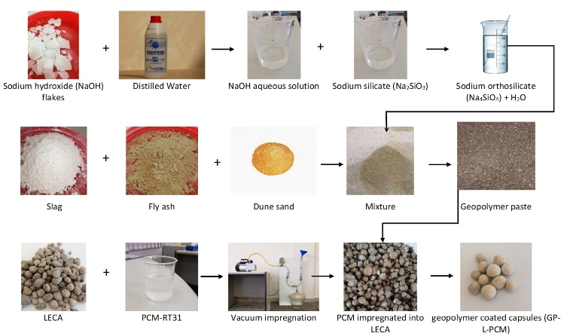
Abstract (300 word limit)
Statement of the Problem: Phase change materials (PCM) can damp and delay indoor cooling load in hot climates but the materials can’t be directly used in buildings due to leakage problem. PCM must be encapsulated into robust and leak-proof shell material to retain PCM inside the shell for several thermal cycles and to accommodate volume change during phase transition. Currently available shell materials are weaker in strength and break down during building construction processes. Methodology: In this study, lightweight expanded clay aggregates (LECA) was used as a matrix to host the PCM (RT-31 procured from Rubitherm, Germany) to evaluate the absorption capacity, viability of coating and stability. PCM was characterized using differential scanning calorimetry (DSC). It was impregnated into the pores of LECA using a customized vacuum impregnation set up. Later, alkali-activated fly ash based geopolymer paste (GP) was used to develop a protective coating around the capsules to avoid leakage. Thermal stability of the prepared form-stable capsules was tested through rapid thermal cycling (RTC) while leak proofing was evaluated using the diffusion-oozing circle test (DOCT). Conclusion & Significance: The performance of GP-LECA-PCM was tested as a function of leak-proof, robust coating and stability over high temperatures. Coating performance and reliability of the developed macrocapsules through the novel mechanical process were examined using weathering test, RTC and DOCT. No seepage and zero weight loss were observed after 1000 RTC and after exposing to the higher temperature. The produced materials can be used for thermal energy storage applications in buildings.

Image
Figure1: Materials and methods involved in the production of macro-encapsulated phase change material.
Recent Publications (minimum 5)
- Kalnæs E, Jelle P (2015) Phase change materials and products for building applications: a state-of-the-art review and future research opportunities. Energy and Buildings 94:150-176.
- Hassan A, Shakeel M, Rashid Y (2016) Micro-encapsulated phase change materials: a review of encapsulation, safety and thermal characteristics. Sustainability 8(10):1046.
- Giro-Paloma J, Konuklu Y, Fernández I (2015) Preparation and exhaustive characterization of paraffin or palmitic acid microcapsules as novel phase change material. Solar Energy 112: 300-309.
Li J, Lu W, Luo Z, Zeng Y (2017) Synthesis and thermal properties of novel sodium nitrate microcapsules for high-temperature thermal energy storage. Solar Energy Materials and Solar Cells 159:440-446.
5. Konuklu Y, Paksoy HÖ (2017) Polystyrene-based caprylic acid microencapsulation for thermal energy storage. Solar Energy Materials and Solar Cells 159:235-242.

Biography (150 word limit)

Eng. Yasir Rashid has recently completed his degree of Master of Science in Mechanical Engineering from the United Arab Emirates University (UAEU), Al Ain, UAE. He is working as a research assistant in the College of Engineering at UAEU. His research interests include building energy efficiency and thermal energy storage using phase change materials.
Email: yasir.rashid@uaeu.ac.ae

Notes/Comments:

Presenting author details
Full name: Yasir Rashid
Contact number: +971568695917
Mail id: yasir.rashid@uaeu.ac.ae
Category: (Oral presentation)

