Specific anion effects on copper surface through electrochemical treatment: Enhanced photoelectrochemical CO₂ reduction activity of derived nanostructures induced by chaotropic anions

Aso Navaee, Abdollah Salimi, university of Kurdistan,66177-15175, Sanandaj- Iran

Abstract
CO₂ conversion into useful chemicals has attracted considerable attention in recent years as a potential strategy aimed at controlling the green house emission and economic benefits [1]. CO₂ can be practically converted through a various chemical, photochemical or electrochemical transformations [1-6]. Electrochemical systems can be easily operated near room temperature where directly controllable by adjusting the applied electrode potential without a noticeable footprint and chemical feeding [5,6]. Copper derivatives are the most prominent CO₂ reduction electrocatalyst. Herein, the metallic copper has been electrochemically treated with some of common ionic salts such as N₃¯, HPO₂¯, S^{2¯}, F¯, Cl¯, Br¯ and I¯ based on the dissolution of a metallic working electrode in an aqueous solution to derive the surface roughness incorporated with nanostructures. Diverse surface morphology can be obtained when the ionic radii of anions are changed. Surface study reveals various roughness shapes based on the size and polarity of the anions, where the ions with higher ionic radii have higher impact on the Cu surface. In comparison, polyatomic oxyanion such as HPO₂¯ even with large ionic radii do not have enough strength to create the surface roughness than that of oxygen-free anions with large ionic radii. The photoelectrochemical behavior of the modified surfaces toward CO₂ reduction was studied at a wide potential window in bicarbonate aqueous solution. Based on our investigations, treated surfaces by I¯, Cl¯ and S^{2¯}give a more surface roughness, while I¯ and N₃¯ offer higher catalytic activity toward CO₂ reduction due to possible complexing ability of these anions with Cu cations, followed by formation of co-catalyst semiconductor and facilitate electron transfer. This methodology can be applied to investigate the effect of ions on transition metals along with obtaining different surface morphologies tailored to different applications.

Image

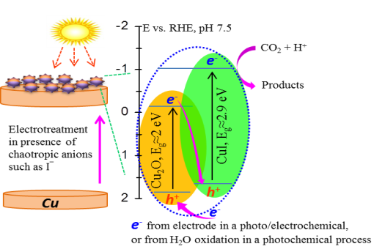

Scheme 1: The proposed electron transfer mechanism assisted by light illumination from possible generated co-catalyst semiconductor of CuI/Cu₂O in the left hand as well as typical chronoamperograms obtained from Cu electrode, commercial CuI and I¯ modified Cu surface by applying constant potential (each of steps represent a respective applied potential from-0.05 to -0.50 V vs. Ag/AgCl) under CO₂ atmosphere and light illumination is located in the right hand.

Recent Publications
- Park S E, Chang J S, Lee K W (EDs), Carbon Dioxide Utilization for Global Sustainability, Elsevier, 2004.
- Najafabadi A T (2013) CO₂ chemical conversion to useful products: An engineering insight to the latest advances toward sustainability. Int. J. Energy Res. 37:485-499.
- Qiao J, Liu Y, Hong F, Zhang J, (2014) A review of catalysts for the electroreduction of carbon dioxide to produce low-carbon fuels. Chem. Soc. Rev. 43 631-675.
- Kumar B, Brian J P, Atla V, Kumari S, Bertram K A, White R T, Spurgeon J M (2016) New trends in the development of heterogeneous catalysts for electrochemical CO₂ reduction. Catal. Today 270:19–30.
- Ganesh I (2016) Electrochemical conversion of carbon dioxide into renewable fuel chemicals – The role of nanomaterials and the commercialization, Ren. Sus. En. Rev. 59:1269–1297.
- Maina J W, Gonzalo C P, Kong L, Schütz J, Hill M, Dumée L F (2017) Metal Organic Frameworks Based Catalysts for CO₂ Conversion Authors. Mater. Horiz. 4:345-361.

Biography (150 word limit)
Aso Navaee has his expertise in electrochemistry under supervising of Prof. Abdollah Salimi in University of Kurdistan. Now he is a researcher in electrocatalysis and photoelectrocatalysis by nanomaterial application in energy conversion.
Email: aso.navaee@gmail.com

Notes/Comments:

Presenting author details
Aso Navaee, ^{a*} Abdollah Salimi ^{a,b*}
ªDepartment of chemistry, university of Kurdistan,66177-15175, Sanandaj- Iran .
^{b}Research Centre for nanotechnology, University of Kurdistan, 66177-15175, Sanandaj- Iran,

Corresponding Authors:
Aso Navaee, a.navaee@sci.uok.ac.ir
Abdollah Salimi, e-mail:absalimi@uok.ac.ir, absalimi@yahoo.com
Tel: +98-87-33624001, Fax: +98-87-33624008;
Category: (Oral presentation/ Poster presentation)

