CHESS-SETUP & EMPORIUM Solar Heating Systems with Seasonal Energy Storage
Renee Wansdronk, Wansdronk Architektuur, NLD

Abstract (300 word limit)

Combined HEat Supply System by using Solar Energy and heaT pUmPs (CHESS-SETUP)

The project objective is to design, implement and promote a reliable, efficient and profitable system able to supply heating and hot water in buildings mainly from renewable sources. The proposed system is based on the optimal combination of solarthermal (ST) energy production, seasonal heat storage and high efficient heat pump use. Heat pumps will be improved technically in order to obtain the best performance in the special conditions of the CHESS-SETUP system.

The used solar panels will be hybrid photovoltaic and solar thermal (PV-ST) panels, which is a promising solution for also producing the electricity consumed by the heat and water pumps of the heating system and part of the electricity consumed in the building. Hybrid solar panels are a key element to achieving energy self-sufficiency in buildings, especially in dense urban areas where the roof availability is one of the most limiting factors.

Also will be considered the integration of other energy sources as biomass or heat waste, to make the system suitable for any climate conditions. The project will also explore the possibility to integrate the system with other electricity or cooling technologies (solar cooling, cogeneration).

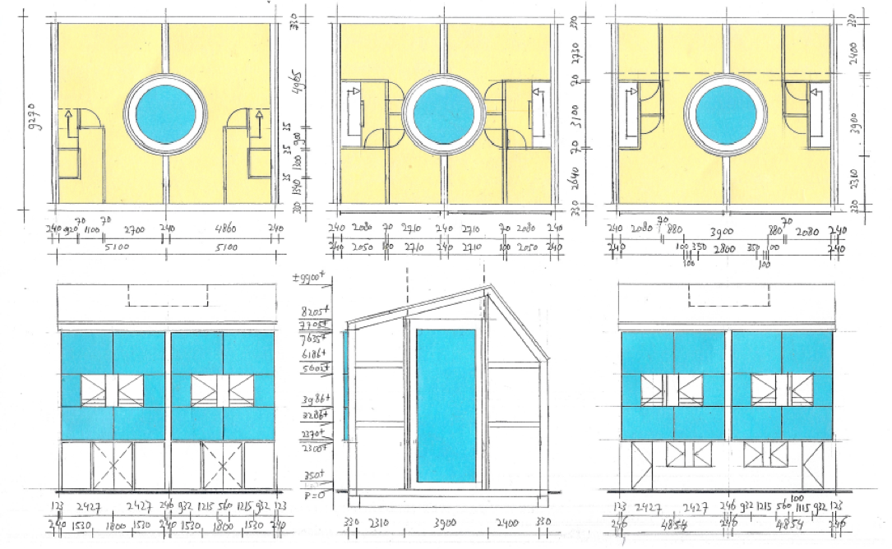
The system operation will be optimized according to some external factors, as electricity price or user requirements by using a smart control and management systems developed specifically for the project.

This proposal will be materialized in three pilot experiences: a small-scale prototype in LaVola's headquarters (Spain), 50 new dwellings located in Corby (England) and a new sport centre located in Sant Cugat (Spain).

Zero-Emission Low-Exergy Building Concept with Seasonal Heat Storage (EMPORIUM)

The Emporium concept is characterized as a seasonal heat storage with the smallest exergy loss (low-exergy), and without any energy loss. In this case exergy (applicability or quality of energy) stands for the temperatures which are used in the Emporium system, and which are as close as
possible to the demand temperatures (20 °C indoor and 45 °C shower). The heat storage water temperature is above these two demand temperatures and below 100 °C, and 50 to 90 °C over the year. These temperatures are produced with a vacuum tube semi-transparent solar heat collector which is integrated in the southern facade of the building. The seasonal heat storage volume is integrated with the building volume to achieve that all heat storage losses (more than 50% through 50 cm glass or stone wool insulation) flow into the building and are used as indoor heating.
CHESS-SETUP https://www.chess-setup.net/
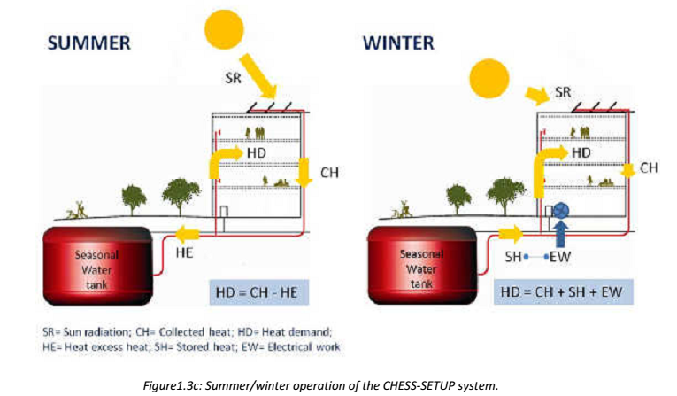
EMPORIUM http://wansdronk.com

Renee Wansdronk (150 word limit)


Wansdronk develops a solar energy, zero-emission and material saving building concept Emporium. A warm water storage container and heat
collectors provide the space heating and hot water supply, and a cold water storage container and cool collectors deliver the space cooling and
cooling source for the refrigerator. The water circulates without pumps; instead it uses thermosiphon, and therefore requires no high-grade energy
such as electricity or fuel.
heating.Email: rw@wansdronk.com

Notes/Comments:

Presenting author details
Full name: Renee Wansdronk, architect
Contact number: +31 85 8784298, +31 6 19716671
Mail id: rw@wansdronk.com
Category: (Oral presentation/ Poster presentation) Oral presentation

