SARCOPENIA – A Corner Stone in the Respiratory Rehabilitation in Elderly People
Dr. Maura-Gabriela FELEA, Lecturer, PhD, Grigore T. Popa University of Medicine and Pharmacy of Iasi, ROMANIA
Dr. Dragos MUNTEANU, Lecturer, PhD, Grigore T. Popa University of Medicine and Pharmacy of Iasi, ROMANIA
Dr. Petre-Augustin CRIVOI, PhD, Preventis Medical Center of Iasi, ROMANIA

Abstract
Statement of the Problem: Sarcopenia, or sarcopenia associated to all geriatric syndromes, including frailty, are related not only to skeletal muscle dysfunction, but also to multisystem decline. The purpose of this study is to describe the importance of Pulmonary rehabilitation programs (PRP) proved to be efficient in terms of symptoms, disease burden, physical function, and overall health status. Theoretical Orientation: Frailty and sarcopenia assessment are useful to identify the impact of chronic respiratory disease upon risk of falls, hospitalizations and mortality. Findings: Hand-grip test, sit-to-stand test (STS), and gait speed can classify together the degree of physical decline. Hand-grip test can measure the muscle strength by using a handle dynamometer. Conclusion & Significance: A complex interplay exists between the quadriceps weakness and daily-life physical activity. Simple segmental muscle strength evaluation, like quadriceps maximal voluntary contraction (QMVC), using a fixed dynamometer represents a reliable and responsive measure for depicting the improvement of quadriceps muscle strength at the end of the Pulmonary rehabilitation programs. Sarcopenia, frailty and rehabilitation have common overlapping goals regarding muscle strength, physical activity and vitality. Hand-grip test, STS test, gait speed or 6 minutes walking test (6MWT) are valuable and easy applicable tools for geriatric and sarcopenia assessment; but their value rises while their role extends towards quickly recognition of the beneficial physical and self-perceived changes at the end of Pulmonary rehabilitation programs.

Image
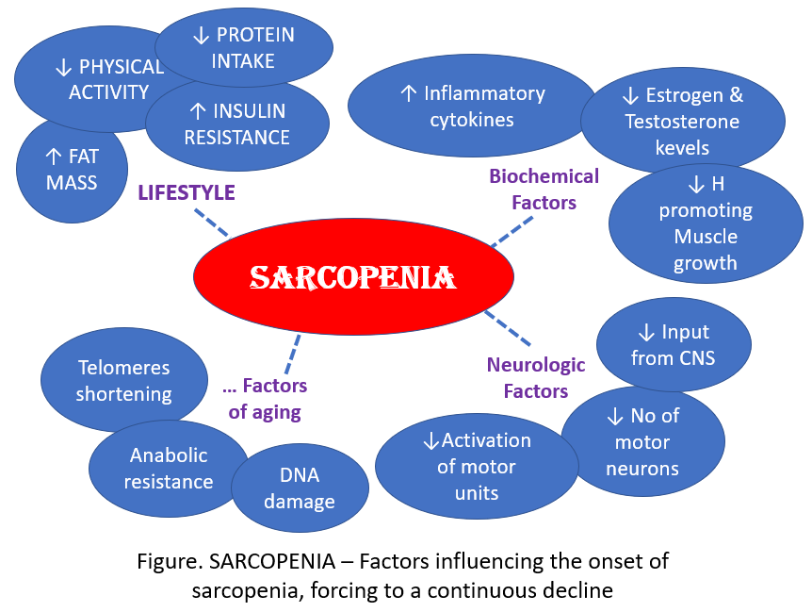
Recent Publications
- Al Namat R, FELEA M, Bazyani A, et al (2020) Psychological evaluation by using the Hamilton depression and anxiety rating scales in coronary artery bypass grafting patients undergoing cardiovascular rehabilitation treatment. Romanian Journal of Cardiology.
- Bazyani A, Al Namat R, FELEA MG, et al (2019) QRISK2 Score in CABG Patients Correlated with Risk Factors. REV.CHIM. (Bucharest) 70 (5): 1676-1680.
- Al Namat R, FELEA M, Costache I, et al (2018) Heart-Type Fatty Acid-Binding Protein (H-FABP) in patients with type 2 diabetes beneficiaries of rehabilitation program post coronary artery bypass grafting. REV.CHIM. (Bucharest) 69 (10): 2712-2717.
- Al Namat R, Aursulesei V, FELEA M, et al (2017) Heart-Type Fatty Acid Binding Protein (H-FABP) in Patients with Coronary Artery Bypass Graft Surgery undergoing Cardiac Rehabilitation Program. REV. CHIM. (Bucharest) 68 (7): 1485-1489, ISSN 2537- 5733.
- Al Namat R, Costache I, FELEA M, et al (2017) Lipid Profiles and Framingham Risk Score In Patients With Coronary Artery ByPass Graft Surgery Undergoing Cardiac Rehabilitation Program. REV.CHIM. (Bucharest) 68 (10): 2219-2230, ISSN 2537-5733.
- Al Namat R, Mitu O, FELEA M, Ghiciuc C, et al (2017) Multiple myeloma complicated with Takotsubo cardiomyopathy: Case report. The Medical-Surgical Journal 121 (2): 286-290, ISSN online: 2286-2560.

Photograph

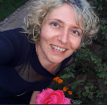Biography
Dr. Maura Gabriela Felea has expertise in clinical evaluation and passion in improving the health and wellbeing of humans. The first approach was towards the medical field of Geriatrics and Gerontology. During the first years of this step, she had the chance of a scholarship on Geriatrics at the Catholic University of Louvain in Belgium. Thus, she began to build her experience that was further continued by the work in the “Grigore T. Popa” University of Medicine and Pharmacy of Iasi, Romania, teaching students the Medical Semiology in a Clinic of Cardiovascular and Respiratory Rehabilitation. She is a lecturer with grate experience in oral presentation in Congresses and Conferences. Her work continued towards Homeopathy, as a complementary therapy approach. And in order to get further in Rehabilitation, she started a new pathway, in the vast domain of Sports Medicine, in order to enrich the management in evaluation, diagnosis and Rehabilitation.
Email: feleamag@yahoo.com

Notes/Comments:

