The Effects of Neurorehabilitation on the Stroke
Fatemeh Fekar Gharamaleki¹⁻², Zahra Thoulaya³, Shima Zarei⁴, Elahe Farmani⁵

- Ph.D. Candidate of Speech Therapy, Department of Speech Therapy, University of Social Welfare and Rehabilitation Sciences, Tehran, Iran
- Ph.D. Student of Speech Therapy, Department of Speech Therapy, School of Rehabilitation, Tabriz University of Medical Sciences, Tabriz, Iran
- Ph.D. Student of Speech Therapy, Department of Speech Therapy, University of Social Welfare and Rehabilitation Sciences, Tehran, Iran
- MSc in Speech Therapy, Department of Speech Therapy, Faculty of Rehabilitation Sciences, Tabriz University of Medical Science, Tabriz, Iran
- Ph.D. Student in Speech Therapy, Department of Speech Therapy, Faculty of Rehabilitation, Iran University of Medical Science, Tehran, Iran

Abstract
Neurorehabilitation is a crucial component of a long path toward recovery. Neurorehabilitation helps the patient adapt to or compensate for their impairments or reduce impairments. With the development of neuroimaging techniques such as functional magnetic resonance imaging (fMRI) and positron emission tomography (PET), many reports have been published revealing the underlying mechanisms of functional language recovery from aphasia. Although there are some pitfalls in the interpretation of neuroimaging, it is recommended that the function and network that compensate for impaired language function should be clarified prior to the initiation of neurorehabilitation for aphasia. We conducted a search in PMC, Web of Science, PubMed, Scopus, Medline, SID, and Ovid databases. The present information is available by reviewing the published articles from 1995 to 2023. Early diagnosis and rehabilitation allow the therapist has so time to resolve the function, motor, speech and language, mood, and personality that can occur with the aphasic patient and their transition to a caregiver role. The results of some double-blind controlled trials on aphasic patients have indicated that speech therapy plays a critical role in the recovery from aphasia. We anticipate limitless future possibilities for the intensive neurorehabilitation of aphasic patients, including constraint-induced language therapy, physical therapy, rTMS application, and cognitive therapy. The application of newly developed neuroimaging techniques may provide additional important information for improving neurorehabilitative intervention for aphasia. There is evidence of achieving a better outcome of neurorehabilitation with early initiation of treatment, high intensity, specific goals and active therapies, and the coordinated work and multimodality of a specialized team. In this context, interdisciplinary goal-setting and regular assessments of the patient are important. Furthermore, several further potential enhancers of neural plasticity, e.g., peripheral and brain stimulation techniques, pharmacological augmentation, and the use of robotics, are under evaluation.

Image
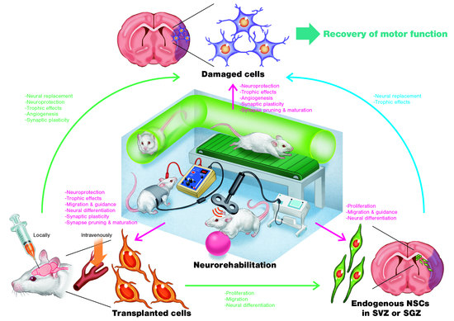
Recent Publications (minimum 5)
- Fekar Gharamaleki, F., Ahadi, H., Dastjerdikazemi, M., Bagherpour, P., Darouie, A., Ebadi, A., ... & Karimijavan, G. (2021). Determinants of Language Impairment in Turkish-Persian Bilingual Children. The Scientific Journal of Rehabilitation Medicine, 10(5), 922-935.
- Kahjoogh, M. A., Pishyareh, E., Gharamaleki, F. F., Mohammadi, A., Someh, A. S., Jasemi, S., & Zali, M. M. (2020). The Son-Rise Programme: an intervention to improve social interaction in children with autism spectrum disorder. International Journal of Therapy and Rehabilitation, 27(5), 1-8.
- Fekar Gharamaleki, F., Bahrami, B., & Masumi, J. (2022). Autism screening tests: A narrative review. Journal of Public Health Research, 11(1), jphr-2021.
- Fekar, F., & Mehri, A. (2019). Effectiveness of the core vocabulary approach for treatment of inconsistent phonological disorder: A case report. The Scientific Journal of Rehabilitation Medicine, 8(3), 279-288.
- Ahmadi Kahjoogh, M., Fekar Gharamaleki, F., Zohrabi, S., Mohammadi, A., & Soltani Someh, A. (2021). Effectiveness of Occupational Performance Coaching (OPC) on the Mental Health in Mothers of Children with Cerebral Palsy. The Scientific Journal of Rehabilitation Medicine, 10(1), 113-123.

Photograph

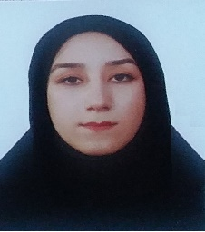
Biography (150 word limit)
Fatemeh Fekar Gharamaleki is studying for her Ph.D. at Social Welfare and Rehabilitation Sciences University, Iran. She is the director of Tabriz University of Medical Sciences, Iran. She has over 70 publications cited in journals and books, her H-index is 5 and she has registered over 6 patents. Her research and writing have focused on the Azeri Turkish language and the assessment of developmental language disorders. She has developed the Azeri Turkish test of grammar perception and research in this field.
Email: slp.fekar@yahoo.com

Notes/Comments:

Presenter Name: Fatemeh Fekar Gharamaleki
Type of Presentation: Speaker
Contact Number: 00989351534384

