Application of Bedriod to improve the independence of people with limited body movement
Mr Jason Yu, Msc(BME), CRSSC, HK

Abstract (300 word limit)
Background
Many individuals disabled people with special needs, especially tetraplegia or dense stroke patients, depend on helpers in their daily life. They are impossible to control their posture in bed due to limited functional movement and therefore they must seek assistance from their helper numerously.

Purpose
In order to restore hope and choices of living, a remote-control adaptation called “Bedriod” is innovated by CRSSC to facilitate their daily living.

Methods
“Bedriod” is a 3D printed holder anchored on the electric bed remote, a microcontroller unit is embedded in it to control the movement of motor, which is attached to the holder, so as to tele-operate the electric bed according to patient’s input. With the aid of LED indicator (i.e. red represents bed up; Yellow represents bed down), patients can trigger the bed position by a single button with small body movement.

Results
Five subjects were recruited, and 100% success rate was reported by therapist. Without “Bedriod”, patients need to seek assistance from helper. Patient lost their verbal ability is even impossible to call for help. Two subjects used push button as input and the remaining used toggle switch.

Conclusion
“Bedriod” allow patients to adjust their posture independently, feedbacks are positive and patients are confidently to use the device. In this stage, two movements (i.e. bed up and bed down) can be tele-operated by “Bedriod”, we are exploring possibilities to control the others in the future for serving more patients, allowing them to become more independent via a safe and user-friendly way.

Image
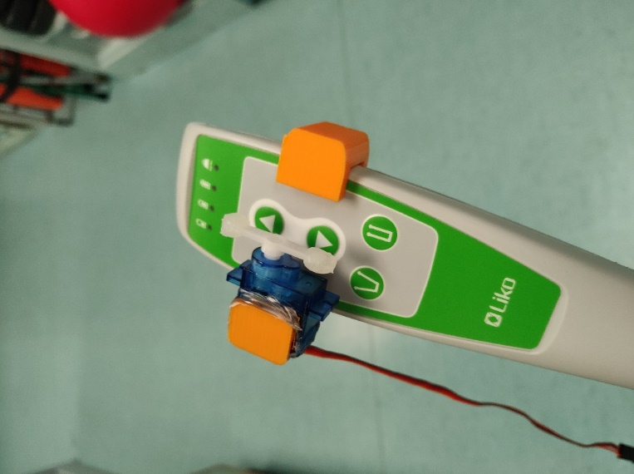
Figure1. 3D printed mount on rehabilitation bed remote control.
Recent Publications (minimum 5)
- Chan, M. K. L., Yeung, W. K. Y., Yu, J. K. P., Ng, S. S. W., & Tong, R. K. Y. (2022). Exploratory Study on the Clinical use of EEG for the People with Chronic Stroke and Their Correlation with the Neuropsychological Outcome. Clinical EEG and Neuroscience, 15500594221074858.
- Yu, K.-P., Yeung, L.-F., Ng, S.-W., & Tong, K.-Y. (2020). Bionic robotics for post-polio walking. Intelligent Biomechatronics in Neurorehabilitation, 83–109.
- Serena, Ng & Simon, Chan & Richy, Ng & Jason, Yu & Jocelyn, Au. (2019). Effective Assessment of Power Standing Device to Adults with Permanent Lower Limb Paralysis. Research in Health Science. 4. p246.
- Chan, S. F., Ng, M. L., Chan, S. Y., Chan, M. M. L., Lau, W. Y., Chan, K. K., & Pong, Y. K. (2019). 44. A third hand for home hemodialysis. Renal Society of Australasia Journal, 15, 35-35.

Photograph


Mr. Jason YU K P
Assistant Manager (Technology), Community Rehabilitation Service Support Centre (CRSSC), Hospital Authority.

Mr. Jason YU is an clinical engineer working in Hospital Authority at present. With the background of electronic engineering, he has participated in the setting up and development of clinical engineer team in CRSSC. The team is a pioneer that has extensive participation in technology supported patient services including tailor-made assistive devices for persons with different disabilities and patients suffered from rare diseases. For the rehabilitation knowledge development, he has been involved in various clinical researches related to lower limb and upper limb exoskeleton, knee robotic, EEG and EMG study. He is now conducting his PhD study in Biomedical Engineering.
Email: ykp587@ha.org.hk

