Dynamometry – a tool to assess functional capacity – precedes rehabilitation in elderly
Dr Maura Gabriela Felea, PhD, Lecturer “Grigore T. Popa” University, Romania
Dr Petre Augustin Crivoi, PhD, Preventis Medical Center, Romania
Dr. Razan Al Namat, PhD, Assistant Professor “Grigore T. Popa” University, Romania

Abstract
Statement of the Problem: Sarcopenia is the key trigger factor for health decline, and the consequence of various comorbidities that will impact functional capacity, cardiorespiratory fitness, morbidity and mortality in elderly. We searched the correlation of sarcopenia and cardiovascular performance. Methodology and Theoretical Orientation: From 2020, we performed a health screening, in urban and rural community-dwelling older adult groups. They benefited from home care services. Clinical evaluation was crowned by lab tests, and adapted tests to assess functional capacity. Findings: While men were outnumbered in this group of people, women presented a higher functional longevity than men, although there were a few in a greater physical disability with bedridden for more than 6 months. The physical performance tests results were correlated to the reduction in mobility, to cardiovascular diseases and cardiovascular deconditioning. As well as the hand grip test, with results below the cut-off value, all data were compared between gender, and urban and rural areas. At hand grip values below the threshold, people climbed less than 10 steps or none. Regarding their health status, they were asked to perform other tests. Conclusion & Significance: According to the sarcopenia guideline, the cut-off values of the hand grip test identify the risk of sarcopenia. The SARC-F questionnaire clinically supports the confirmation of the diagnosis, but physical performance tests play a key role in classifying the severity of sarcopenia. The hand-grip strength test reveals lower values with ageing, there is still a great reserve capacity for recovery compared to immobilization effects in young or adults. The target of rehabilitation would be to evaluate and diagnose, to regain independence for daily activities and self-esteem, and to reduce the family burden during the years to come. A comprehensive management of sarcopenia, including rehabilitation, is the key element to surpass this border called ageing.
.

Image
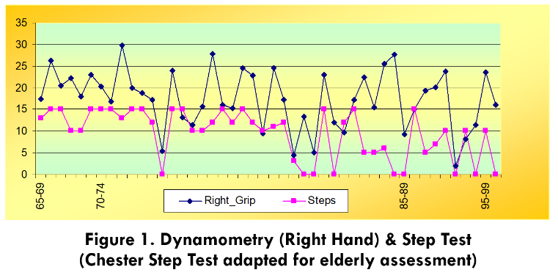
Recent Publications
- Al Namat R, FELEA M, Bazyani A, et al (2020) Psychological evaluation by using the Hamilton depression and anxiety rating scales in coronary artery bypass grafting patients undergoing cardiovascular rehabilitation treatment. Romanian Journal of Cardiology.
- Bazyani A, Al Namat R, FELEA MG, et al (2019) QRISK2 Score in CABG Patients Correlated with Risk Factors. REV.CHIM. (Bucharest) 70 (5): 1676-1680.
- Al Namat R, FELEA M, Costache I, et al (2018) Heart-Type Fatty Acid-Binding Protein (H-FABP) in patients with type 2 diabetes beneficiaries of rehabilitation program post coronary artery bypass grafting. REV.CHIM. (Bucharest) 69 (10): 2712-2717.
- Al Namat R, Aursulesei V, FELEA M, et al (2017) Heart-Type Fatty Acid Binding Protein (H-FABP) in Patients with Coronary Artery Bypass Graft Surgery undergoing Cardiac Rehabilitation Program. REV. CHIM. (Bucharest) 68 (7): 1485-1489, ISSN 2537- 5733.
- Al Namat R, Costache I, FELEA M, et al (2017) Lipid Profiles and Framingham Risk Score In Patients With Coronary Artery ByPass Graft Surgery Undergoing Cardiac Rehabilitation Program. REV.CHIM. (Bucharest) 68 (10): 2219-2230, ISSN 2537-5733.
- Al Namat R, Mitu O, FELEA M, Ghiciuc C, et al (2017) Multiple myeloma complicated with Takotsubo cardiomyopathy: Case report. The Medical-Surgical Journal 121 (2): 286-290, ISSN online: 2286-2560.

Photograph

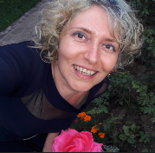Biography
Dr. Maura Gabriela Felea has expertise in clinical evaluation and passion in improving the health and wellbeing of humans. The first approach was towards the medical field of Geriatrics and Gerontology. During the first years of this step, she had the chance of a scholarship on Geriatrics at the Catholic University of Louvain in Belgium. Thus, she began to build her experience that was further continued by the work in the “Grigore T. Popa” University of Medicine and Pharmacy of Iasi, Romania, teaching students the Medical Semiology in a Clinic of Cardiovascular and Respiratory Rehabilitation. She is a lecturer with grate experience in oral presentation in Congresses and Conferences. Her work continued towards Homeopathy, as a complementary therapy approach. And in order to get further in Rehabilitation, she started a new pathway, in the vast domain of Sports Medicine, in order to enrich the management in evaluation, diagnosis and Rehabilitation.
Email: feleamag@yahoo.com

Notes/Comments:

