Title: Saving a Severely Crushed Hand by Implantation into the Abdomen: A Case Report
Name: Khalil A
Affiliation: AMC, EGYPT

Abstract
Crush hand injuries are rare however they represent devastating and challenging events. They are usually caused by a compressive force, resulting from a high-energy mechanism such as a motor vehicle or industrial accidents, leading to damage of multiple tissue types, including skin, soft tissues, blood vessels, nerves and bones. The objective of this case study is to highlight the management plan to save a severely crushed hand with a high risk of amputation.
It is a case report of a 45-year male patient that was referred to our tertiary trauma centre with a severe crushing injury of his left hand and distal forearm following RTA. After proper resuscitation and investigations, the patient was operated; washout, debridement of all necrotic tissues, and amputation of the completely devitalized index finger and thumb was performed. Fractured bones were stabilized, and then coverage of the big raw area with the underlying bones exposed was managed by implanting the patient hand into his abdomen that was kept for 4 weeks before separation. Results: The results were marvelous and the taken flap was completely viable; the hand was saved with a fairly good functional outcome, and the patient is being followed for 18 months up till now.

Implantation of a crushed hand into the abdomen is not a so popular procedure for reconstruction; however, it was the best option to save a severely crushed hand as in our case study. The primary aim of management is to save life, limb and then restore limb function in that order.
Biography
Khalil A, MD is the chief of general and vascular surgery department, AMC Group, Egypt. He is an international author, and he has many publications in reputed journals indexed in Pub Med and has been serving as an editorial board member in some of them. Dr Khalil has passion in management of challenging and complicated cases, and he is interested in sharing his case reports in international conferences around the globe.
Email ID: draymankhalil55@gmail.com

Presenter Name: Khalil A
Type of presentation: Speaker
Contact Number: +2 01001816306

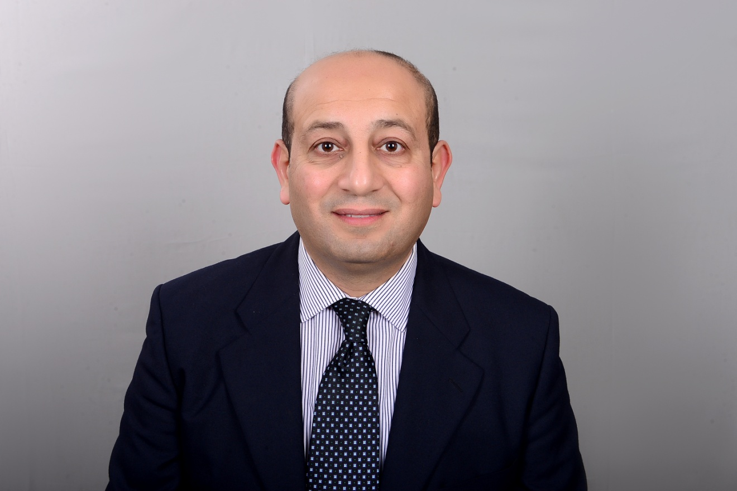

Dr AYMAN KHALIL

